St. Mary’s EYFS Policy for Number & Calculation: Autumn 2023

Nursery: 22-36 months
Selects a small number of objects f rom a group when asked, for example, ‘please give me one’, ‘please give me two’. Creates and experiments with symbols and marks representing ideas of number
Begins to make comparisons between quantities.
Uses some language of quantities, such as ‘more’ and ‘a lot’
Knows that a group of things changes in quantity when something is added or taken away.
Representations | Key knowledge and vocabulary | Concrete & pictorial Conceptual modelling | Abstract  Skills and knowledge | Application across the environment
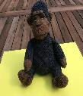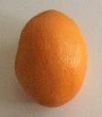  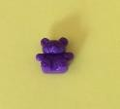  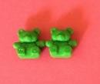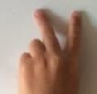  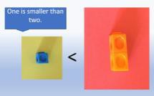 | Concepts of quantity, equality and inequality. | Natural materials and  physical objects in all | Spoken number names.  One, once, alone, first. | Ten Town  Wonderful one and terrific
 | Modelling combining sets of small quantities. | environments.  Pictures to show one or two items. |  | two displays.  Hiding objects find one of,
 | Modelling adding to a quantity to make it bigger. | Objects and resources to physically represent a | Mark making and graphics to represent a small number | or lots of in the sand, across  the setting.
 | Removing objects from a set to show the amount is now smaller. | quantity. Images and  pictures to represent a small quantity. | in the context of play. | Matching one item to  another then to one image. Repeat with two.
 |  | Using dishes/hoops to make |  | Snack time: one piece of
 |  | quantities of different | Mark making and graphics | fruit to one person, two
 |  | values that visually show | to represent a small | pieces each
 |  | one set has more than the | quantity to compare in the
 |  | other. | context of play.

 |  | Images of quantities to compare. Which has more? |  | Problem solving: “We need one/two each how can we sort the bears?”

Nursery/Reception: 30 - 50 months
Knows that numbers identify how many objects are in a set.
Beginning to represent numbers using f ingers, marks on paper or pictures. Sometimes matches numeral and quantity correctly.
Compares two groups of objects, saying when they have the same number.
Separates a group of three or four objects in different ways, beginning to recognise that the total is still the same. Shows an interest in representing numbers.
Representations | Key Vocabulary | Key knowledge | Concrete & pictorial  Conceptual modelling | Abstract  Skills and knowledge | Application across the environment
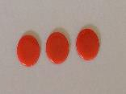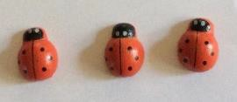 | Layers of  vocabulary  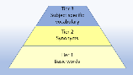  Appendix 1a Beck’s Tiers of Vocabulary Appendix 1b: Vocabulary book | Concepts of  cardinality, equality, inequality and rearranging the same quantity.  Counting to 3. One to one correspondence. Knowing how many are in the set. | Natural materials  and physical objects in all environments to count. (cardinality) Pictures to show a quantity that can be counted. | Represent a  quantity by drawing.  Mark making and graphics to represent a small quantity and | Construction.  What can you make with 3 / 4 bricks?  Small world.  Put three carriages on the train.  How many cars are in the car park?

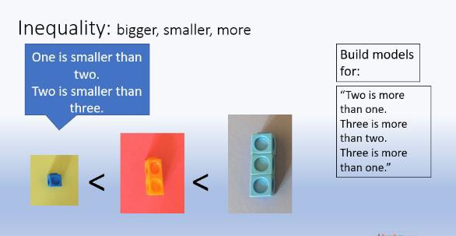  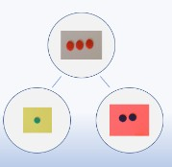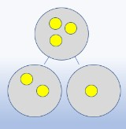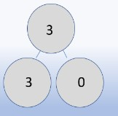 | Basic to subject specific (Beck’s Tiers):  Add, more, and, make, sum, total, altogether, double, how many  Instructional vocabulary: Listen, join in, say, start from, look at, carry on | Comparing numbers 1,2 and 3 – ‘bigger’ and ‘smaller’  Stable ordering numbers 1 to 3.  3 is made up of 2 and 1.  Using counting strategies and subitising to identify the number of concrete objects in the set. | Use fingers to show small amounts.  Images and pictures to represent a small quantity.  Resources that match a numeral to a quantity. E.g a number track, digits cards with numerals and quantities represented. | attempts at numerals.  Mark making and drawings to replicate the concrete and pictorial model.  With models, attempts to write numerals and continue to mark make. | How many skittles have you knocked over?  Mark making and graphics to represent a small number in the context of play.

Reception: 40 - 60 months
Counts up to three or four objects by saying one number name for each item. Counts objects to 10 and beginning to count beyond 10.
Selects the correct numeral to represent 1 to 5, then 1 to 10 objects.
Uses the language of ‘more’ and ‘fewer’ to compare two sets of objects. Finds the total number of items in two groups by counting all of them.
Says the number that is one more than a given number.
In practical activities and discussion, beginning to use the vocabulary involved in adding and subtracting.

Representations | Key Vocabulary | Key knowledge and  vocabulary | Concrete & pictorial  Conceptual modelling | Abstract  Skills and knowledge | Application across the  environment
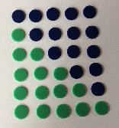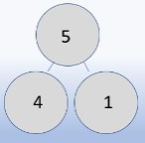 | Layers of vocabulary  Basic to subject specific (Beck’s Tiers):  Add, more, and, make, sum, total, altogether, double, how many more to make, how many are left, how many have gone?  Instructional vocabulary:  Listen, join in, say,  start f rom, look at, carry on, what comes next, f ind, choose, talk about | Number structure. Equality, inequality. Partitioning and recombing.  Subitising to 5. 5 as an anchor.  Modelling the combining of sets, recognising that the quantity has increased.  Using counting strategies and subitising to identify the number of concrete/pictorial objects in the set  . | Natural materials, physical objects and mathematical resources e.g. counters in all environments to count accurately. (cardinality).  To 10 and beyond. Pictures to show a quantity that can be counted then to 10 and beyond.  Resources that match a numeral to a quantity  Models of mathematical counting resources to show the more or fewer.  Using a number track or line to show one more than a given  number | Represent a quantity by drawing or by using graphics. (using drawings to show a resource)  Mark making and graphics to represent numbers to 10 and beyond in their play.  Graphics and attempts at numerals in the correct orientation.  Mark making and numerals to replicate the concrete and pictorial model.  Graphics and numerals to show the addition | Malleable play: problem solving  ‘Let’s put 5 cherries on  the cakes.’  ‘How will you put your 5 candles on the two cakes?’  Role play: problem solving  Each shelf in the shop must have 5 or more items to sell.  How shall we arrange the items?  Find items in the sand. 3 shells and 2 fish. How many items altogether?

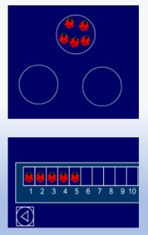
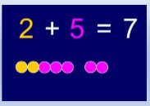
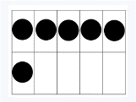
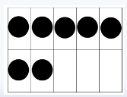

Reception: ELG 2018
Numbers to 20: place them in order and say which number is one more or one less than a given number
Using quantities and objects, they add and subtract two single-digit numbers and count on or back to f ind the answer They solve problems, including doubling, halving and sharing.
Representations | Key Vocabulary | Key knowledge and  vocabulary | Concrete & pictorial  Conceptual modelling | Abstract  Skills and knowledge | Application across the  environment
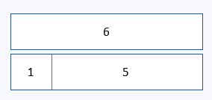  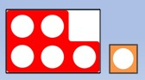  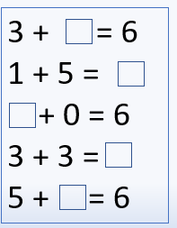 | Layers of vocabulary  Basic to subject specific (Beck’s Tiers):  Add, more, and, make, sum, total, altogether, double, how many more to make, how many are left, how many have gone?  One less, two less, ten less, the difference between, odd and even. | Number structure. Equality, inequality. Partitioning and recombing.  Subitising to 5. 5 as an anchor.  Modelling the combining of sets, recognising that the quantity has increased.  Using counting strategies and subitising to identify the number of concrete/pictorial objects in the set | Natural materials, physical objects and mathematical resources e.g. counters in all environments to count accurately. (cardinality).  To 10 and beyond. Pictures to show a quantity that can be counted then to 10 and beyond.  Resources that match a numeral to a quantity  Models of mathematical counting | Represent a quantity by drawing or by using graphics. (using drawings to show a resource)  Mark making and graphics to represent numbers to 10 and beyond in their play.  Graphics and attempts at numerals in the correct orientation.  Mark making and numerals to replicate the concrete and  pictorial model. | Malleable play: problem solving  ‘Let’s put 5 cherries on  the cakes.’  ‘How will you put your 5 candles on the two cakes?’  Role play: problem solving  Each shelf in the shop must have 5 or more items to sell.  How shall we arrange the items?  Find items in the sand. 3 shells and 2 fish.  How many items altogether?

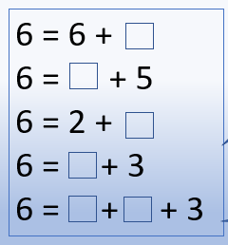 | Instructional vocabulary:  Listen, join in, say,  start f rom, look at, carry on, what comes next, f ind, chose, talk about, repeat, tell me, describe,  complete | . | resources to show the more or fewer.  Using a number track or line to show one more than a given number | Graphics and numerals to show the addition
Reception: ELG 2018
Numbers to 20: place them in order and say which number is one more or one less than a given number
Using quantities and objects, they add and subtract two single-digit numbers and count on or back to f ind the answer
They solve problems, including doubling, halving and sharing.
Representations | Key Vocabulary | Key knowledge | Concrete & pictorial Conceptual modelling | Abstract  Skills and knowledge | Application across the environment
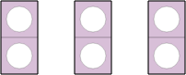  Counting in 2s  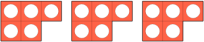  Counting in 5s | Layers of vocabulary  Basic to subject specific (Beck’s Tiers):  Add, more, and, make, sum, total, altogether, double, how many more to make, how many | Knowing that groups of the same quantity are added together. That is what makes a double.  The quantity divided into two equal groups. Halving.  Sharing and grouping.  Sharing is where you take a quantity and count out into how | Natural materials, physical objects and mathematical resources e.g. counters in all environments to double, share, group and half accurately.  Modelling and demonstrating groups  of and shared quantities. | Represent a quantity by drawing or by using graphics. (using drawings to show a resource)  Graphics and numerals to show the double/halving/grouping and sharing used. | In small world play:  All the animals in the enclosures are doubles. How many lions will there be etc?  Doubles shop Everything in the shop has to be double.  Snack time

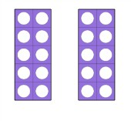  Double 10 is 20.  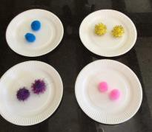  8 divided in to groups of 2.  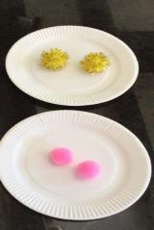  4 shared equally into two groups. | are left, how many have gone?  One less, two less, ten less, the difference between, odd and even.  Equals, share, groups of, halve and half  Instructional vocabulary:  Listen, join in, say, start f rom, look at, carry on, what comes next, f ind, choose, talk about, repeat, tell me, describe, complete, pattern, remember, ring, work out, check, another way | many equal groups you want.  Grouping is where you take the quantity and make the groups (of two, or three etc) | Showing that the quantity has increased when doubled and reduced when halved. |  | How will we share the fruit so that we can have half each?

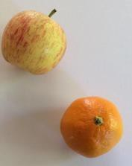

To halve the apple it would be cut into two equal pieces
To halve the satsuma we would could the segments and share them equally.

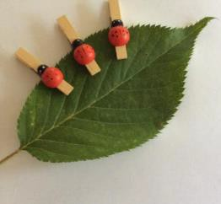
Double the number of ladybirds.
This show half the number of lady birds sitting on the leaf.

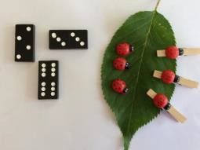

Doubling and halving.

