KS1 ADDITION – Year 1 and Year 2

EYFS – prior learning  What should the children already know?  ELG (Early Learning Goals) | Number ELG Children at the expected level of development will:  • Have a deep understanding of number to 10, including the composition of each number;  • Subitise (recognise quantities without counting) up to 5;  • Automatically recall (without reference to rhymes, counting or other aids) number bonds up to 5 (including subtraction facts) and some number bonds to 10, including double facts.  Numerical Patterns ELG Children at the expected level of development will:  • Verbally count beyond 20, recognising the pattern of the counting system;  • Compare quantities up to 10 in different contexts, recognising when one quantity is greater than, less than or the same as the other quantity;  • Explore and represent patterns within numbers up to 10, including evens and odds, double facts and how quantities can be distributed equally.
Year | Year 1 | Year 2
Layers of vocabulary  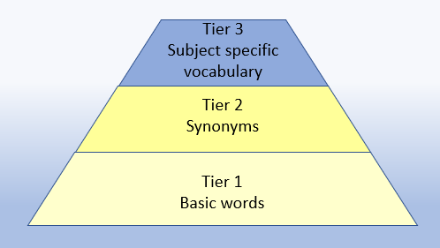  Appendix 1a  Beck’s Tiers of Vocabulary  Appendix 1b: Vocabulary book | Key Vocabulary  Basic to subject specific (Beck’s Tiers):  +, add, more, plus, make, sum, total, altogether, score, double, near double, one more, two more… ten more… How many more to make…? How many more is… than…? How much more is…?  Instructional vocabulary:  start from, start with, start at, look at, point to, show me…  NFER– language of tests and questions  match, tick, draw, complete, write, circle, share, jumps, count on, use a ruler | Key Vocabulary  Basic to subject specific (Beck’s Tiers):  +, add, addition, more, plus, make, sum, total, altogether, score, double, near double, one more, two more... ten more... one hundred more… how many more to make…? How many more is… than…? How much more is…?  Instructional vocabulary:  tell me, describe, name, pick out, discuss, talk about, explain, explain your method, explain how you got your answer, give an example of… show how you…  NFER– language of tests and questions  tick, match, count, tick two, circle, write, draw, complete, use these numbers, shade, write, make, choose, circle the three, complete, write, tick all, complete the number sentence, put a digit, How many…?
KS1 ADDITION – Year 1 and Year 2

Year | Year 1 | Year 2

Known facts | Represent & use number bonds and related subtraction facts within 20  Add and subtract 1 digit and 2 digit numbers to 20, including zero. | Recall and use addition and subtraction facts to 20 fluently, and derive and use related facts up to 100.

Essential Knowledge | 1 more | Number bonds: 5 and 6 | 10 more | Number bonds:20,12 and 13
Essential Knowledge | Largest number first | Number bonds: 7 and 8 | Add 1 digit to 2 digit by bridging | Number bonds: 14 and 15
Essential Knowledge | Add 10 | Number bonds:9 and 10 | Partition second number and add tens then ones | Number bonds: 16 and 17
Essential Knowledge | Ten plus ones | Use number bonds of 10 to derive bonds of 11 | Add 10 and multiples of 10 | Number bonds: 18 and 19
Essential Knowledge | Doubles up to 10 | Use number bonds to 20 | Doubles up to 20 and multiples of 5 | Partition and recombine
Essential Knowledge |  |  | Add near multiples of 10

NC 2014 | Read, write and interpret mathematical statements involving addition (+), subtraction (-) and equals (=) signs. | Recording addition in columns supports place value and prepares for formal written methods with larger numbers.

KS1 ADDITION – Year 1 and Year 2

 | concrete, pictorial, abstract
Year | Year 1 |  |  | Year 2
Developing Conceptual/  Procedural Understanding | Number bonds  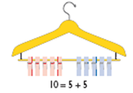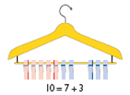  We have 10 pegs on the coathangers, how can we split them into 2 groups? Is there another way? How can we be sure we have got them all?  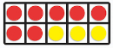  Numicon Ten Frame  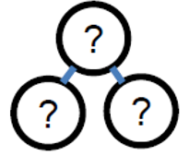  Whole-part model  8 + 2 = ?    Year 1  3 + ? = 10  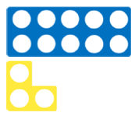  6 + ? = 10  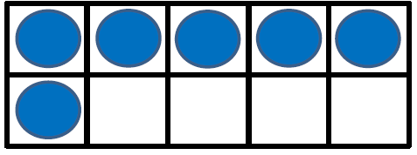  7 + ? = 10  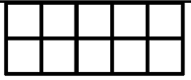  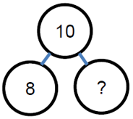  8 + ? = 10  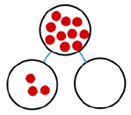  Fill in the missing numbers.  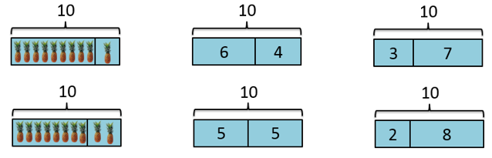  Number 10 fact families  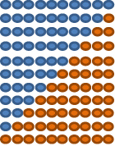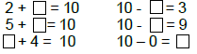  Use the pattern to complete the number sentences.  Year 1  Use bonds of 10 to calculate bonds of 20  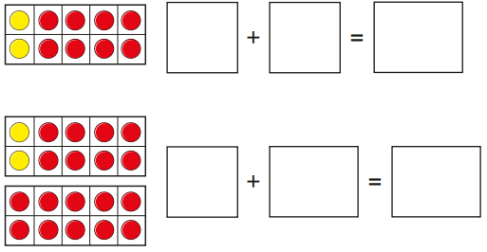  2 + 8 = 10  18 + ____ = 20  19 + 1 = ?  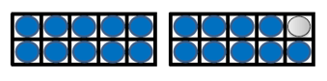  18 + 2 = ?    14 + 6 = ?  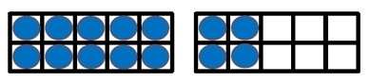  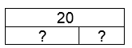 | Story contexts  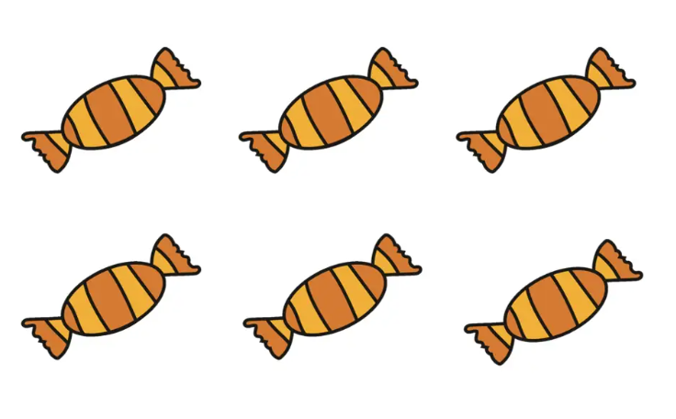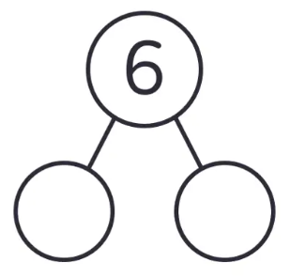  5 + 1 = 6  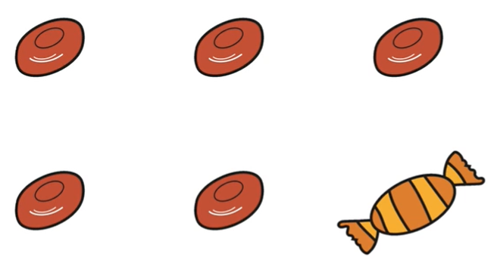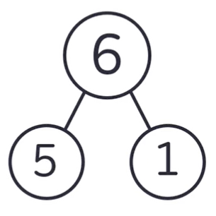  Story of 6  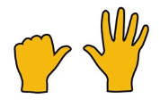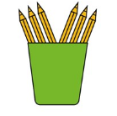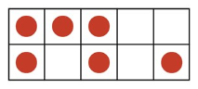  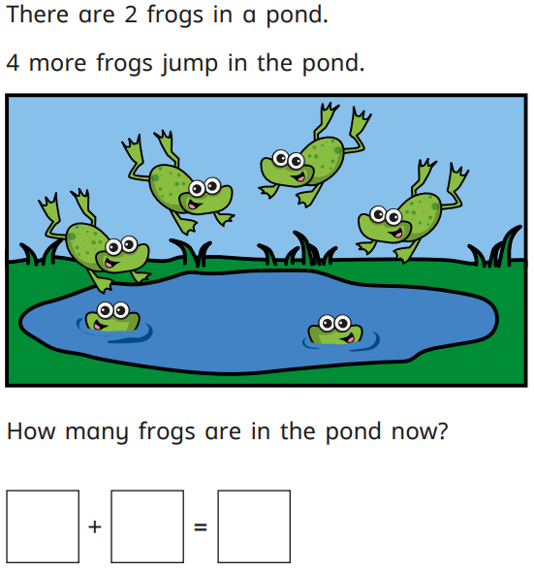  Part-whole model  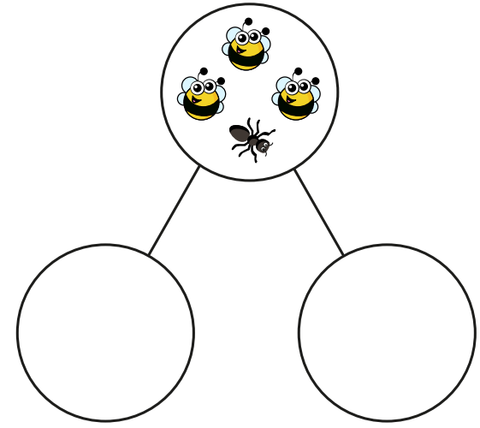  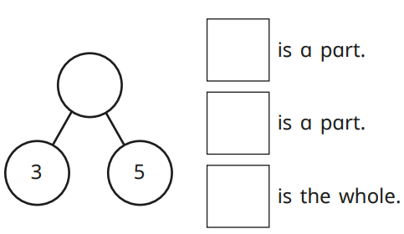  5 + 3 = ?  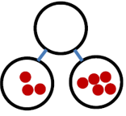  Balance image for concept of equality  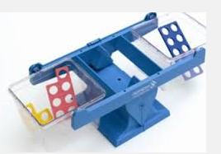  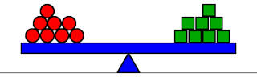  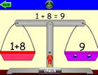.  Biggest number first  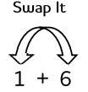  When the order of two numbers being added is changed the total remains the same.  1 + 8 = 8  8 + 1 = 8  Year 1  Count on in 1s  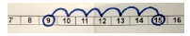  Count on, on number track in 1s.  Five and a bit  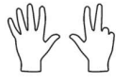  The numbers 6, 7, 8 and 9 are mad up of ‘five and a bit’. Supports decomposition of these numbers.  5 + 3 = 8  9 – 5 + 4  Year 1  Develop knowledge of fact families  7 = 5 + 2  7 = 2 + 5  7 – 2 = 5  7 – 5 = 2  Ten and a bit  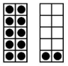  3 + 10 = 13  17 – 7 = 10  Recognising the and understanding the structure of these numbers.  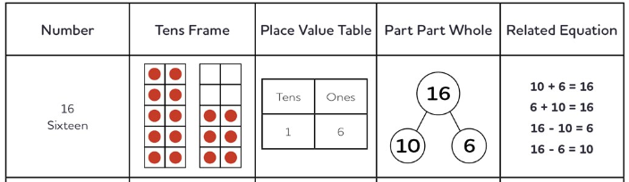 | One more  8 + 1 = ?  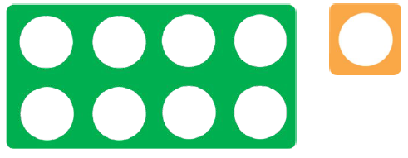  14 + 1 = ?  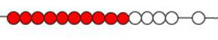  23 + 1 = ?  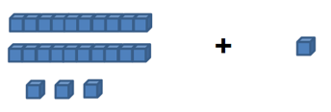  Moving onto a number line  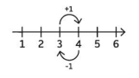  When we add 1 we get the next counting number.  Two more, odds and evens  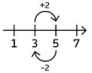  If we add two to a number, we go from odd to next or even to next even.  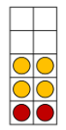  2 + 7 = 9  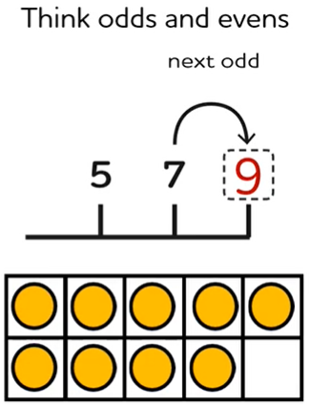  Practical  17 + 2 = ?  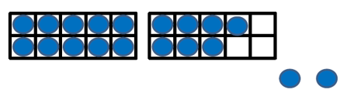  6 + 13 = ?    7 + 8 = ?  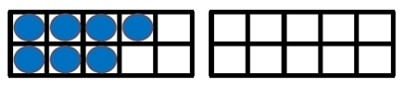  8 + 9 = ?  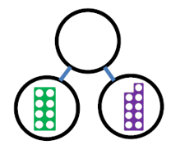  23 + 21 = ?  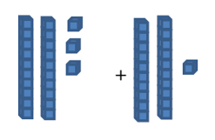  Part-whole model  21 + 12 = ?  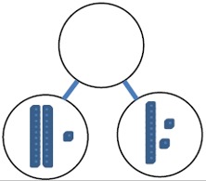  23 + 12 = ?  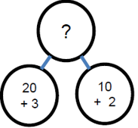  18 + 13 = ?  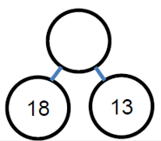 | Adding multiples of ten  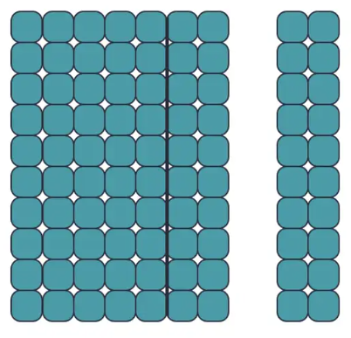  7 + 2 = 9  70 + 20 =90  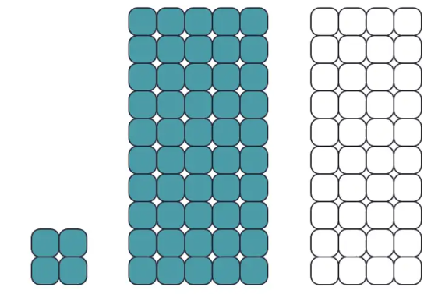  50 + 40 = 90  54 + 40 = 94  Adding ones to a two digit number  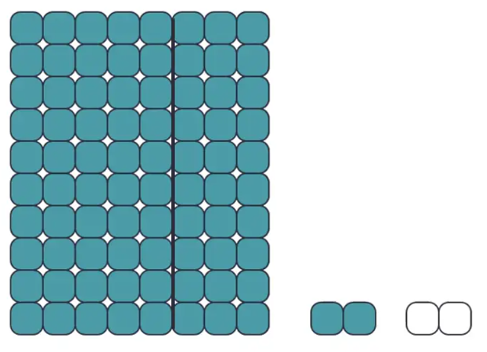  2 + 2 = 4  Year 2  82 + 2 =84  Finding safe numbers (multiples of 10)  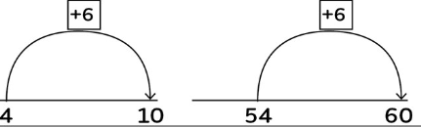  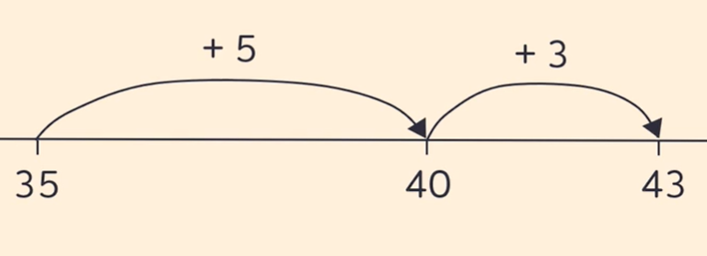  35 + 8 = 43  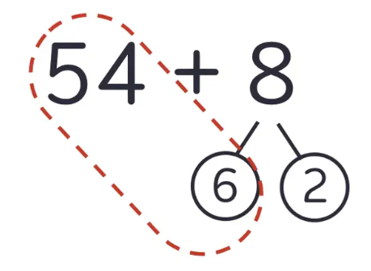  54 + 8 = 62 = 54 + 6 + 2  Adding more than two numbers  Strategy to include looking for facts or bonds that are useful e.g. bonds up to and including 10, doubles or adding 10 to a given number.  Year 2  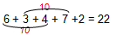  Children to show notation. | Adjustment strategy  7 + 9 =  7 + 10 – 1= 16  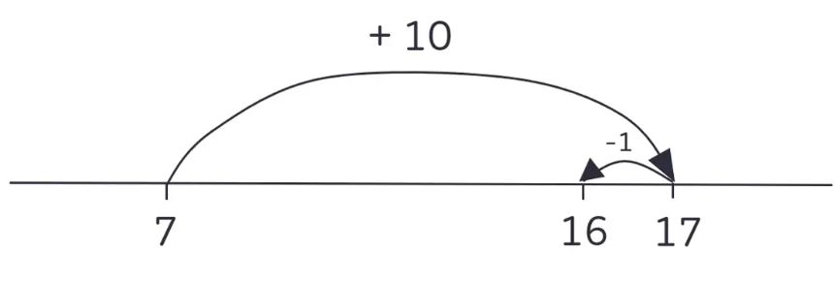  (Round and adjust)  Doubles then near doubles  Near bonds  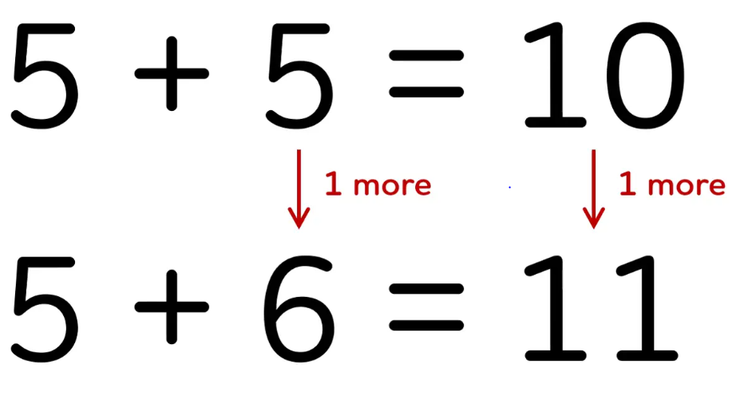  One more and one less.  5 + 6 =  5 + 5 + 1 = 11  7 + 8 =  8 + 8 - 1 = 15  Re-arranging  18+4 =  Tell me what you know about 4, e.g. 3+1, 2+2  18+4= Rearrange the 4 into 2+2  So 18+2+2= 20+2 =22  59+24 = Partition the 24 into 20 +4 and rearrange the 4 into 1+3.  So 59+24= 59+20+1+3  = 59+1+20+3  = 83 | Whole-part model  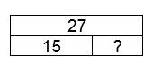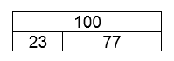  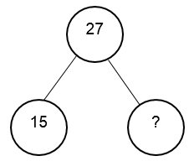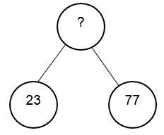  Fill in the missing numbers.  All answers to be recorded in a number sentence following any informal recording.  Partition and recombine  Record partitioned steps in number sentences then add mentally.  40+20=60  6+7 =13  60+13=73  Moving on to:  46 + 27 = 60 + 13 = 73  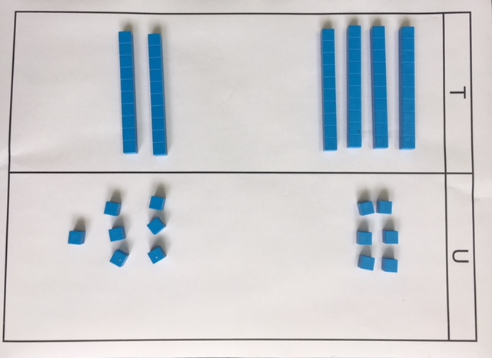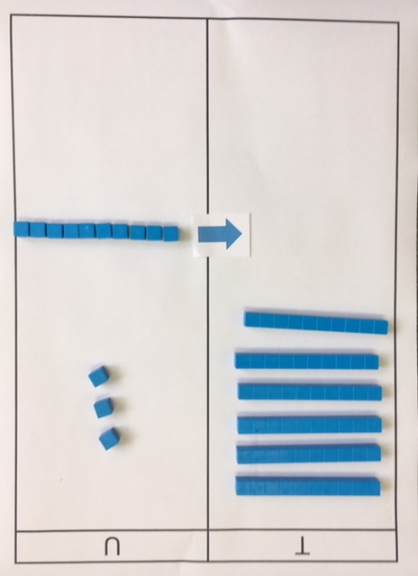  Tens and units – exchanging  46 + 27 = 73  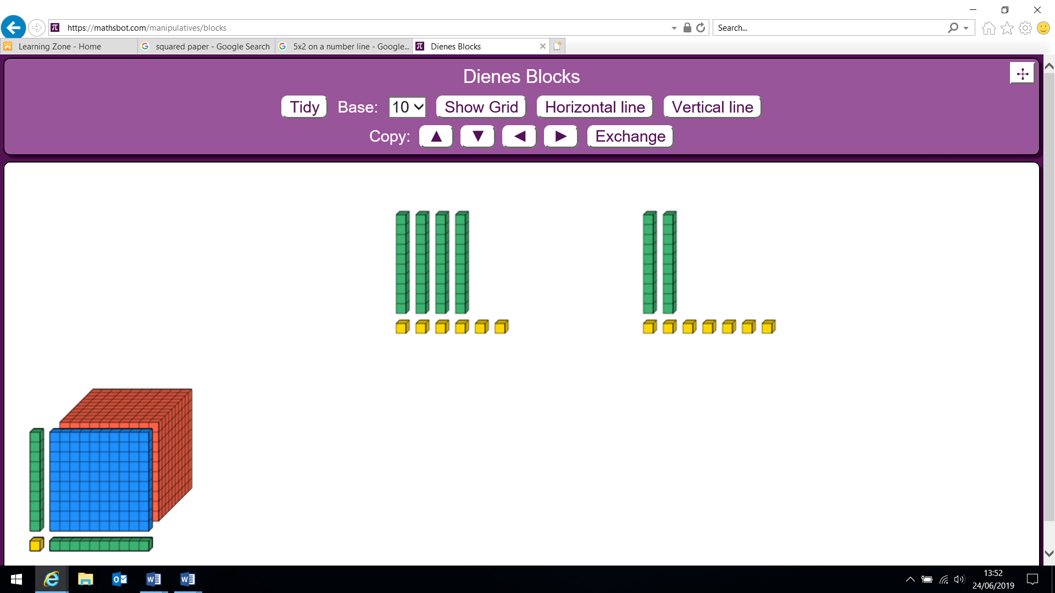  + = 60  + = 13  Balance in the equation  14 = 8 + 6, 7+6=8+5  = 13+9  3+ +6 =16  14+ = 15+27  Decision making  Using statements such as:  Ben did 14 + 9 = 23  How could he have done it?

