KS2 ADDITION – Year 3 and Year 4

KS1  Prior learning  What should children already know about addition? | KS1  Pupils should practise addition to 20 and within to become increasingly fluent. They should use the facts they know to derive others, e.g. using 7 + 3 = 10 to find 17 + 3= 20, 70 + 30 = 100.  They should use concrete objects and practical apparatus, such as bead strings and number lines to explore additions including missing numbers.  Use pictorial representations such as bar models and whole part diagrams to show additive relationships.  100 squares could be used to explore patterns in calculations such as 74 +11, 77 + 9 encouraging children to think about ‘What do you notice?’ where partitioning or adjusting is used.  Pupils should learn to check their calculations, by using the inverse.  They should continue to see addition as both combining groups and counting on.  They should use Dienes to model partitioning into tens and ones* and learn to rearrange numbers in different ways e.g. 23 = 20 + 3 = 10 + 13.  Show understanding that adding zero leaves a number unchanged.
Year | Year 3 | Year 4
Layers of vocabulary  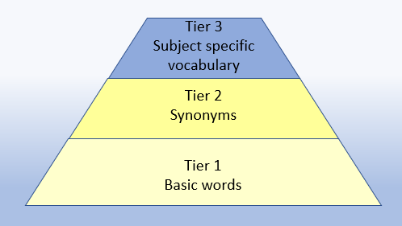  Appendix 1a  Beck’s Tiers of Vocabulary  Appendix 1b: Vocabulary book | Basic to subject specific (Beck’s Tiers):  +, add, addition, more, plus, make, sum, total, altogether, score, double, near double, one more, two more... ten more... one hundred more, How many more to make…? How many more is… than…? How much more is…?  Instructional vocabulary:  explain your method, explain how you got your answer, give an example of… show how you… show your working  NFER – language of tests and questions  estimate, write….in order, complete, circle, estimate, tick, draw, draw two, draw the arrow, show your working, use the…, what number, complete, shade, write in, true or false, tick two, circle all, write a possible, use a ruler, What numbers could be? How many are left? What is next…? What is…? How many…? Which of these? | Basic to subject specific (Beck’s Tiers):  add, addition, more, plus, increase, sum, total, altogether, score, double, near double, How many more to make…?  Instructional vocabulary:  calculate, work out, solve, investigate, question, answer, check  NFER – language of tests and questions  write, order, complete, draw three, write….in the boxes, show your working, use the method, write the missing, shade, write in order, tick, write your answer as…, write the letter (can be used more than once), describe, write one word, write your answer in, match, to make…you need, draw four, on which, calculate, write these numbers, use the coordinates to draw, estimate, in each box, write these values, circle the best, complete the table, round each number, draw one line, circle all, tick three, plot, Who takes…? How many? What is…? What number?
KS2 ADDITION – Year 3 and Year 4

Year | Year 3 | Year 4

Known facts | Derive and use addition and subtraction facts to 100, e.g. 33+ 67 =100. | Derive and use addition and subtraction facts (for multiples of 10) to 1000, e.g. 330+ 670=1000.

Essential knowledge | Add single digit bridging through boundaries | Add multiples of 10, 100 | Fluency of 2 digit + 2 digit | Add multiples of 10, 100 and 1000
Essential knowledge | Partition second number to add | Pairs of 100 (complements of 100) | Partition second number to add | Decimal pairs of 10 and 1
Essential knowledge | Use near doubles to add | Add near multiples of 10 and 100 by rounding and adjusting | Use near doubles to add | Adjust both numbers before adding
Essential knowledge | Partition and recombine |  | Add near multiples | Partition and recombine

NC 2014 | Add and subtract numbers with up to 3 digits, using formal written methods of columnar addition and subtraction. | Add and subtract numbers with up to 4 digits using the formal written method of columnar addition and subtraction where appropriate. Solve addition and subtraction two-step problems in contexts, deciding which operations and methods to use and why.

KS2 ADDITION – Year 3 and Year 4

 | concrete, pictorial, abstract
Year | Year 3 |  |  | Year 4
Developing Conceptual/  Procedural Understanding  NB: carried digits must be positioned below the line. | Add ones  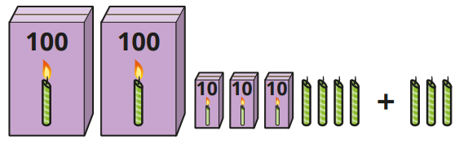  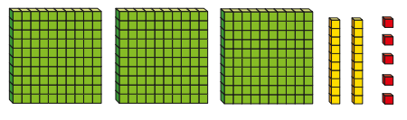  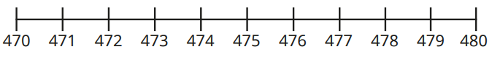  Add tens  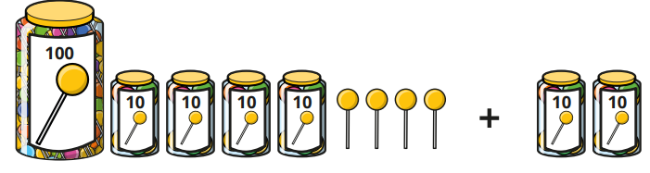  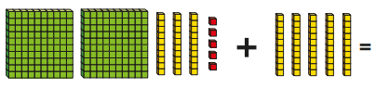  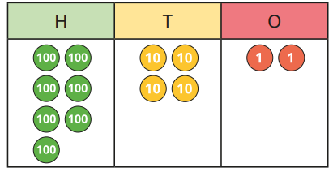  Add hundreds  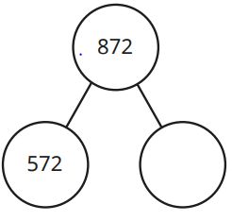  Near doubles  13+14 =  Double 13= 26  26+1 =27  or  Double 14 =28  28-1=27  Using known facts  40 + 80 = 120 using 4 + 8 = 12  So 400 + 800 = 1200  Remodelling strategy  243 + 198  241 + 200 = 441  Place value materials to represent calculations  Diennes and then place value counters.  243 + 198 =  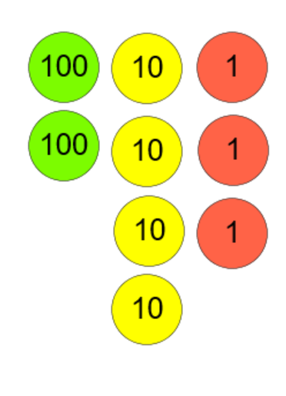  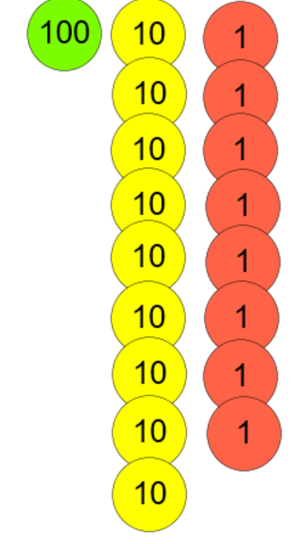  +  Teaching point – you cant have more than 9 in each column. | Add ones across a ten  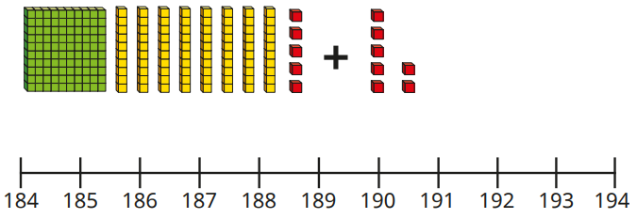  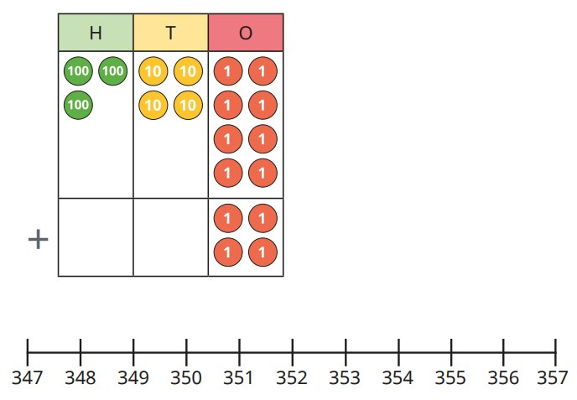  Add tens across a hundred  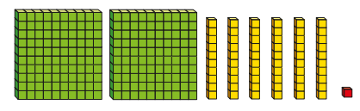  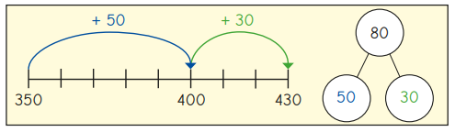  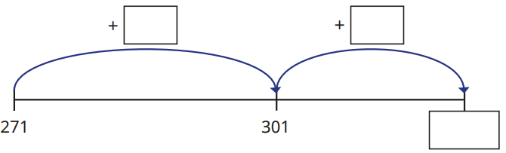  Start with least significant digit  6 7  + 2 4  1 1 (7+4)  + 8 0 (60+20)  9 1  “7 add 4 equals 11 and 60 add 20 equals 80. 1+ 0 = 1 and 1 ten + 8 tens = 9 tens”  6 2 5  + 4 8  1 3 (5+8)  6 0 (20+40)  + 6 0 0 (600+0)  6 7 3  All language in the context of the place value and the mental addition of the totals to be done in any order. | Columnar addition  Add two numbers (no exchange)  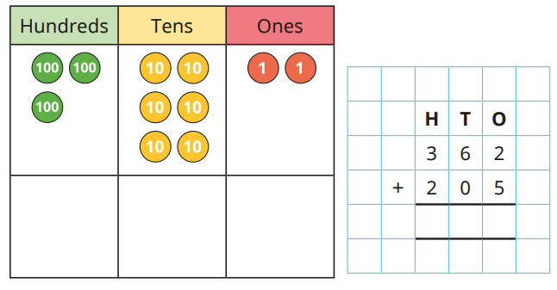  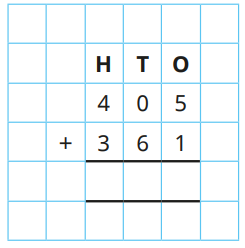  Add two numbers (across a ten)  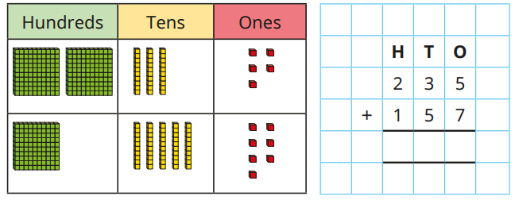  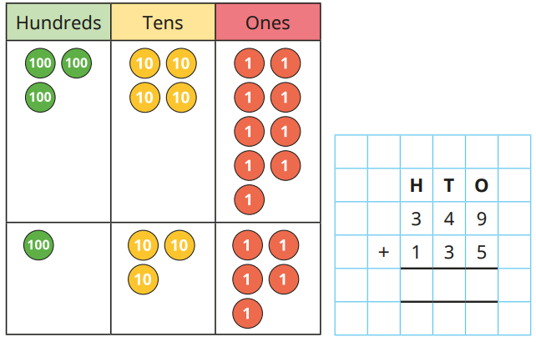  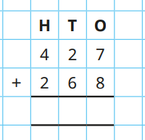  Add two numbers (across a hundred)  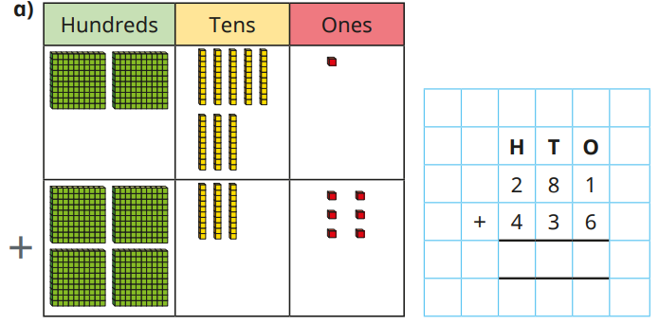  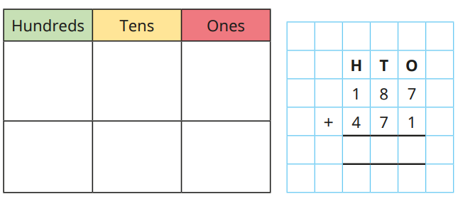  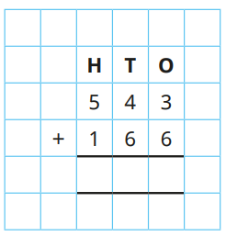  H T U  6 2 5  + 4 8  6 7 3  ¹  Representing problems  There are 334 children at Springfield School and 75 at Oak Nursery. How many children are there altogether? | Using known facts  40 + 80 = 120 using  4 + 8 = 12  So 400 + 800 = 1200 and 4000 + 8000 = 12,000  Remodelling strategy  3548 + 1998  3546 + 2000 = 5546  Place value materials to represent calculations  Add 1s, 10s, 100s and 1000s  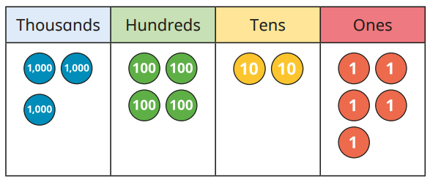  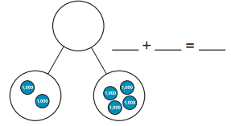  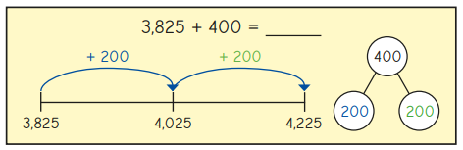 | Columnar addition  Add up to two 4-digit numbers (no exchange)  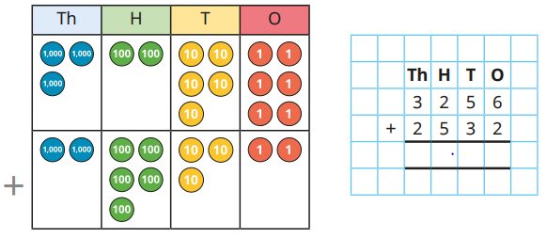  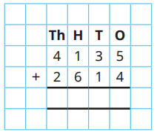  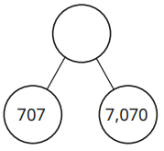  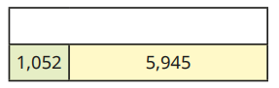  Add two 4-digit numbers (one exchange)  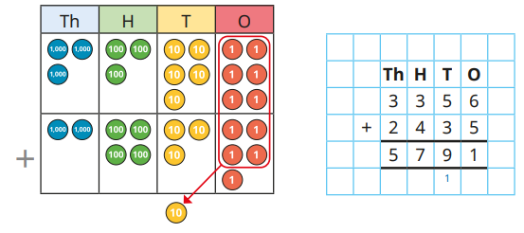  Add two 4-digit numbers (more than one exchange)  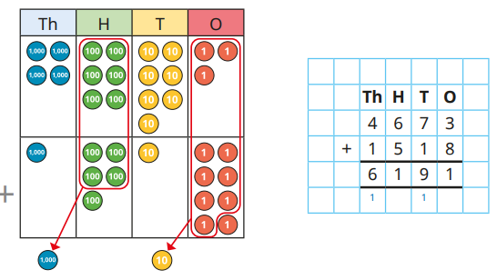  Th H T U  2 5 8 7  +1 4 7 5  3 0 6 2  ¹ ¹  “7 add 5 equals 12. That’s 2 units and 1 ten to carry over. 80 add 70 equals 150 and the1 ten to carry makes 160. That’s 6 tens and 100 to carry over. 500 add 400 equals 900 and the 1 hundred to carry makes 1000”  7 6 4 8  + 1 4 8 6  1 4 (8+6)  1 2 0 (40+80)  1 0 0 0 (600+400)  + 8 0 0 0 (7000+1000)  9 1 3 4  7 6 4 8  + 1 4 8 6  9 1 3 4  ¹ ¹ ¹ | Efficientcy of strategy choice  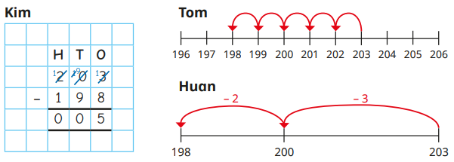  Columnar addition (decimals) in contexts such as money and measurement  1 2 . 4 5  7 . 3 6  + 2 4 . 5 0  4 4 . 3 1  ¹ ¹ ¹  Representing problems  There are 259 more boys than girls in Lucy’s school. If there are 789 girls, how many pupils are there altogether?  ?  759  759  + 259

KS2 ADDITION – Year 5 and Year 6

Year | Year 5 | Year 6
Layers of vocabulary  Appendix 1a  Beck’s Tiers of Vocabulary  Appendix 1b: Vocabulary book | Basic to subject specific (Beck’s Tiers):  add, addition, more, plus, increase, sum, total, altogether, score, double, near double, How many more to make…?  Instructional vocabulary:  put, place, arrange, rearrange, change, change over split, separate  NFER– language of tests and questions  complete the sequence, circle the same as, draw four lines, circle the, circle the number that is not, circle two, write yes or no to a statement, circle all, write the, write the missing, circle the incorrect, show your method, show your working, circle three, by how much, calculate, estimate, shade, write the missing, use the diagram, complete the table, circle the number that is both, write a, b, c, d, label, true or false, order, draw a line, write the missing digits, circle true and false, What number is? Which is the closest? Which one of these must also? Who gets the most? What is the total number? | Basic to subject specific (Beck’s Tiers):  add, addition, more, plus, increase, sum, total, altogether, score, double, near double, How many more to make…?  Instructional vocabulary:  put, place, arrange, rearrange, change, change over adjusting, adjust, split, separate, carry on, continue, repeat, predict, describe the pattern, describe the rule, find, find all, find different, investigate, What comes next?  NFER– language of tests and questions  which expression, write three, complete, draw the, explain why, write each number, show your method, tick the, calculate, increase by, complete the tables, circle all, calculate, What was the…? What is the difference? How much? What are…? What is…? What could…? What number is…? Which of these…?

KS2 ADITION – Year 5 and Year 6

Year | Year 5 | Year 6

Known facts | Derive and use addition and subtraction facts to 10 and 1,  E.g. 3.3 + 6.7 = 10 and so 0.33 + 0.67 = 1. BIDMAS. | All the KS2 required facts. BIDMAS.

Essential knowledge | Fluency of 2 digit + 2 digit including with decimals | Add multiples of 10, 100, 1000 and tenths | Fluency of 2 digit + 2 digit including with decimals | Add multiples of 10, 100, 1000, tenths and hundredths
Essential knowledge | Partition second number to add | Use number facts, bridging and place value | Partition second number to add | Use number facts, bridging and place value
Essential knowledge | Adjust numbers to add | Partition and recombine | Adjust numbers to add | Partition and recombine
Essential knowledge | Negative numbers, counting forwards and backwards through zero |  | Negative numbers, calculate intervals across zero

NC 2014 | Add and subtract whole numbers with more than 4 digits, including using formal written methods (columnar addition and subtraction).  Solve addition and subtraction multi-step problems in contexts, deciding which operations and methods to use and why. | Solve problems involving addition, subtraction, multiplication and division.

KS2 ADITION – Year 5 and Year 6

 |  | concrete, pictorial, abstract
Year |  | Year 5 |  | Year 6
Developing Conceptual/  Procedural Understanding | Columnar addition  Include calculations involving more than 2 numbers and more than one exchange.  2 5 5 6 7  1 6 3 9 7  + 1 5 9 8 4  5 7 9 4 8  ¹ ¹ ² ¹  Include calculations with decimal point and missing digits.  124.9 + 7.25  1 2 4 . 9 0  + 7 . 2 5  1 3 2 . 2 5  ¹ ¹  Use rounding and estimating to check answers. |  | Representing problems  If 2541 is the answer, what’s the question? - Can you create three addition calculations? - Can you create three subtraction calculations? - Did you use a strategy?  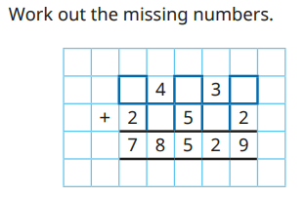  Lead onto multi-step addition problems. | Columnar addition  Include calculations with decimal point and missing digits.  128.7 + 3.014  1 2 8 . 7 0 0  + 3 . 0 1 4  1 3 1 . 7 1 4  ¹  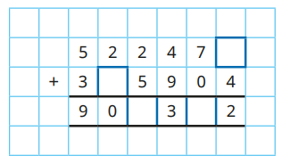 | Representing problems  7208 females attended a concert as well as 8963 males. There were originally 20000 seats on sale. How many empty seats were there at the concert?  