KS1 DIVISION – Year 1 and Year 2

EYFS – prior learning  What should the children already know?  ELG (Early Learning Goals) | Number ELG Children at the expected level of development will:  • Have a deep understanding of number to 10, including the composition of each number;  • Subitise (recognise quantities without counting) up to 5;  • Automatically recall (without reference to rhymes, counting or other aids) number bonds up to 5 (including subtraction facts) and some number bonds to 10, including double facts.  Numerical Patterns ELG Children at the expected level of development will:  • Verbally count beyond 20, recognising the pattern of the counting system;  • Compare quantities up to 10 in different contexts, recognising when one quantity is greater than, less than or the same as the other quantity;  • Explore and represent patterns within numbers up to 10, including evens and odds, double facts and how quantities can be distributed equally.
Year | Year 1 | Year 2
Layers of vocabulary  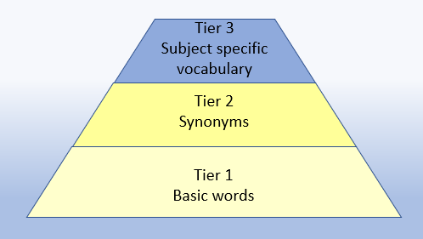  Appendix 1a  Beck’s Tiers of Vocabulary  Appendix 1b: Vocabulary book | Key Vocabulary  Basic to subject specific (Beck’s Tiers):  count in ones, twos… tens… share, groups of, equal groups, dividend, divisor, odd, even  Instructional vocabulary:  count out, share out, left, left over  NFER– language of tests and questions  match, tick, draw, complete, write, circle, share, jumps, count on, use a ruler | Key Vocabulary  Basic to subject specific (Beck’s Tiers):  share, share equally, one each, two each, three each… group in pairs, threes… tens equal groups of ÷, divide, divided by, divided into left, left over, dividend, divisor  Instructional vocabulary:  tell me, describe, name, pick out, discuss, talk about, explain, explain your method, explain how you got your answer, give an example of… show how you…  NFER– language of tests and questions  tick, match, count, tick two, circle, write, draw, complete, use these numbers, shade, write, make, choose, circle the three, complete, write, tick all, complete the number sentence, put a digit, How many?
KS1 DIVISION – Year 1 and Year 2

Year | Year 1 | Year 2

Known facts | Count in multiples of twos, fives and tens. | Recall and use x and ÷ facts for the 2, 5 and 10 x tables, including recognising odd and even numbers.

Essential Knowledge | Count back in 2s | Halves up to 10 | Division facts (2 x table) | Halves up to 20
Essential Knowledge | Count back in 10s | Halve multiples of 10 | Division facts (10 x table) | Review division facts (2 x, 5 x, 10 x tables)
Essential Knowledge | Count back in 5s | How many 2s? 5s? 10s? | Division facts (5 x table) | Count back in 3s

NC 2014 | Solve one-step problems involving multiplication and division, by calculating the answer using concrete objects, pictorial representations and arrays with the support of the teacher. | Calculate mathematical statements for multiplication and division within the multiplication tables and write them using the multiplication (x), division (÷) and equals (=) signs.

KS1 DIVISION – Year 1 and Year 2

 | concrete, pictorial, abstract
Year | Year 1 |  | Year 2
Developing Conceptual/  Procedural Understanding | Grouping/Sharing models  Using practical contexts and cross-curricular links (PE) such as socks and shoes; animals in the ark to get into groups. Sharing models such as sharing pieces of fruit.  Sharing into equal groups  6 frogs shared equally between 2 lily pads gives 3 frogs on each lily pad.  or  Grouping in equal groups  6 frogs grouped in 2s need 3 lily pads to sit on.  Year 1  How many twos?  Socks put into groups of 2.  Moving onto jumps on a numberline.  Decision making  How many different ways can you arrange 12 buttons in equal groups?  Year 1  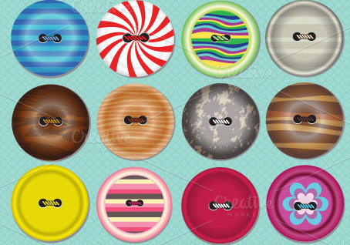  Halving  Understanding that a half is two equal groups – using sharing.  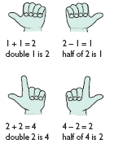  Year 1 | Recognise equal groups  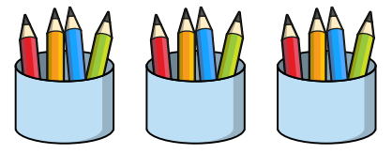  Arrays  Dividend - the answer from the multiplication calculation.  2 x 3 = 6  6 ÷ 2 = 3  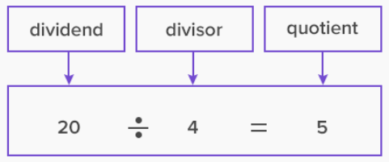  (rectangular arrangements to show equal groups)  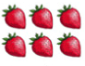  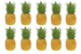  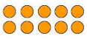  How many groups of the divisor are in the dividend?  Grouping/Sharing practical  Starting with the dividend – biggest number.  8 in groups of 2 = ?  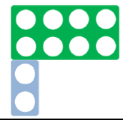  8 in groups of 2 = ?    4 shared between 2 = ?    20 shared between 10 = ?  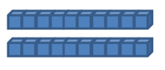  Halving  Starting with the whole and knowing that they need two equal sized groups.  Half of ten = ?  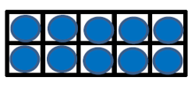  How many groups of 5 are there in 10?  ½ of 10 = ?  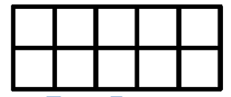  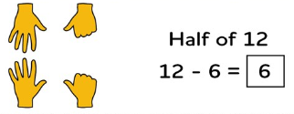  Identifying halves in calculations.  Fractions of a set of objects  To start with the whole.  ¼ of 8 = ?  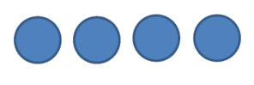  ¼ of 8 = ?  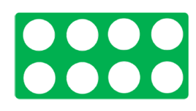 | Grouping/Sharing models  Introduce the ÷ symbol  15 frogs shared equally between three lily pads.  15 ÷ 3 = 5  or  15 frogs grouped in 5s need 3 lily pads to sit on.  15 ÷ 5 = 3  15 ÷ 3 = 5 groups of 3 (grouping)  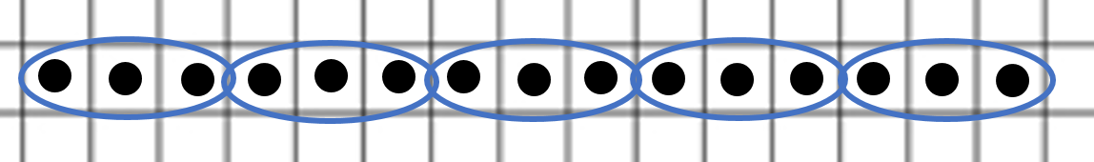  Year 2  15 ÷ 3 = 5  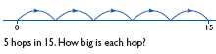  20 ÷ 2 = 10    Remainders  There are 7 cakes and 2 children. How many cakes will they get each? (Leftovers/remainders introduced)  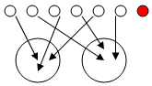7 ÷ 2 = 3r1 | Arrays  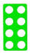8 ÷ 2 = 4 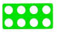and 8 ÷ 4 = 2  Using known facts.  Repeated addition  (to reach a given target)  6 ÷ 2 = 3  There are 20 sweets in a bag. How many children can have 5 each?  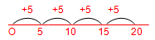  Repeated subtraction  (from a given quantity)  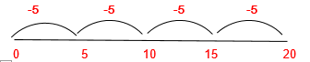  Links to tables  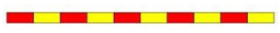  Use language of division linked to tables using counting stick.  Representing problems  Jane has 30 cakes. She wants to share them equally between 5 boxes. How many cakes should go in each box?  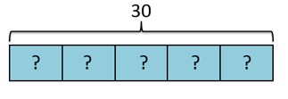  30 ÷ 5 = 6  Number of cakes in each box = 6

