KS2 DIVISION – Year 3 and Year 4

KS1  Prior learning  What should children already know about division? | KS1  Noticing how counting in multiples if 2, 5 and 10 relates to the number of groups you have counted (introducing times tables) links to division.  An understanding of the more you share between, the less each person will get (e.g. would you prefer to share these grapes between 2 people or 3 people? Why?).  Secure understanding of grouping means you count the number of groups you have made. Whereas sharing means you count the number of objects in each group.
Year | Year 3 | Year 4
Layers of vocabulary  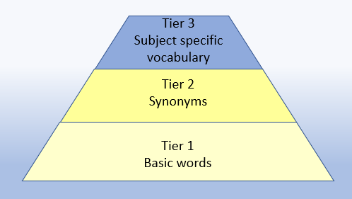  Appendix 1a  Beck’s Tiers of Vocabulary  Appendix 1b: Vocabulary book | Basic to subject specific (Beck’s Tiers):  share, share equally one each, two each, three each… group in pairs, threes… tens equal groups of ÷, divide, division, divided by, divided into left, left over, remainder  Instructional vocabulary:  calculate, work out, solve, investigate question, answer, check  NFER – language of tests and questions  estimate, write….in order, complete, circle, estimate, tick, draw, draw two, draw the arrow, show your working, use the, complete, shade, write in, true or false, tick two, circle all, use a ruler, write a possible, What numbers could be…? How many are left? What is? How many? What number…? What is next? Which of these…? | Basic to subject specific (Beck’s Tiers):  share, share equally one each, two each, three each… group in pairs, threes… tens equal groups of ÷, divide, division, divided by, divided into left, left over, remainder, dividend, divisor  Instructional vocabulary:  calculate, work out, solve, investigate question, answer, check  NFER – language of tests and questions  write, order, complete, draw three, write….in the boxes, show your working, use the method, write the missing, shade, write in order, tick, write your answer as…, write the letter (can be used more than once), describe, write one word, write your answer in, match, to make…you need, draw four, on which, calculate, write these numbers, use the coordinates to draw, estimate, in each box, write these values, circle the best, complete the table, round each number, draw one line, circle all, tick three, plot, check, How many? What is? How much…? What number…? Who takes…?

KS2 DIVISION – Year 3 and Year 4

Year | Year 3 | Year 4

Known facts | Recall and use x and ÷ facts for the 3, 4 and 8 x tables. | Recall x and ÷ facts for x tables up to 12 x 12.

Essential knowledge | Review division facts (2 x, 5 x and 10 x tables) | Halve 2 digit numbers | Division facts (4x and 8x tables) | 10x smaller
Essential knowledge | Division facts (4 x table) | Division facts (3 x table) | Division facts (3 x, 6 x and 12 x tables) | Halve larger numbers and decimals
Essential knowledge | Division facts (8 x table) | Division facts (6 x table) | Division facts (3 x and 9 x tables) | Division facts (11 x and 7 x tables)

NC 2014 | Write and calculate mathematical statements for multiplication and division using the multiplication tables that they know, including 2 digit numbers times 1 digit numbers progressing to formal written methods. | Practise to become fluent in the formal written method of short division with exact answers (see Mathematics Appendix 1).

KS2 DIVISION – Year 3 and Year 4

 | concrete, pictorial, abstract
Year | Year 3 |  | Year 4
Developing Conceptual/  Procedural Understanding | Sharing and Grouping  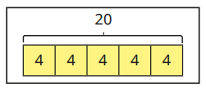  To divide by 3    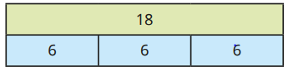  To divide by 4  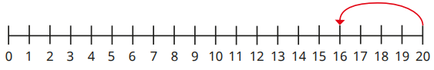  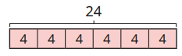  To divide by 8  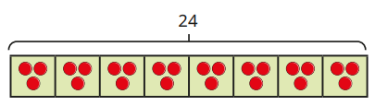  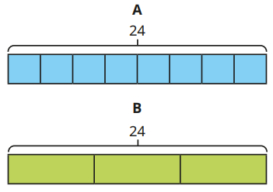  Links to tables  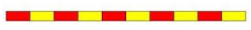  For example, use language of division linked to tables using counting stick  Using known facts  If 3 x 2 = 6, then 30 x 2 = 60, 60 ÷3 = 20 and  30 = 60 ÷ 2.  Partitioning strategy to halve  Halve 68  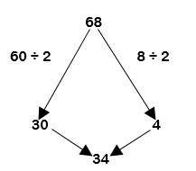  68  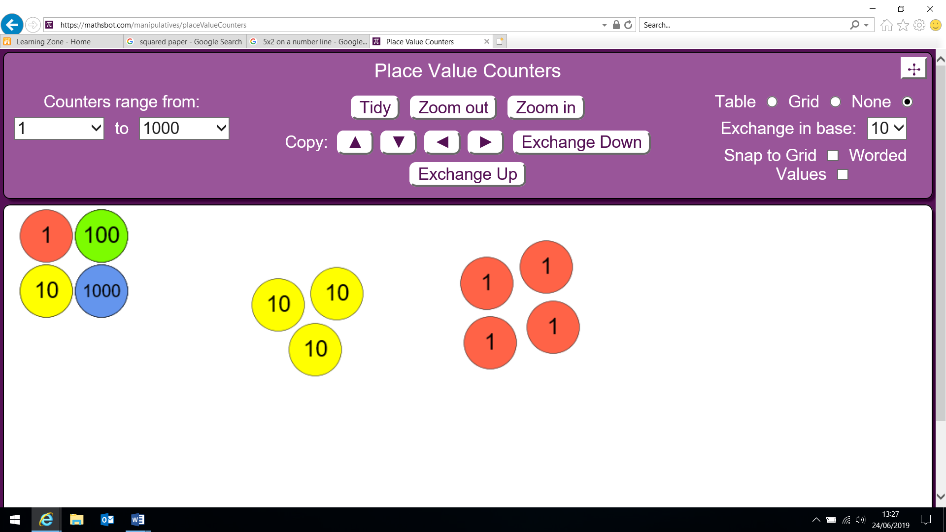  34 | Place value materials and diennes to represent calculations  Place value counters to build the dividend.  Divide a 2-digit number by a 1-digit number (no exchange)  63 ÷ 3 =  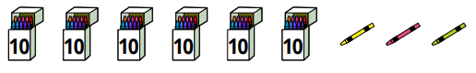  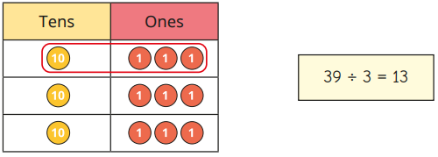  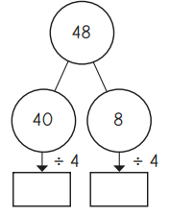  Rearranging the dividend to find multiples of the divisor.  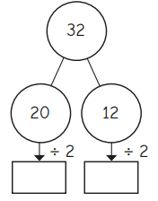  48 ÷ 3 =  ‘What do I know about the 3 x tables?’  “I know 3 x 10 = 30 and 3 x 6 = 18.”  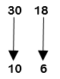  48 ÷ 3 = 16  72 ÷ 3 =  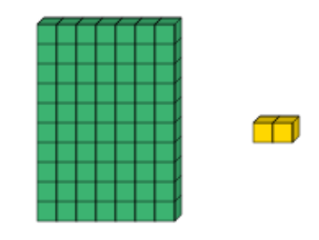  72 is made up of 60 and 12 using multiples of 3.  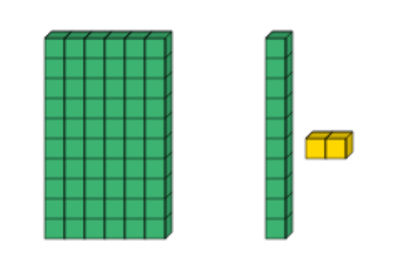  60 ÷ 3 = 20 12 ÷ 3 = 4  Divide a 2-digit number by a 1-digit number (with remainders)  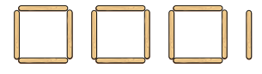  31 ÷ 4 =  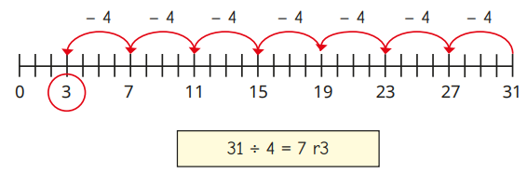  Representing problems  Andy says ‘I can use my three times table to work out 180 ÷ 3’. Explain what Andy could do to work out this calculation. | To divide by 6    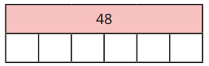  To divide by 9  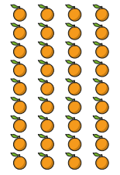  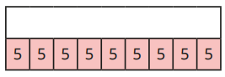  To divide by 7    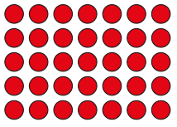  To divide by 11  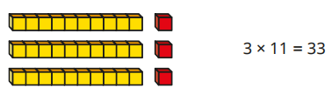  To divide by 12  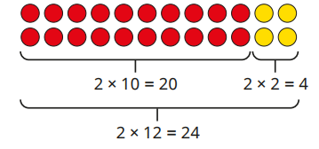  Links to tables  For example, use language of division linked to tables using counting stick.  Using known facts  If 2 x 3 = 6 then 200 x 3 = 600 and 600 ÷3 = 200  Rearranging the dividend to find multiples of the divisor.  69÷ 3 =  ‘What do I know about the 3 x tables?’  “I know 3 x 10 = 30 and 3 x 3 = 9.”  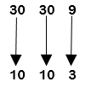  69 ÷ 3 = 23 | To divide by 10  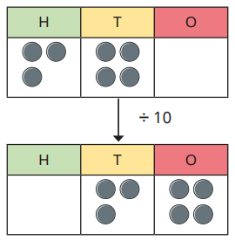  To divide by 100  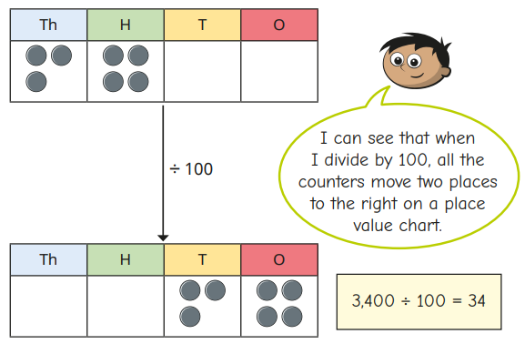  Place value materials to represent calculations and to show each digit get 10x and 100x smaller.  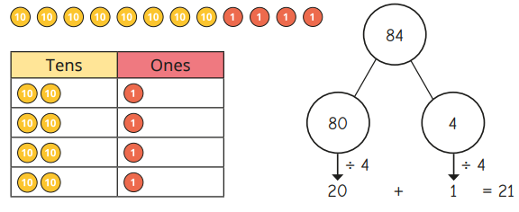  Short division  72 ÷ 3 =  ’72 divided by 3. 7 tens shared equally between 3 is 2 with a remainder of 1 ten. Exchange the 1 ten for 10 units. I now have 12 units which shared equally between 3 is 4. The answer is 24.”  Short division  372 ÷ 6 =  ’372 divided by 6. 3 hundreds cannot be shared equally between 6, so exchange the hundreds for 30 tens. I now have 37 tens which shared equally between 6 is 6 with a remainder of 1 ten. Exchange the ten for 10 units. I now have 12 units which shared equally between 6 is 2. The answer is 62.”  Representing problems – Questioning for greater depth  Alan says that the solution to 186 ÷ 4 can be written as ‘46 remainder 2’ or as ‘46.5’. Do you agree? Explain your answer.
   | 2 4
  3 | 7 ¹2
   | 6 2
  6 | 3 ³7¹2
KS2 DIVISION – Year 5 and Year 6

Year | Year 5 | Year 6
Layers of vocabulary  Appendix 1a  Beck’s Tiers of Vocabulary  Appendix 1b: Vocabulary book | Basic to subject specific (Beck’s Tiers):  equal groups of, divide, division, divided by, divided into, remainder, factor, quotient, divisible by inverse  Instructional vocabulary:  calculate, work out, solve, investigate, question, answer, check, same, different missing number/s, number facts, number pairs, number bonds, greatest value, least value  NFER– language of tests and questions  complete the sequence, circle the same as, draw four lines, circle the, circle the number that is not, circle two, circle two, write yes or no to a statement, circle all, write the, write the missing, circle the incorrect, show your method, show your working, circle three, by how much, calculate, estimate, shade, write the missing, use the diagram, complete the table, circle the number that is both, write a, b, c, d, label, true or false, order, draw a line, write the missing digits, circle true and false, tick two, What number is? Which is the closest? Which one of these must also…? Who gets the most…? What is the total number? | Basic to subject specific (Beck’s Tiers):  equal groups of, divide, division, divided by, divided into, remainder, factor, quotient, divisible by inverse, remainders as fractions or decimals  Instructional vocabulary:  calculate, work out, solve, investigate, question, answer, check, same, different missing number/s, number facts, number pairs, number bonds, greatest value, least value  NFER– language of tests and questions  write three, complete, draw the, explain why, what are, write each number, show your method, tick the, calculate, increase by, complete the tables, circle all, calculate, What was the…? What is the difference? Which expression? How much? What is? What could? What number is? Which of these…?

KS2 DIVISION – Year 5 and Year 6

Year | Year 5 | Year 6

Known facts | Know and use the vocabulary of prime numbers, prime factors and composite (non-prime) numbers. Recall prime numbers up to 19. | Identify common factors, common multiples and prime numbers.

Essential knowledge | Division facts (4 x and 8 x tables) | 100, 1000 times smaller | Division facts up to 12 x 12 | Halve larger numbers and decimals
Essential knowledge | Division facts (3 x, 6 x and 12 x tables; 3 x and 9 x tables) | Partition to divide mentally | Apply place value to derive division facts, e.g. 12 ÷ 3 = 4 so 1.2 ÷ 3 = 0. 4 | Partition to divide mentally including decimals
Essential knowledge | Division facts (11 x and 7 x tables) | Halve larger numbers and decimals |  | Partition to divide mentally including decimals
Essential knowledge | Test divisibility |  | Test divisibility

NC 2014 | Divide numbers up to 4 digits by a 1 digit number using the formal written method of short division and interpret remainders appropriately for the context (as remainders, as fractions, as decimals or by rounding, e.g. 98 ÷ 4 = = 24 r2 = 24 ½= 24.5 ≈ 25).  Solve problems involving multiplication and division including using knowledge of factors and multiples, squares and cubes. Solve problems involving addition, subtraction, multiplication and division and a combination of these, including understanding the meaning of the equals sign. Solve problems involving multiplication and division including scaling by simple fractions and problems involving simple rates. | Divide numbers up to 4 digits by a 2 digit whole number using the formal written method of long division, and interpret remainders as whole number remainders, fractions, or by rounding, as appropriate to the context.  Divide numbers up to 4 digits by a 2 digit number using the formal written method of short division where appropriate, interpreting remainders according to the context.  Solve problems involving addition, subtraction, multiplication and division.

KS2 DIVISION – Year 5 and Year 6

 | concrete, pictorial, abstract
Year | Year 5 |  | Year 6
Developing Conceptual/  Procedural Understanding | Building tables  For example, apply tables knowledge to multiples of 10, 100 and 1000 using counting stick- forwards and backwards and with missing jumps.  Using known facts  If 6 ÷ 2 = 3 then 6000 ÷ 2 = 3000 and  6000 ÷ 20 = 300  To divide by 1000  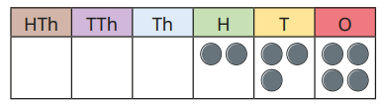  To move each digit three places to the right using place value counters.  Place value materials to represent calculations  605 ÷ 5 =  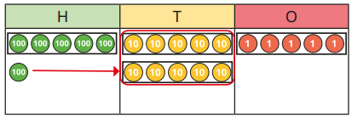  Short division  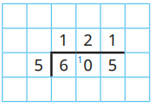  483 ÷ 7 =  “484 divided by 7. 4 hundreds cannot be shared equally between 7, so exchange the hundreds for 40 tens. I now have 48 tens which shared equally between 7 is 6 with a remainder of 6 tens. Exchange the 6 tens for 60 units, we now have 64 units. 64 shared equally between 7 equals 9 remainder 1. The answer is 69 r1.” | Divide a 4-digit number by a 1-digit number  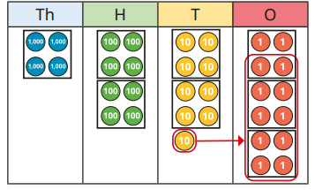  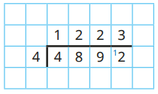  Remainders  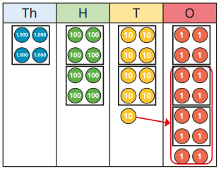  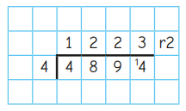  Interpreting remainders  17 ÷ 5  “What do I know? 17 is not a multiple of 5.”  Examples:  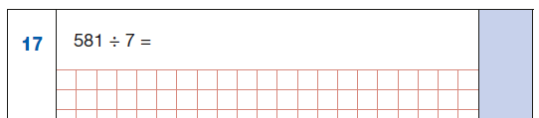  581 ÷ 7 could be calculated by the formal written method of short division or it could be calculated by rearranging the dividend, using known facts, into 560 and 21. | Building tables  For example, apply tables knowledge to multiples of 10, 100 and 1000 using counting stick- forwards and backwards and with missing jumps – links to decimals and identifying rules of divisibility.  Using known facts  If 6 ÷ 2 = 3 then 6÷ 0.2 = 30 and  6 ÷ 0.02 = 300  Short division  8524 ÷ 4 =  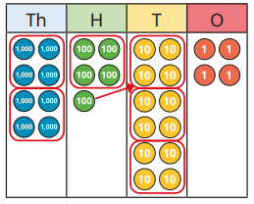  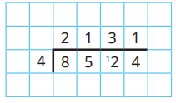  Long division (with remainders)  7355 ÷ 15 =  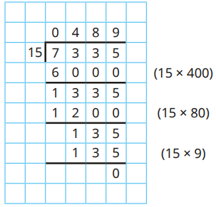  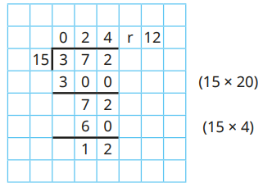 | 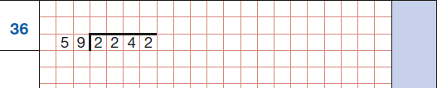  With questions of this type where the divisor is close to a number linked to the times tables, encourage the children to use known facts and adjustment to set up the partial tables.  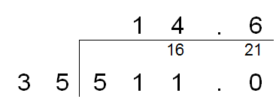  Factorising - 35 can be divided by 5 and 7.  Representing problems  Megan divides 500 by 8 and gets the answer 62r4. She re writes it as 62 r 1/2 . Is she right? Explain your answer.
   | 0 6 9r1
  7 | 4 ⁴8 ⁶4
  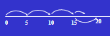 | 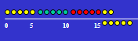
   | 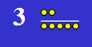
   | 