KS2 MULTIPLICATION – Year 3 and Year 4

KS1  Prior learning  What should children already know about multiplication? | KS1  Pupils should memorise and reason with numbers in 2, 5 and 10 times tables.  They should see ways to represent odd and even numbers and know how they are represented in tables. This will help them to understand the pattern in numbers.  Pupils should begin to understand multiplication as scaling in terms of double and half (e.g. that tower of cubes is double the height of the other tower).  Commutative law shown on array.  Repeated addition can be shown mentally on a number line.  Inverse relationship between multiplication and division.  Use an array to explore how numbers can be organised into groups.
Year | Year 3 | Year 4
Layers of vocabulary  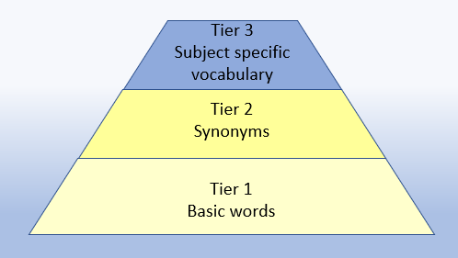  Appendix 1a  Beck’s Tiers of Vocabulary  Appendix 1b: Vocabulary book | Basic to subject specific (Beck’s Tiers):  lots of, groups of ×, times, multiply, multiplication, multiplied by multiple of, product once, twice, three times… ten times… times as (big, long, wide… and so on) repeated addition, array, row, column, double, halve, share, share equally, one each, two each, three each…  Instructional vocabulary:  carry on, continue, repeat, predict, describe the pattern, describe the rule, find, find all, find different, investigate, choose, decide, collect, What comes next?  NFER – language of tests and questions  estimate, write...in order, complete, circle, estimate, tick, draw, draw two, draw the arrow, show your working, use the, complete, shade, write in, true or false, tick two, circle all, use a ruler, write a possible, What numbers could be? How many are left? What is next…? What is…? How many…? What number…? Which of these…? | Basic to subject specific (Beck’s Tiers):  lots of, groups of times, multiply, multiplication, multiplied by, multiple of, product once, twice, three times… ten times… times as (big, long, wide… and so on) repeated addition, array, row, column, double, halve, factor, multiple  Instructional vocabulary:  carry on, continue, repeat, predict, describe the pattern, describe the rule, pattern, puzzle, calculate, calculation, mental calculation, method, jotting, answer right, correct, wrong, number sentence sign, operation, symbol, equation, What comes next? What could we try next? How did you work it out…?  NFER – language of tests and questions  write, order, complete, draw three, write….in the boxes, show your working, use the method, write the missing, shade, write in order, tick, write your answer as…, write the letter (can be used more than once), describe, write one word, write your answer in, match, to make…you need, draw four, on which, calculate, write these numbers, use the coordinates to draw, estimate, in each box, write these values, circle the best, complete the table, round each number, draw one line, circle all, tick three, plot, check, How many…? What is…? How much…? What number…? Who takes…?

KS2 MULTIPLICATION – Year 3 and Year 4

Year | Year 3 | Year 4

Known facts | Recall and use x and ÷ facts for the 3, 4 and 8 x tables. | Recall x and ÷ facts for x tables up to 12 x 12.

Essential knowledge | Review 2x, 5x and 10x | Double 2 digit numbers | 4x and 8x tables | 10x bigger
Essential knowledge | 4x table | 3x table | 3x, 6x and 12x tables | Double larger numbers and decimals
Essential knowledge | 8 x table | 6x table | 3x and 9x tables | 11x and 7x tables

NC 2014 | Write and calculate mathematical statements for multiplication and division using the multiplication tables that they know, including 2 digit numbers times 1 digit numbers progressing to formal written methods. | Multiply 2 digit and 3 digit numbers by a 1 digit number using formal written layout. Solve problems involving multiplying and adding.

KS2 MULTIPLICATION – Year 3 and Year 4

 | concrete, pictorial, abstract
Year | Year 3 |  |  | Year 4
Developing Conceptual/  Procedural Understanding | Equal groups  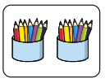  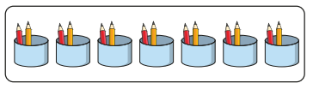  Repeated addition and multiplication calculation represented.  Use of arrays  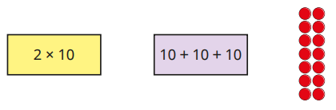  Associativity  (2 x 3) x 4 = 2 x (3 x 4)  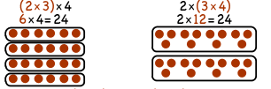  To multiply by 3  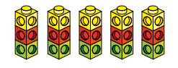    To multiply by 4    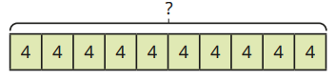  To multiply by 8  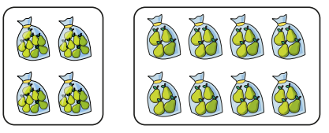  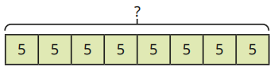  Building tables    For example, build tables using counting stick- forwards and backwards and with missing jumps.  Using known facts  If 3 x 2 = 6, then 30 x 2 = 60, 60 ÷3 = 20 and  30 = 60 ÷ 2. | Partitioning strategy to double  Double 35  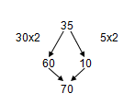  Place value materials to represent calculations  Place value counters  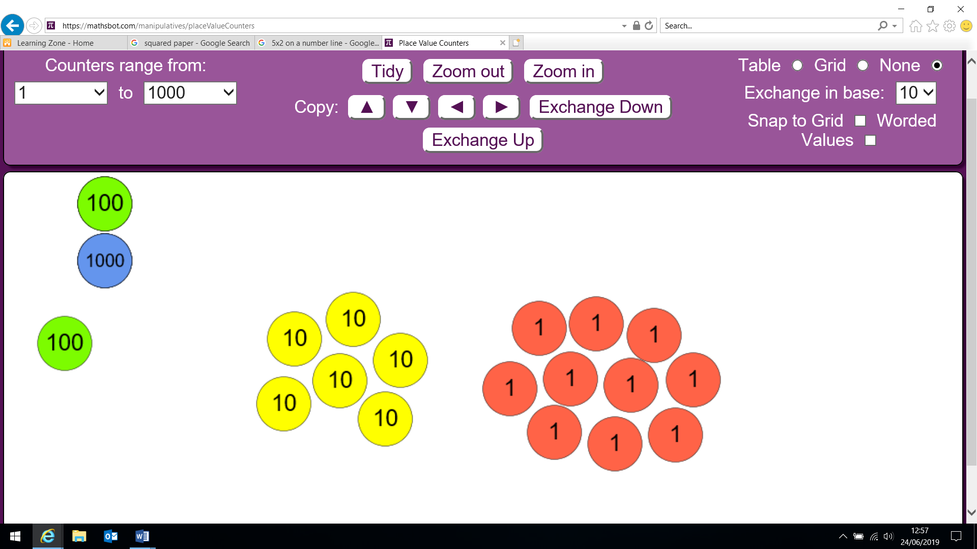  35  70  Partitioning  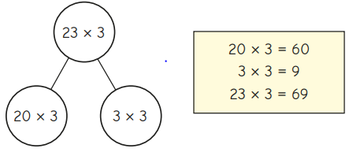  Informal recording of partitioned numbers  15 x 5 = 75  10 x 5 = 50  5 x 5 = 25  27 x 3 = 81  20x3 = 60  7x3 = 21  “20 multiplied by 3 equals 60 and 7 multiplied by 3 equals 21. 60 add 21 equals 81.” | Multiply a 2-digit number by a 1-digit (no exchange)  23 x 3 =  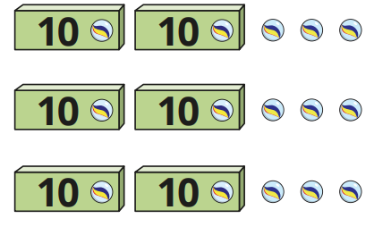  43 x 2 =  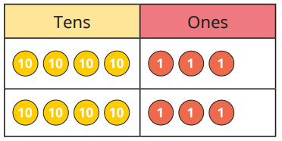  Multiply a 2-digit number by a 1-digit (with exchange)  23 x 5 =  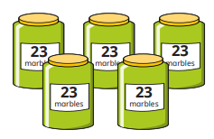  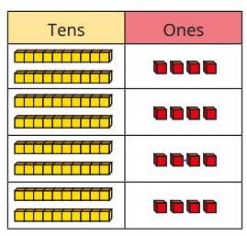  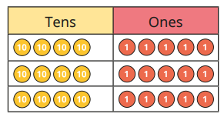  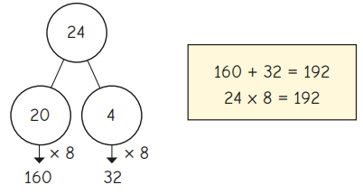  Representing problems  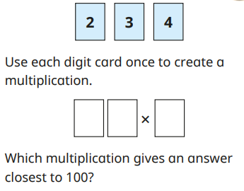 | To multiply by 6  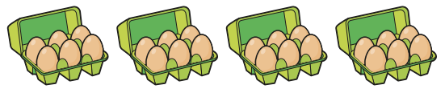  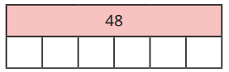  To multiply by 9  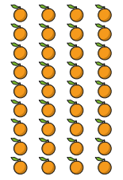  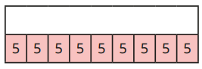  To multiply by 7    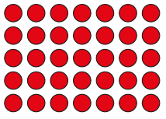  To divide by 11  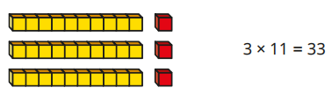  To divide by 12  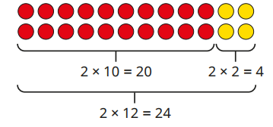  Building tables  For example, build tables using counting stick- forwards and backwards and with missing jumps  Using known facts  If 2 x 3 = 6 then 200 x 3 = 600 and 600 ÷ 3 = 200  Factor pairs  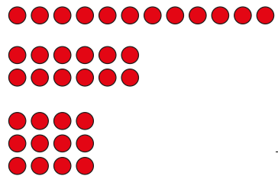  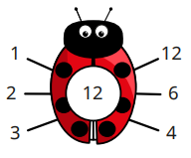 | Distributivity  3 x (2 + 4 ) = 3 x 2 + 3 x 4  So the ‘3’ can be ‘distributed’ across the ‘2 + 4’ into 3 times 2 and 3 times 4  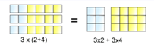  leading to  13 x 4 = 10 x 4 + 3 x 4 = 52  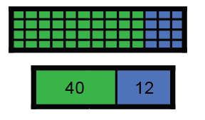  Multiply by 10  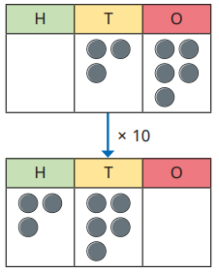  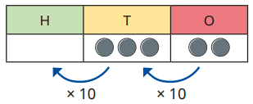  Multiply by 100  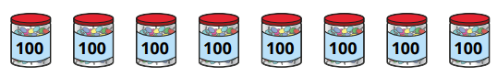  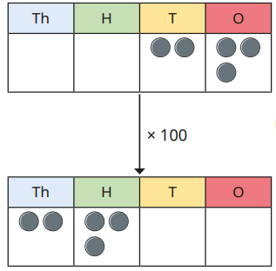 | Place value materials to represent calculations  Place value counters  346 x 9  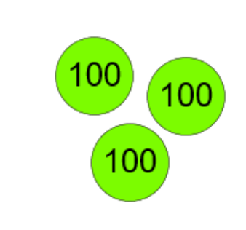  X 9 = 2700  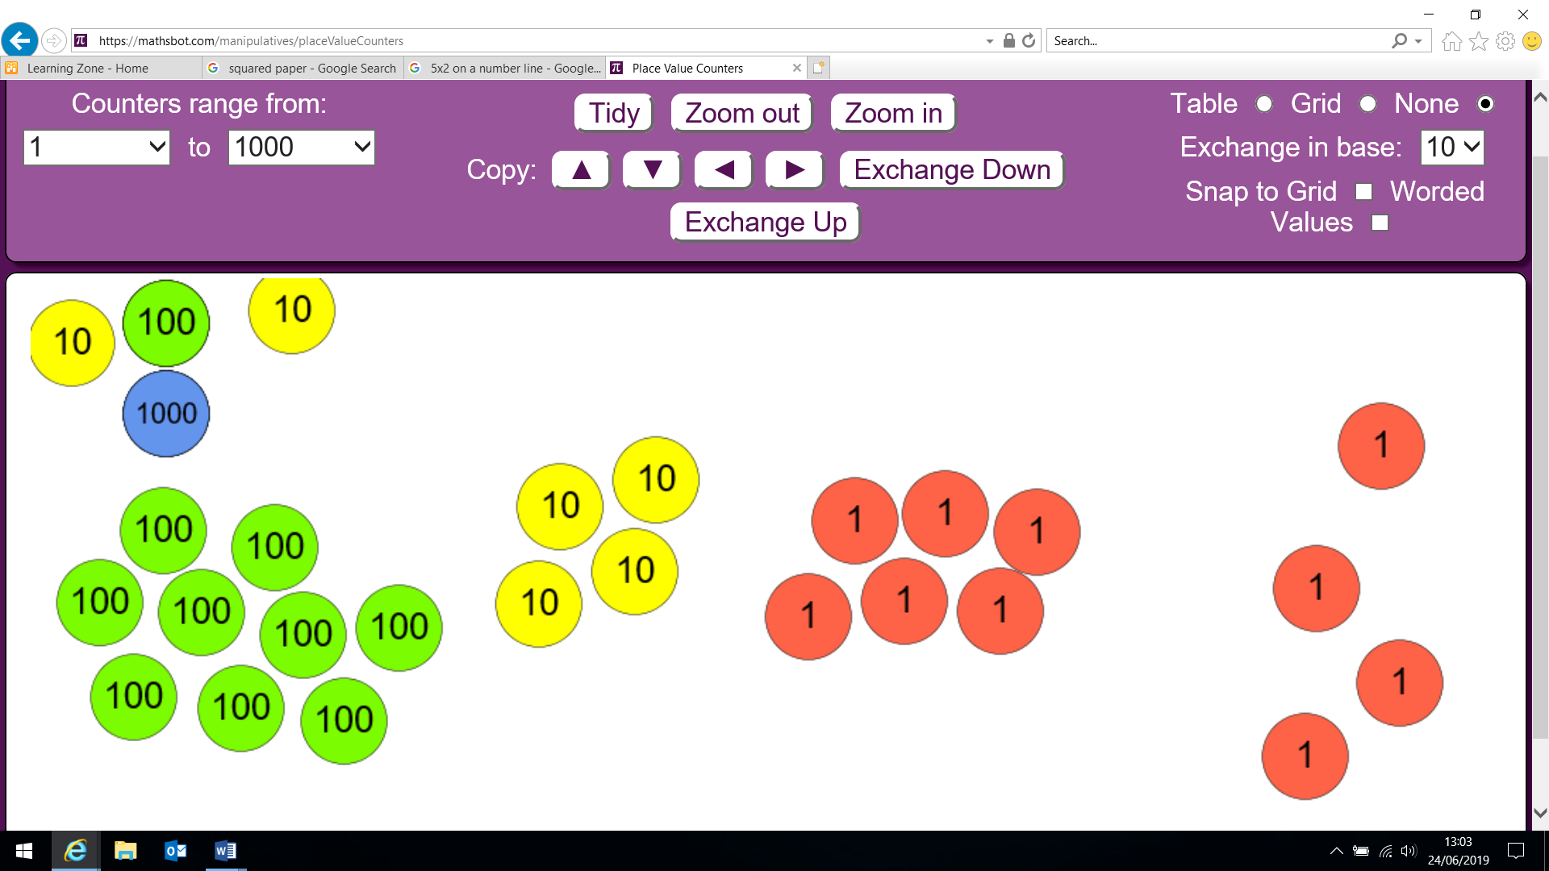  X 9 = 360  X 9 =54  Grid method  23 x 8 =  20 x 8 =160  3 x 8 = 24  23 x 8= 184  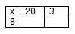  Short multiplication  Expanded  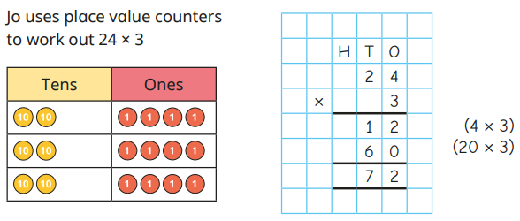  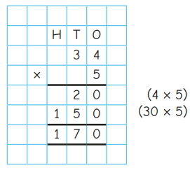  2 3  x 8  2 4 (8x3)  1 6 0 (8x20)  1 8 4  leading to compact  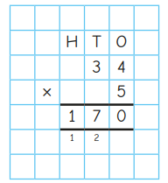  2 3  x 8  1 8 4  ²  Grid method  (if needed for conceptual understanding)  346 x 9  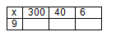  Short multiplication  Expanded  3 4 6  x 9  5 4 (9x6)  3 6 0 (9x40)  2 7 0 0 (9x300)  3 1 1 4  leading to compact  3 4 6  x 9  3 1 1 4  Representing problems  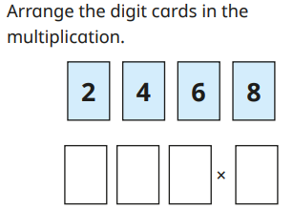

KS2 MULTIPLICATION – Year 5 and Year 6

Year | Year 5 | Year 6
Layers of vocabulary  Appendix 1a  Beck’s Tiers of Vocabulary  Appendix 1b: Vocabulary book | Basic to subject specific (Beck’s Tiers):  lots of, groups of times, multiply, multiplication, multiplied by multiple of, product once, twice, three times… ten times… times as (big, long, wide… and so on) repeated addition, array, row, column double, halve, share, share equally, factor, multiple, prime, composite  Instructional vocabulary:  carry on, continue, repeat, predict, describe the pattern, describe the rule, find, find all, find different, investigate, What comes next?  NFER– language of tests and questions  complete the sequence, circle the same as, draw four lines, circle the, circle the number that is not, circle two, circle two, write yes or no to a statement, circle all, write the, write the missing, circle the incorrect, show your method, show your working, circle three, who gets the most, by how much, calculate, estimate, shade, write the missing, use the diagram, complete the table, circle the number that is both, write a, b, c, d, label, true or false, order, draw a line, write the missing digits, circle true and false, tick two, What number is? Which is the closest? Which one of these must also? What is the total number…? | Basic to subject specific (Beck’s Tiers):  lots of, groups of times, multiply, multiplication, multiplied by, multiple of, product once, twice, three times… ten times… times as (big, long, wide… and so on) repeated addition, array, row, column, double, halve, share, share equally, factor, multiple, prime, composite  Instructional vocabulary:  carry on, continue, repeat, predict, describe the pattern, describe the rule, find, find all, find different, investigate, What comes next?  NFER– language of tests and questions  write three, complete, draw the, explain why, write each number, show your method, tick the, calculate, increase by, complete the tables, circle all, calculate, What was the…? What is the difference? Which expression? How much…? What are…? What is…? What could…? What number is…? Which of these…?

KS2 MULTIPLICATION – Year 5 and Year 6

Year | Year 5 | Year 6

Known facts | Know and use the vocabulary of prime numbers, prime factors and composite (non-prime) numbers.  Recall prime numbers up to 19.  Recognise and use square and cube numbers and the notation for squared (²) and cubed (³) BIDMAS. | Identify common factors, common multiples and prime numbers.  Recognise and use square and cube numbers and the notation for squared (²) and cubed (³) BIDMAS.

Essential knowledge | 4x and 8x tables | 100, 1000 times bigger | Multiplication facts up to 12 x 12 | Partition to multiply mentally
Essential knowledge | 3x, 6x and 12x tables; 3x and 9x tables | 10, 100, 1000 times smaller | Apply place value to derive multiplication facts, e.g. 3 x 4 = 12 so 3 x 0.4 = 1.2 | Double larger numbers and decimals
Essential knowledge | 11x and 7x tables | Double larger numbers and decimals

NC 2014 | Multiply numbers up to 4 digits by a 1 or 2 digit number using a formal written method, including long multiplication for 2 digit numbers.  Solve problems involving multiplication and division including using knowledge of factors and multiples, squares and cubes.  Solve problems involving addition, subtraction, multiplication and division and a combination of these, including understanding the meaning of the equals sign.  Solve problems involving multiplication and division including scaling by simple fractions and problems involving simple rates. | Multiply multi-digit numbers up to 4 digits by a 2 digit whole number using the formal written method of long multiplication.  Solve problems involving addition, subtraction, multiplication and division.

KS2 MULTIPLICATION – Year 5 and Year 6

 | concrete, pictorial, abstract
Year | Year 5 |  |  | Year 6
Developing Conceptual/  Procedural Understanding | Building tables  For example, apply tables knowledge to multiples of 10, 100 and 1000 using counting stick- forwards and backwards and with missing jumps  Using known facts  If 2 x 3 = 6 then 2000 x 3 = 6000 and  200 x 30 = 6000  Common multiples  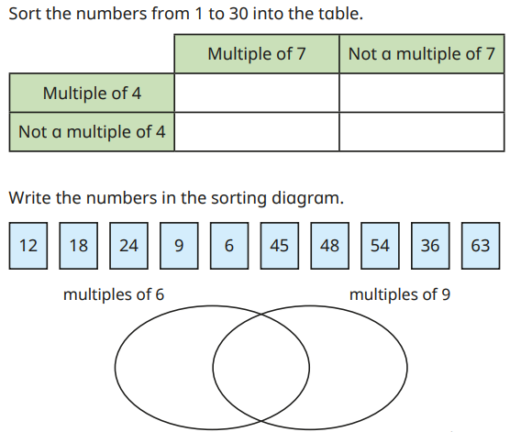  Move onto to factor pairs and common factors.  Square numbers  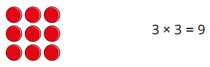  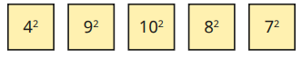  Cube numbers  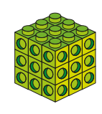  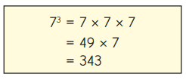  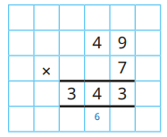  To multiply by 1000  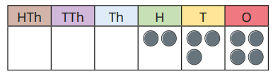  To move each digit three places to the left using place value counters.  Place value materials to represent calculations  4346 x 8 =  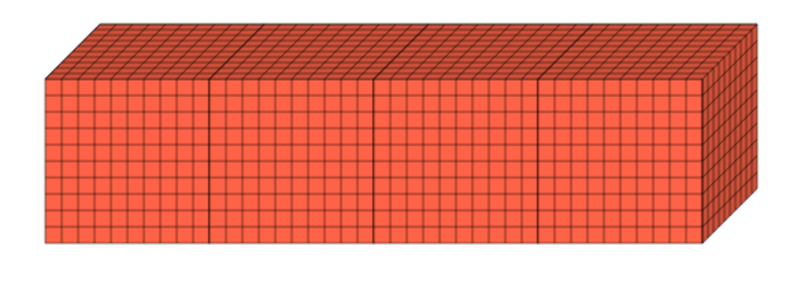  X 8 = 3200  (4000)  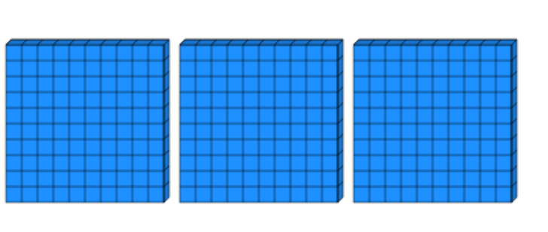  X 8 = 2400  (300)  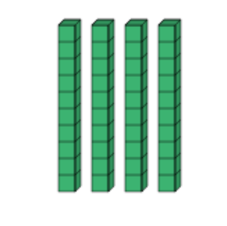  X 8 = 320  (40)  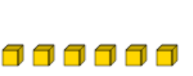  (6) X 8 = 48  Short multiplication  Use expanded method first if needed to build conceptual understanding  4 3 4 6  x 8  3 4 7 6 8  ² ³ ⁴ | Grid method  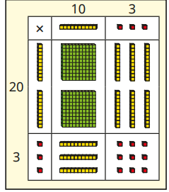  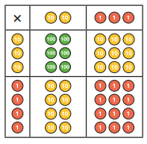  (if needed for conceptual understanding)  28 x 27 =  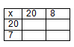  Addition to be done mentally or across followed by column addition  Long multiplication  Expanded  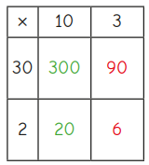  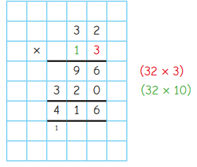  Moving onto 3-digit and 4-digit numbers multiplied by a 2-digit number. | leading to compact  Drop down  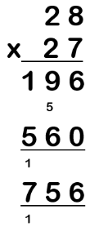  Extend to HTU x TU or ThHTU x TU as appropriate  Representing problems  40 cupcakes cost £3.60, how much do 20 cupcakes cost? How much do 80 cupcakes cost? How much do 10 cupcakes cost? | Building tables  For example, apply tables knowledge to decimals using counting stick- forwards and backwards and with missing jumps  Using known facts  If 2 x 3 = 6 then 0.2 x 3 =0.6 and 0.02 x 3 = 0.06  Common factors  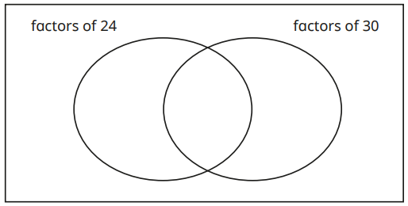  Representing problems that include prime, square and cube numbers  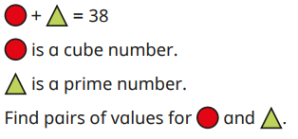  Long multiplication  Use expanded method first if needed to build conceptual understanding.  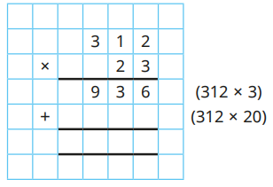  Moving onto a 4-digit multiplied by a 2-digit.  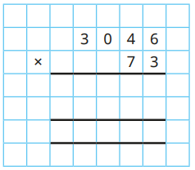 | If place value is secure, use grid method for decimal multiplication  0.75 x 6  0.7 x 6 = 4.2  0.05 x 6 = 0.3  0.75 x 6 = 4.5  Make explicit links between decimals and money  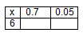  Representing problems  Amy is given the calculation 5413 x 600. She says “I can do this without a written method.” Write down the mental steps you think Amy could do.

