KS1 SUBTRACTION – Year 1 and Year 2

EYFS – prior learning  What should the children already know?  ELG (Early Learning Goals) | Number ELG Children at the expected level of development will:  • Have a deep understanding of number to 10, including the composition of each number;  • Subitise (recognise quantities without counting) up to 5;  • Automatically recall (without reference to rhymes, counting or other aids) number bonds up to 5 (including subtraction facts) and some number bonds to 10, including double facts.  Numerical Patterns ELG Children at the expected level of development will:  • Verbally count beyond 20, recognising the pattern of the counting system;  • Compare quantities up to 10 in different contexts, recognising when one quantity is greater than, less than or the same as the other quantity;  • Explore and represent patterns within numbers up to 10, including evens and odds, double facts and how quantities can be distributed equally.
Year | Year 1 | Year 2
Layers of vocabulary  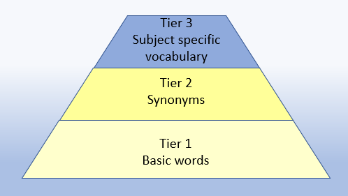  Appendix 1a  Beck’s Tiers of Vocabulary  Appendix 1b: Vocabulary book | Key Vocabulary  Basic to subject specific (Beck’s Tiers):  take away, distance between, difference between, less than, subtract, take (away), minus, leave, one less, two less, ten less… difference, halve, equals, sign, is the same as, How many more? How much greater? How many fewer? How much more is…? How many are left/left over? How many have gone? How many fewer is… than…? How much less is…?  Instructional vocabulary:  start from, start with, start at, look at point, to show me  NFER– language of tests and questions  match, tick, draw, complete, write, circle, share, jumps, count on, use a ruler | Key Vocabulary  Basic to subject specific (Beck’s Tiers):  subtract, subtraction, take (away), minus leave, one less, two less… ten less… one hundred less, difference, halve, equals, sign, is the same as, tens boundary, difference, partition, rearrange, inverse, place value, How many are left/left over? How many fewer is… than…? How much less is…?  Instructional vocabulary:  tell me, describe, name, pick out, discuss, talk about, explain, explain your method, explain how you got your answer, give an example of… show how you…  NFER– language of tests and questions  tick, match, count, tick two, circle, write, draw, complete, use these numbers, shade, write, make, choose, circle the three, complete, write, tick all, complete the number sentence, put a digit, How many…?

KS1 SUBTRACTION – Year 1 and Year 2

Year | Year 1 | Year 2

Known facts | Represent & use number bonds and related subtraction facts within 20.  Add and subtract 1 digit and 2 digit numbers to 20, including zero. | Recall and use addition and subtraction facts to 20 fluently, and derive and use related facts up to 100.

Essential knowledge | 1 less | Number bonds: subtraction 5 and 6 | 10 less | Number bonds: subtraction 20,12 and 13
Essential knowledge | Count back | Number bonds: subtraction 7 and 8 | Subtract 1 digit from 2 digit by bridging | Number bonds: subtraction 14 and 15
Essential knowledge | Subtract 10 | Number bonds: subtraction 9 and 10 | Partition second number and count back in tens then ones. | Number bonds: subtraction 16 and 17
Essential knowledge | Teens subtract 10 | Difference between | Subtract 10 and multiples of 10. | Number bonds: subtraction 18 and 19
Essential knowledge |  |  | Subtract near multiples of 10. | Difference between
Essential knowledge |  |  | Add near multiples of 10.

NC 2014 | Read, write and interpret mathematical statements involving addition (+), subtraction (-) and equals (=) signs. | Recording subtraction in columns supports place value and prepares for formal written methods with larger numbers.

KS1 SUBTRACTION – Year 1 and Year 2

 | concrete, pictorial, abstract
Year | Year 1 |  |  | Year 2
Developing Conceptual/  Procedural Understanding | Number bonds  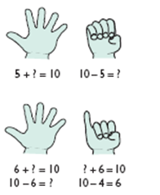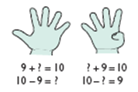  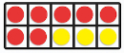  Numicon Ten Frame  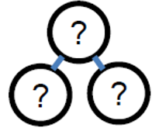  Whole-part model  10 – 5 = ?  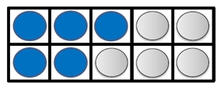  10 - ? = 7  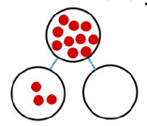  Year 1  10 - ? = 6  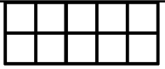  10 - ? = 8  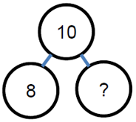  Whole-part model  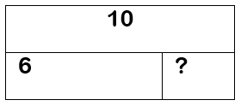  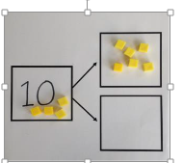  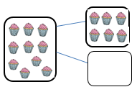  Year 1  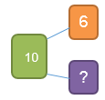  Number 10 fact families  Difference between 7 and 10.  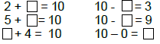  Use the pattern to complete the number sentences.  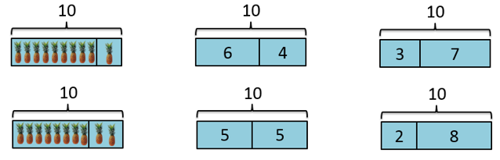    6 less than 10 is 4.  Use bonds of 10 to calculate bonds of 20.  10 - 4 = 6  20 - ____ = 6  Year 1  20 – 1 = ?  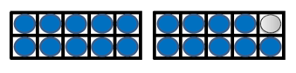  20 – 15 = ?    20 – 9 = ?  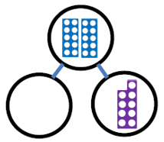 | Story contexts  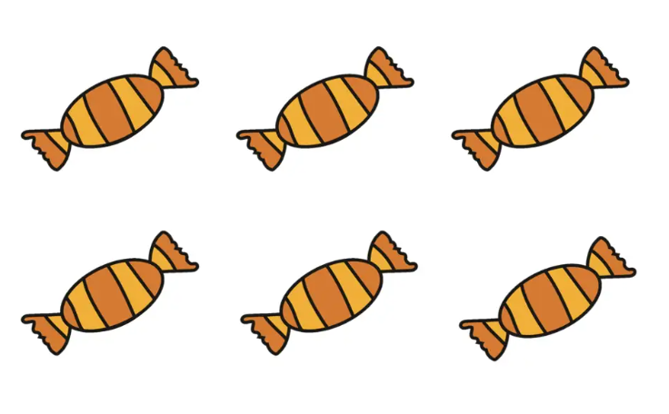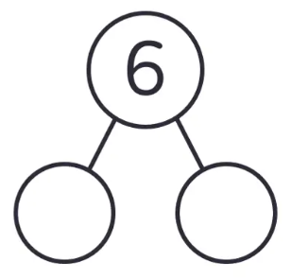  6 - 1 = 5  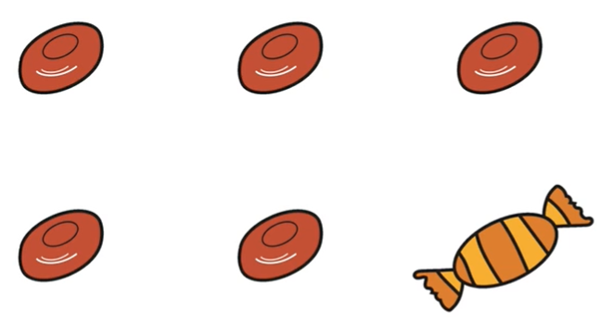  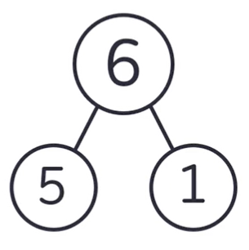  Count out, then count how many are left.  7 – 4 = 3    Subtraction-take away  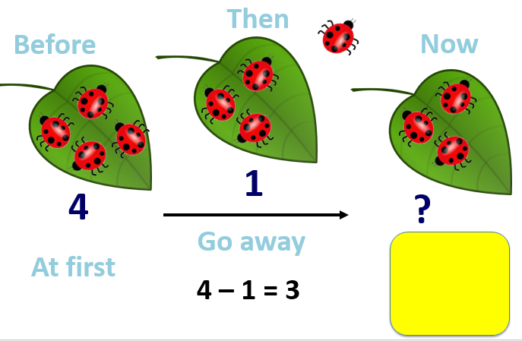  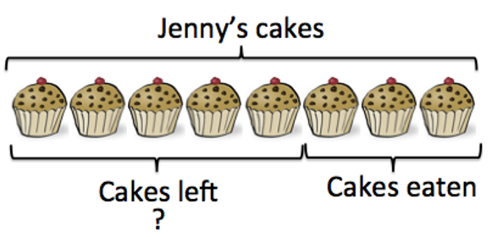  8 – 3 = ?  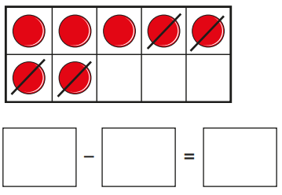  What subtractions are shown?  Count back on a number track  15 – 6 = 9  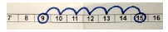  Difference between  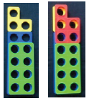  13 - 8 =__  8+ __= 13  Subtraction-finding the difference  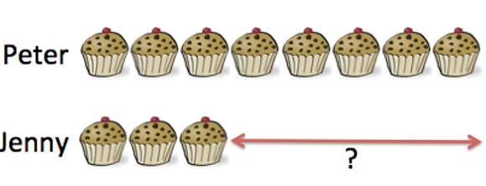  How many more cakes does Peter have than Jenny? 8-3=?  Five and a bit  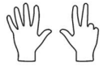  The numbers 6, 7, 8 and 9 are mad up of ‘five and a bit’. Supports decomposition of these numbers.  5 + 3 = 8  9 – 5 = 4  2 + 5 = 7  Develop knowledge of fact families  7 = 5 + 2  7 = 2 + 5  7 – 2 = 5  7 – 5 = 2  Ten and a bit  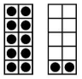  3 + 10 = 13  17 – 7 = 10  Recognising the and understanding the structure of these numbers.  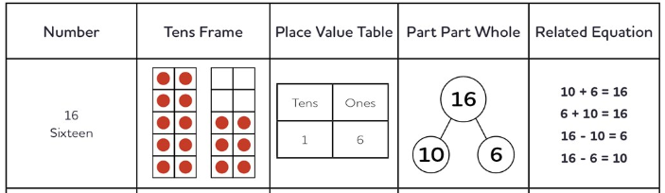 | One less  11 - 1 = ?  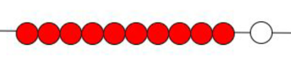  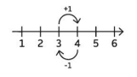  When we subtract 1, we get the previous counting number.  Two less  8 - 2 = ?    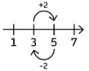  If we subtract two from a number, we go from odd to  previous odd or even to previous even.  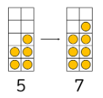  Practical  15 - 6 = ?  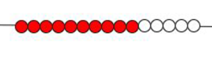  17 - 12 = ?  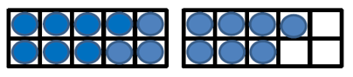  14 - 5 = ?  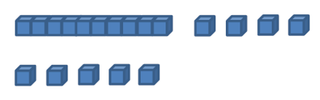  43 - 21 = ?  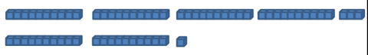  Whole-part model  Fill in the missing numbers.  44 - 1 = ?  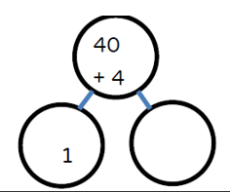  34 - 11 = ?  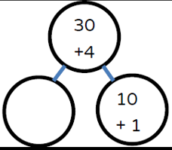  22 - 14 = ?  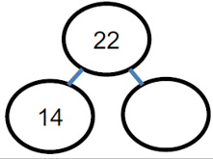 | Subtracting multiples of tens  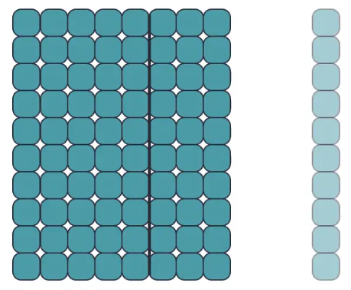  9 – 1 = 8  90 – 10 = 80  Using known facts.  60 – 20 = 40  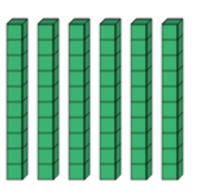  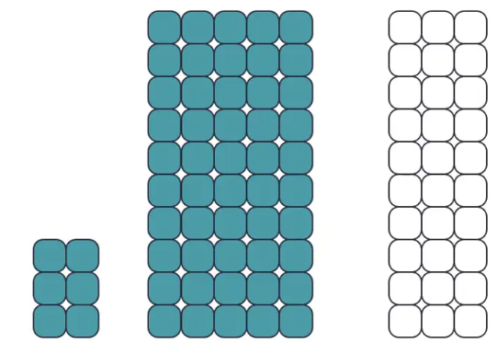  80 – 30 = 50  86 – 30 = 56  Year 2  Subtracting ones from two-digit numbers  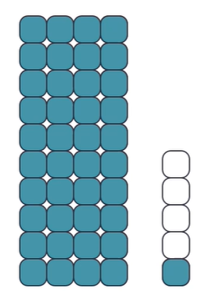  5 – 4 = 1  45 – 4 = 41  Finding safe numbers (multiples of 10)  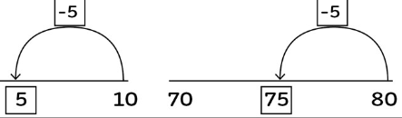  Using knowledge of number bonds to identify multiples of ten.  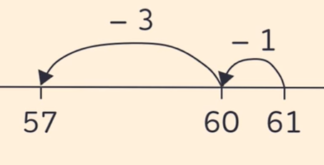  61 – 4 = 57  Year 2  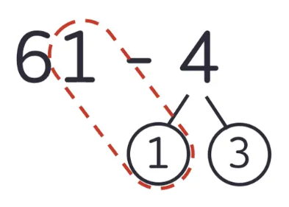  61 – 4 = 61 – 1 – 3  Whole-part model  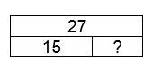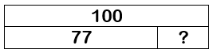  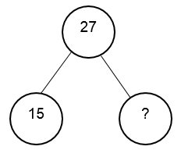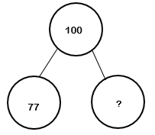  Fill in the missing numbers.  All answers to be recorded in a number sentence following any informal recording.  Adjustment strategy  15 - 9 =  15-10 +1 =6  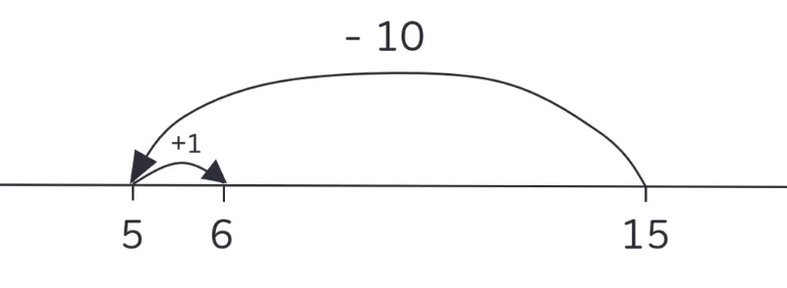  (Round and adjust)  What is the nearest 10?  Year 2  55 – 27 =  55 – 30 +3 =25 + 3  = 28  91 – 48 =  91-50 +2=41 +2  =43  Subtraction-finding the difference  72 - 68 = ?  Appropriate number steps 68 to 70 is 2 and then 70 to 72 is 2  4. | Re-arranging  35 - 8 =  Tell me what you know about 8, e.g. 2 + 6, 5 + 3  35 - 8=  Rearrange the 8 into 5 + 3  So 35 - 5 - 3= 30 - 3 =27  55 - 27 = ?  Partition the 27 into 20 +7 and rearrange the 7 into 5 + 2.  So…  55 – 27 = 55 -20 -5 -2  = 35 – 5 - 2  = 28  Taking away and exchanging  73 – 46 = 27  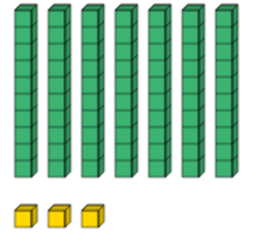  73 becomes 60 and 13.  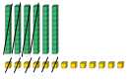 | Subtract mentally pairs of multiples of 10 using known facts  60 – 20 = 40 because 6 – 2 = 4  Subtracting multiples of tens  Partitioning of the second number strategy  74 – 47  74 – 40 = 34  34 – 4 – 3 = 27  Balance in the equation  35 - = 31  - 12 =34  20 - = 14 - 3  (Open-ended)  18 - = 15 -  Decision making  27 - = 12  Sam works out  27 – 15 = 12.  How could he have done this?

