 | sT mARY’S CATHOLIC PRIMARY SCHOOL  Progression in Knowledge and skills  WRITING

Statement of Intent:
At St Mary’s, we understand how a strong grounding in English will impact the future learning and development of a pupil in all aspects of their life. We want to prepare children with the essential writing skills they will need for later life by providing an enriched and engaging English curriculum, where they write with a clear purpose across all subjects.
We intend:
- To create confident writers who develop stamina for writing throughout school and can write at length.
- For all of our children to be independent writers, building on a range of skills as they work through each journey of writing.
- That all of our children are exposed to high quality texts that model excellent writing practises across a broad range of genres.
- For our children to have a secure understanding of the purpose of a text type, the purpose and intended impact of writing skills/tools and the ability to carefully select vocabulary with focus on the desired effect on the readers’ thoughts and feelings so that the impact of their writing is positive.
- Ensure that all pupils know how to plan, practise, evaluate their work as well as carry out an effective edit and improvement process using feedback from the teacher.
- That our children are challenged and encouraged to take risks and view mistakes as a positive part of the learning process.
- To celebrate writing at each stage through the learning process to encourage children to take pride in their work.
- To provide a balanced and broad curriculum, which encompasses writing practice and equips children with the skills and knowledge of writing processes including handwriting, spelling, grammar, widening vocabulary and writing for different styles.
- To be inclusive of all children, including SEND by providing the appropriate scaffolding, support and writing tools those children need in their writing process to experience success.
- For all our children to apply the 3 R’s (Respect, Resilience and Relationships) to all their work.
- That our children have high expectations of themselves where they take pride in all aspects of learning and in everything they produce.

Implementation

At St Mary’s Primary School, writing is taught at least 4x per week across the whole school. Each class studies a variety of genre and use high-quality text, these units run across a set of sessions. We passionately believe that reading and writing are inextricably linked therefore studying a high-quality text before writing sessions encourages children to make links and become empathetic and ambitious writers.

Teachers use long, medium and short term plans to ensure both coverage of genre and progressions of knowledge and skills.
Writing is also a key focus in the wider curriculum, especially in ‘Topic’ lessons. Children are given the opportunity to transfer and build upon their knowledge of a genre studied during English lessons and apply this learning to other curriculum subjects.

Through a personalised and differentiated approach in writing, children will acquire and learn the skills to plan, draft and refine their written work over time and are encouraged to develop independence in being able to identify their own areas for improvement in all pieces of writing. Children regulary self-assess their own writing, highlighting in different colour areas of success against the success criteria for the lesson, identifying key vocabulary, punctuation, word and sentence choices. They write in blue pen to identify thier self-assessment notes for their teacher. Children are given opportunities to peer assess and offer advice to their peers.
Within each unit of work, sequenced lessons ensure that prior learning is checked and built upon and that National Curriculum objectives are taught through a combination of approaches/opportunities e.g.

- Opportunities to participate in drama & spoken language activities
- Exploring the features of different text types and modelled examples e.g. Spotting features in a WAGOLL (What a good one looks like)
- Handwriting practise
- Vocabulary practise
- Shared writing (modelled expectations)
- Discrete Spelling, Punctuation and Grammar lessons
- Independent writing
- Planning, drafting, editing, up-levelling and presenting
- Performing
Handwriting
It is paramount that children are systematically taught correct letter formation from the very beginning of their time in school. During the foundation stage at St. Mary’s the children are taught to sit properly in order to have the correct posture for writing, hold a pencil in the correct position and develop a legible handwriting style. In KS1 and KS2 we use letter join to support letter formation, joins and spelling practice. This font is used to produce LO’s and work on the board as a continued good example for children.
Teachers are expected to role model the school’s handwriting style when marking children’s work, writing on the board and on displays around the school.

Spellings
Children learn phonic using the Ruth Miskin ‘Read , Write, Inc’ programme, this is followed on in Year 2-Year 6 where the children follow the ‘Read, Write, Spell’ programme. This is a systematic programme including clips and interactive games, practice books and tasks that children learn explicitly throughout the week. Through exploring spelling patterns and rules, we aim to create confident and proficient spellers using a discrete teaching approach underpinned by phonics.
Children are also taught to
- Spell accurately and identify reasons for mis-spellings.
- Proof-read their spellings
- Recognise and use word origins, families and roots to build their skills
- Use dictionaries and thesauruses.

Impact
Teachers use assessment as an integral part of the teaching and learning process and link it clearly to the children’s next steps.
- Formative assessment grids (statements taken from target grids and knowledge and skills document )
- Constructive marking with ‘next steps’, ‘try again’ and ‘modelling’ where appropriate. Teachers leave next steps in books when marking to ensure that children know exactly what they need to do next to make progress. Teacher use green marking pens to highlight success and and red for improvement and points for children to respond to (Green for good, Red for response)

The impact on our children is that they have the knowledge and skills to be able to write successfully for a purpose and audience. With the implementation of the writing sequence being established and taught in both key stages, children are becoming more confident writers and have the ability to plan, draft and edit their own work. By the end of key stage 2, children have developed a writer’s craft, they enjoy sustained writing and can manipulate language, grammar and punctuation to create effect. As all aspects of English are an integral part of the curriculum, cross curricular writing standards have also improved and skills taught in the English lesson are transferred into other subjects; this shows consolidation of skills and a deeper understanding of how and when to use specific language, grammar and punctuation. Our children writing is broadly in line with National expectations in all key stages.

 | EYFS | Year 1 | Year 2 | Year 3 | Year 4 | Year 5 | Year 6
Knowledge and Skills
Vocabulary Knowledge | Know an increasing amount of vocabulary | - Know and as a joining word  - That a finger space is needed between each word in a sentence | - Know what an expanded noun is and how to build one | - Know the difference between a main and subordinating clause  - Know that: when, if , because and although are conjunctions and they extend sentences  - Know the difference between a noun and a pronoun | - Know the difference between a main cluse and a subordinate clause  - Know what an adverb, proposition and pronoun are | - Know how to use a thesaurus  - Know what an extended noun phrase is and how to build one  - Know a range of modal verbs | - Know how to use a thesaurus quickly and accurately  - Know an increasing range of modal verbs and adverbs
Vocabulary Skills | *offer explanations for why things might happen, making use of recently introduced vocabulary from stories, non-fiction, rhymes and poems as appropriate | - leaving spaces between words.  - joining words and joining clauses  using "and". | - Use expanded noun phrases to describe and specify. | - extending the range of sentences with more than one clause by using a wider range of conjunctions, including when, if, because, although.  - Choose nouns or pronouns appropriately for clarity and cohesion and to avoid repetition.  using conjunctions, adverbs and prepositions to express time and cause (and place). | - extending the range of sentences with more than one clause by using a wider range of subordinating and coordinating conjunctions, including when, if, because, although.  - choosing nouns or pronouns appropriately for clarity and cohesion and to avoid repetition.  using conjunctions, adverbs and prepositions to express time and cause (and place). | - use a thesaurus to improve vocabulary choices  - using expanded noun phrases to convey complicated information concisely.  - using modal verbs or adverbs to indicate degrees of possibility. | - use a thesaurus.  - using expanded noun phrases to convey complicated information concisely.  - using modal verbs or adverbs to  indicate degrees of possibility, with increasing accuracy and purpose
Grammar Knowledge | *know how to talk in a full sentence | - know regular plural noun suffixes (-s, - es).  - Know verb suffixes where root word is  unchanged (-ing, -ed, -er).  - Know un- prefix to change meaning of adjectives/adverbs.  - Know ‘and’ joins sentences  - Sequencing sentences to form  short narratives.  - separation of words with spaces.  *Know sentence demarcation (. ! ?)  • capital letters for names and pronoun 'I'). | - Know the difference between sentences with different forms: statement, question, exclamation, command.  - Know past and present forms  - Know a suffix comes before a root word and can change the meaning  - Know a variety of end punctuation  - Know that commas separate items in a list  - Know an apostrophe can be used for omission or possession and where to write it on the line | *know what the present perfect form is  *Know increasing range of prefixes  *Know word families based on common words (solve, solution, dissolve, insoluble).  - Know the correct form of 'a' or 'an'. | - Know the difference between plural and  possessive -s.  *Know how to build and punctuate a fronted adverbial  - Know Standard English verb inflections  (I did vs I done).  *Know an appropriate range of pronouns | *know the perfect form  *know relative clause beginning with who, which, where, when, whose  - Know how to convert nouns or adjectives into verbs.  *know a variety of devices to build cohesion, including adverbials of time, place and number. | - Recognise formal speech and writing, including subjunctive forms.  - Know range of passive verbs  - Know what the perfect form of verb is  - Know the differences in informal and  formal language.  - Know a variety Synonyms & Antonyms.
Grammar Skills | *express ideas and feelings about their experiences using full sentences including use of past, present and future tense and making use of conjunctions, with modelling and support from their teacher | - how to to combine words to make  sentences, including using and.  - Use regular plural noun suffixes (-s, - es).  - use verb suffixes where root word is  unchanged (-ing, -ed, -er).  un- prefix to change meaning of adjectives/adverbs. | - Use the present and past tenses correctly and consistently including the progressive form.  - subordination (using when, if, that, or because) and co- ordination (using or, and, or but).  - some features of written  Standard English.  - suffixes to form new words (-ful,  -er, -ness).  - sentence demarcation.  - commas in lists.  - apostrophes for omission &  - singular possession. | - using the present perfect form of verbs in contrast to the past tense.  - Use different form nouns using prefixes  (super-, anti-). | - using fronted adverbials.  - Use extended noun phrases,  including with prepositions.  - Quickly decide on appropriate choice of pronoun or noun to create cohesion. | - using the perfect form of verbs to mark relationships of time and cause.  - using relative clauses beginning with who, which, where, when, whose, that or with an implied (ie omitted) relative pronoun.  - Use converting nouns or adjectives into verbs in writing .  - Use verb prefixes accurately . | - using passive verbs to affect the presentation of information in a sentence.  - using the perfect form of verbs to mark relationships of time and cause.  - Decide when to use differences in informal and  formal language.  - Make choices about Synonyms & Antonyms to improve writing  - Use further cohesive devices such as grammatical connections and adverbials  - use of ellipsis
Grammatical terminology | Phoneme grapheme letter word digraph capital letter full stop | letter, capital letter, word, singular, plural, sentence punctuation, full stop, question mark, exclamation mark | noun, noun phrase, statement, question, exclamation, command, compound, adjective, verb, suffix, adverb tense (past, present), apostrophe, comma | adverb, preposition conjunction, word family, prefix, clause, subordinate clause, direct speech, consonant, consonant letter vowel, vowel letter, inverted commas (or ‘speech marks’) | determiner, pronoun, possessive pronoun, adverbial | modal verb, relative pronoun, relative clause, parenthesis, bracket, dash, cohesion, ambiguity | subject, object, active, passive, synonym, antonym, ellipsis, hyphen, colon, semi-colon, bullet points
. |  |  |  |  |  |  |  |  | • beginning to punctuate sentences using a capital letter and a full stop, question mark or exclamation mark.  using a capital letter for names of people, places, the days of the week, and the personal pronoun ‘I’. | learning how to use both familiar and new punctuation correctly, including full stops, capital letters, exclamation marks, question marks, commas for lists and apostrophes for contracted forms and the possessive (singular). | using and punctuating direct speech (i.e. Inverted commas). | •using commas after fronted  adverbials.  •indicating possession by using the possessive apostrophe with singular and plural nouns.  using and punctuating direct speech (including punctuation within and surrounding inverted commas). | - using commas to clarify meaning  or avoid ambiguity in writing.  - using brackets, dashes or  commas to indicate parenthesis. | • using hyphens to avoid  ambiguity.  • using semicolons, colons or dashes to mark boundaries between independent clauses.  using a colon to introduce a list punctuating bullet points consistently.
Knowledge  Phonic and whole word spelling | *know letter names, sounds and shapes | - *know 40 phonemes  *know the name the letters of the alphabet in order. | - Know how to segment words  - Know how to spell some common exception words | - Know what a homophone is | - Know an increasing number of homophones | - Know what a silent letter is and words it is used in  - Know Morphology is the study of words and their parts. Morphemes, like prefixes, suffixes and base words, are defined as the smallest meaningful units of meaning. Morphemes are important for phonics in both reading and spelling, as well as in vocabulary and comprehension | - Know an increasing number of silent letters and the words they are used in  - Know with increasing depth the morphology and etymology of an increasing number of words  Etymology is the study of the origin of words and how the meaning of words has changed over the course of history. ... “Etymology” derives from the Greek word etumos, meaning “true.” Etumologia was the study of words' “true meanings.”
Skills Phonic and whole word spelling | -Write recognizable letters  -spell words by identifying sounds in them, identifying sound with a letter or letters  - | •read words containing each of the 40+  phonemes taught.  - Read common exception words.  - Say and identify the days of the week.  *using letter names to distinguish between alternative spellings of the same sound. | - segmenting spoken words into phonemes and representing these by graphemes, spelling many correctly.  - learning new ways of spelling phonemes for which 1 or more spellings are already known, and learn some words with each spelling, including a few common homophones.  - learning to spell common  exception words.  distinguishing between homophones and near- homophones. | - spell further homophones.  spell words that are often misspelt. (English National Curriculum Appendix 1) | - spell further homophones.  spell words that are often misspelt. (English National Curriculum Appendix 1) | - spell some words with ‘silent’  letters.  - continue to distinguish between homophones and other words which are often confused.  use knowledge of morphology and etymology in spelling and understand that the spelling of some words needs to be learnt specifically, as listed in English National Curriculum Appendix 1. | - spell some words with ‘silent’  letters.  - continue to distinguish between homophones and other words which are often confused.  use increasing understanding of morphology and etymology in spelling and understand that the spelling of some words needs to be learnt specifically, as listed in English National Curriculum Appendix 1.
Knowledge other word building skills | *know that marks on a page convey meaning that others an decode | - know spelling rules for making plurals  - *know a range of suffixes to add to a root word, ing, est, er, ed, | - Know what an apostrophe is and where is fits on a line  - *know an apostrophe can be used to show possession | - Know an increasing range of prefixes (see Read, Write , Spell book)  - Know what a plural is and the ways to show it in writing | - Know further prefixes and suffixes (see Read, Write Spell book)  - Know how to use a dictionary | - Know an increasing range of prefixes and suffixes (see Read, Write , Spell book)  - Know how to use a dictionary and thesaurus | - Know an increasing range of prefixes and suffixes (see Read, Write , Spell book)  - Know how to use a dictionary and thesaurus quickly and accurately
Skills Other word building spelling | Write a simple phrase or sentence that can be read by others | - using the spelling rule for adding  –s or –es as the plural marker for nouns and the third person singular marker for verbs.  - using the prefix un–  - using –ing, –ed, –er and –est where no change is needed in the spelling of root words.  apply simple spelling rules | - learning the possessive  apostrophe (singular).  - learning to spell more words  with contracted forms.  - add suffixes to spell longer words, including –ment, –ness, – ful, –less, –ly.  apply spelling rules and guidelines from English National Curriculum Appendix 1. | - use further prefixes and suffixes  and understand how to add them.  - place the possessive apostrophe accurately in words with regular plurals and in words with irregular plurals.  use the first 2 or 3 letters of a word to check spelling and definition in a dictionary | - use further prefixes and suffixes  and understand how to add them.  - place the possessive apostrophe accurately in words with regular plurals and in words with irregular plurals.  use the first 2 or 3 letters of a word to check spelling and definition in a dictionary | - use further prefixes and suffixes and understand the guidance for adding them.  - use dictionaries to check the  spelling and meaning of words.  use the first 3 or 4 letters of a word to check spelling, meaning or both of these in a dictionary. | - use further prefixes and suffixes and understand the guidance for adding them.  - use dictionaries to check the  spelling and meaning of words.  use the first 3 or 4 letters of a word to check spelling, meaning or both of these in a dictionary.
Knowledge Transcription | *Know that some words make questions and other words can give the answer | *Know the corresponding grapheme for the phonemes known | *Know when to use a capital letter and end punctuation to create a sentence | *know how to build a sentences and check it is correct | *know punctuation and spellings to write a variety of sentences | *know punctuation and spellings to write a variety of sentences | *know punctuation and spellings to write a variety of sentences
Skills Transcription | Listen attentively and respond with relevant questions, when , comments and actions when being read to and during whole class discussions. | write from memory simple sentences dictated by the teacher that include words using the GPCs and common exception words taught so far. | write from memory simple sentences dictated by the teacher that include words using the GPCs, common exception words and punctuation taught so far. | write from memory simple sentences, dictated by the teacher, that include words and punctuation taught so far. | write from memory simple sentences, dictated by the teacher, that include words and punctuation taught so far. | write from memory simple sentences, dictated by the teacher, that include words and punctuation taught so far. | write from memory simple sentences, dictated by the teacher, that include words and punctuation taught so far.
Skills Handwriting | write recognizable letters, most of which are correctly formed | - sit correctly at a table, holding a  pencil comfortably and correctly.  - begin to form lower-case letters in the correct direction, starting and finishing in the right place.  - form capital letters.  - form digits 0-9.  understand which letters belong to which handwriting ‘families’ and to practise these. | - form lower-case letters of the correct size relative to one another.  - start using some of the diagonal and horizontal strokes needed to join letters and understand which letters, when adjacent to one another, are best left unjoined.  - write capital letters and digits of the correct size, orientation and relationship to one another and to lower-case letters.  - use spacing between words that  reflects the size of the letters. | - use the diagonal and horizontal strokes that are needed to join letters and understand which letters, when adjacent to one another, are best left unjoined.  increase the legibility, consistency and quality of their handwriting. | - use the diagonal and horizontal strokes that are needed to join letters and understand which letters, when adjacent to one another, are best left unjoined.  increase the legibility, consistency and quality of their handwriting. | - choosing which shape of a letter to use when given choices and deciding whether or not to join specific letters.  - choosing the writing implement  that is best suited for a task. | - choosing which shape of a letter to use when given choices and deciding whether or not to join specific letters.  - choosing the writing implement  that is best suited for a task.
Contexts for writing  Skills |  | - writing simple recounts about personal experiences and real events  - retell well know stories  - writing simple poetry | - writing narratives about personal experiences and those of others (real and fictional).  - writing about real events.  - writing poetry.  writing for different purposes. | discussing writing similar to that which they are planning to write in order to understand and learn from its structure, vocabulary and grammar. | discussing writing similar to that which they are planning to write in order to understand and learn from its structure, vocabulary and grammar. | Identifying the audience for and purpose of writing, selecting the appropriate form and using other similar writing as models for their own.  In writing narratives, considering how authors have developed character and settings in what pupils have read, listened to or seen performed. | Identifying the audience for and purpose of writing, selecting the appropriate form and using other similar writing as models for their own.  In writing narratives, considering how authors have developed character and settings in what pupils have read, listened to or seen performed.
Planning writing Skills | participate in small group and 1:1 discussion offering their own ideas using recently introduced vocabulary | - saying out loud what they are  going to write about.  - composing a sentence orally  before writing it. | planning or saying out loud what they are going to write about. | - discussing and recording ideas.  composing and rehearsing sentences orally (including dialogue), progressively building a  varied and rich vocabulary and an increasing range of sentence structures. | - discussing and recording ideas.  composing and rehearsing sentences orally (including dialogue), progressively building a  varied and rich vocabulary and an increasing range of sentence structures. | noting and developing initial ideas, drawing on reading and research where necessary. | Choosing appropriate planning formats  noting and developing initial ideas, drawing on reading and research where necessary.
Drafting writing Skills |  | - sequencing sentences to form  short narratives.  re-reading what they have written to check that it makes sense. | - writing down ideas and/or key  words, including new vocabulary.  - encapsulating what they want to  say, sentence by sentence. | - organising paragraphs around a  theme.  - in narratives, creating settings,  characters and plot.  in non-narrative material, using simple organisational devices (headings & subheadings). | - organising paragraphs around a  theme.  - in narratives, creating settings,  characters and plot.  in non-narrative material, using simple organisational devices (headings & subheadings). | - selecting appropriate grammar and vocabulary, understanding how such choices can change and enhance meaning.  - in narratives, describing settings, characters and atmosphere and integrating dialogue to convey character and advance the action.  - using a wide range of devices to build cohesion within and across paragraphs.  using further organisational and presentational devices to structure text and to guide the reader. | - selecting appropriate grammar and vocabulary, understanding how such choices can change and enhance meaning.  - in narratives, describing settings, characters and atmosphere and integrating dialogue to convey character and advance the action.  - précising longer passages.  - using a wide range of devices to build cohesion within and across paragraphs.  using further organisational and presentational devices to structure text and to guide the reader.
Editing writing Skills |  | - discuss what they have written  with the teacher or other pupils. | - evaluating their writing with the teacher and other pupils.  - rereading to check that their writing makes sense and that verbs to indicate time are used correctly and consistently, including verbs in the continuous form.  proofreading to check for errors in spelling, grammar and punctuation. | - assessing the effectiveness of their own and others’ writing and suggesting improvements.  - proposing changes to grammar and vocabulary to improve consistency, including the accurate use of pronouns in sentences.  - proofread for spelling and  punctuation errors. | - assessing the effectiveness of their own and others’ writing and suggesting improvements.  - proposing changes to grammar and vocabulary to improve consistency, including the accurate use of pronouns in sentences.  proofread for spelling and punctuation errors. | - assessing the effectiveness of their own and others’ writing.  - proposing changes to vocabulary, grammar, and punctuation to enhance effects and clarify meaning.  - ensuring the consistent and correct use of tense throughout a piece of writing.  - ensuring correct subject and verb agreement when using singular and plural, distinguishing between the language of speech and writing and choosing the appropriate register.  - proofread for spelling and  punctuation errors. | - assessing the effectiveness of their own and others’ writing.  - proposing changes to vocabulary, grammar, and punctuation to enhance effects and clarify meaning.  - ensuring the consistent and correct use of tense throughout a piece of writing.  - ensuring correct subject and verb agreement when using singular and plural, distinguishing between the language of speech and writing and choosing the appropriate register.  - proofread for spelling and  punctuation errors.
Performing writing | read aloud simple sentences and books that are consistent with their phonic knowledge | read their writing aloud clearly enough to be heard by their peers and the teacher. | read aloud what they have written with appropriate intonation to make the meaning clear. | read their own writing aloud, to a group or the whole class, using appropriate intonation and controlling the tone and volume so that the meaning is clear. | read their own writing aloud, to a group or the whole class, using appropriate intonation and controlling the tone and volume so that the meaning is clear. | perform their own compositions, using appropriate intonation, volume, and movement so that | perform their own compositions, using appropriate intonation, volume, and movement so that meaning is clear.

EYFS Knowledge Checklist

Skills
Skills
Skills
Knowledge
Text structure  KNo | Sentence construction | Word structure/ Language | Punctuation | Terminology
Introduce:  Whole class or group retelling of a story.  Understanding of 7-part story structure.  Retell simple 7-part story. Non-fiction.  Factual writing closely linked to a story.  Simple factual sentences based around a theme:  Names Labels Captions Lists Diagrams Messages Instructions Recount | Introduce:  Simple phrases  Simple sentences. Simple conjunctions  and but  Say a sentence, write and read it back to check it makes sense.  Compound sentences using conjunctions (coordinating conjunctions)  and / but  -‘ly’ openers  Luckily / Unfortunately, Repetition for rhythm: e.g.  He walked and he walked Repetition in description e.g. a lean cat, a mean cat | Introduce:  Determiners  the / a my your an this that his her their some all  Prepositions:  up down in into out to onto  Adjectives e.g. old, little, big, small, quiet  Adverbs e.g. luckily, unfortunately, fortunately  Similes – using ‘like’ | Introduce:  Letter formation Finger spaces Full stops Capital letters | Introduce:  Finger spaces Letter  Word Sentence Full stops Capital letter Simile – ‘like’
 |  |  | 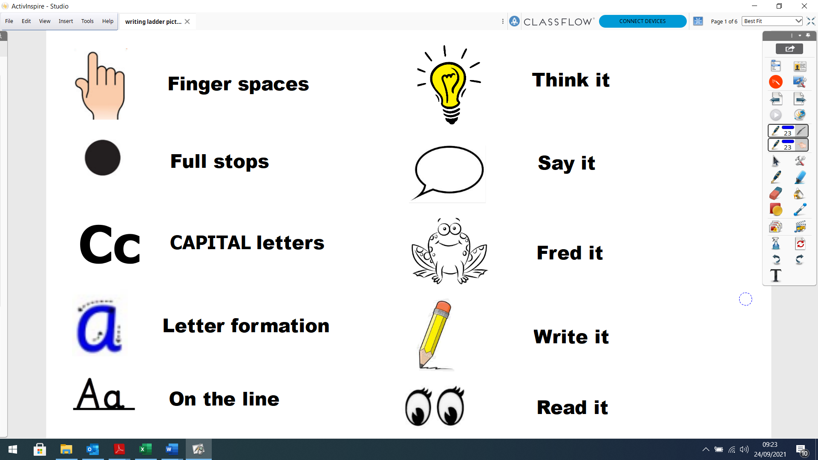

Sentence construction | Word structure/ Language | Punctuation | Terminology | Punctuation ladder
Consolidate EYFS list  Introduce:  Types of sentences: Statements Questions Exclamations  Please be aware that according to DfE rules, for the purposes of the grammar test, exclamation sentences have to begin with What’ or ‘How’!  Simple conjunctions:  and or but so  because so that then that while when where  Also as openers:  While… When… Where…  -‘ly’ openers: Fortunately,…Unfortunately, Sadly…  Simple sentences e.g.  I went to the park. The castle is haunted.  Embellished simple sentences | Consolidate EYFS list Introduce:  Prepositions: inside outside towards across  under  Determiners:  the a my your an this that his her their some all lots of many more those these  Adjectives to describe:  e.g. The old house… The huge elephant…  Alliteration  e.g. dangerous dragon slimy snake  Similes using ‘as’  e.g. as tall as a house as red as a radish  Precise, clear language to give information e.g.  First, switch on the red Next, wait for the green light to flash...  Regular plural noun suffixes –s or –es (e.g. dog, dogs; wish, wishes) | Consolidate EYFS list Introduce:  Capital Letters: Capital letter for names  Capital letter for the personal pronoun I Full stops  Question marks Exclamation marks Speech bubble Bullet points | Consolidate:  Finger spaces Letter  Word Sentence Full stops Capital letter Simile – ‘like’  Introduce:  Punctuation Question mark Exclamation mark Speech bubble Bullet points Singular/ plural Adjective | Used by children and staff to assess extended pieces of writing.  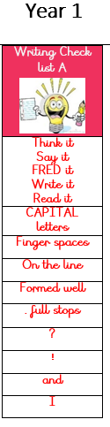 visual list for children
Year 1 Knowledge Checklist

using adjectives e.g.  The giant had an enormous beard. Red squirrels enjoy eating delicious nuts.  Compound sentences using connectives (coordinating conjunctions)  and/or/ but/so e.g.  The children played on the swings  and slid down the slide.  Spiders can be small or they can be large.  Charlie hid but Sally found him.  It was raining so they put on their coats.  Complex sentences: Use of ‘who’  (relative clause) e.g.  Once upon a time there was a little old woman who lived in a forest.  There are many children who like to eat ice cream.  BOYS sentences  Many Questions sentences | Suffixes that can be added to verbs (e.g. helping, helped, helper)  How the prefix un– changes the meaning of verbs and adjectives (negation, e.g. unkind, or undoing, e.g. untie the boat)

Sentence construction | Word structure/ Language | Punctuation | Terminology | Punctuation ladder
Consolidate Year 1 list: Introduce:  Types of sentences: Statements Questions Exclamations Commands  -‘ly’ openers  e.g. Usually, Eventually, Finally,  Carefully, Slowly, …  Vary openers to sentences  Embellished simple sentences using: adjectives e.g. The boys peeped inside the dark cave.  adverbs e.g. Tom ran quickly down the hill.  Secure use of compound sentences (Coordination) using connectives: and/ or / but / so  (coordinating conjunctions)  Additional subordinating conjunctions: what/while/when/where/ because/then/so that/ if/to/until  e.g. While the animals were munching breakfast, two visitors arrived  During the Autumn, when the weather is cold, the leaves fall off the trees. | Consolidate Year 1 list: Introduce:  Prepositions:  behind above along before between after  Alliteration e.g. wicked witch slimy slugs  Similes using…like… e.g.  … like sizzling sausages  …hot like a fire  Two adjectives to describe the noun  e.g.  The scary, old woman… Squirrels have long, bushy Tails  .  Adverbs for description e.g.  Snow fell gently and  covered the cottage in the wood.  Adverbs for information e.g.  Lift the pot carefully onto the tray. The river quickly flooded  the town.  Generalisers for information, e.g.  Most dogs…. Some cats….  Formation of nouns using  suffixes such as –ness, –er  Formation of adjectives  using suffixes such as –ful, | Consolidate Year 1 list: Introduce:  Demarcate sentences: Capital letters Full stops Question marks  Exclamation marks  Commas to separate items in a list  Speech bubbles for direct speech  Implicitly understand how to change from indirect speech to direct speech  Apostrophes to mark contracted forms in spelling  e.g. don’t, can’t  Apostrophes to mark singular possession e.g. the cat’s name | Consolidate:  Punctuation Finger spaces Letter  Word Sentence Full stops Capital letter  Question mark Exclamation mark  Speech bubble Singular/ plural Adjective  Verb Conjunction Alliteration  Simile – ‘as’/ ‘like’  Introduce:  Commas for description  ‘Speech marks’  Suffix  Verb / adverb Statement question exclamation  Command (Bossy verbs)  Tense (past, present, | 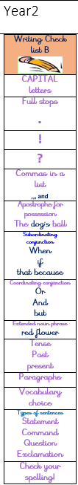  Used by children and staff to assess extended pieces of writing. Ladders are labelled A, B, C etc to allow children to work on ladders that meet their needs if they are working below age related expectation.
Year 2 Knowledge Checklist

Use long and short sentences:  Long sentences to add description or information. Use short sentences for emphasis.  Expanded noun phrases  e.g. lots of people, plenty of food  List of 3 for description  e.g. He wore old shoes, a dark cloak and a red hat.  African elephants have long trunks, curly tusks and large ears.  2A Sentence, SIMILE Sentence  Ad, same ad Sentence, double ly Sentence, All the W’s Sentence, List Sentence, SHORT Sentence (for effect) | –less  (A fuller list of suffixes can be found in the spelling appendix.)  Use of the suffixes –er and  –est to form comparisons of adjectives and adverbs  The consistent use of present tense  versus past tense throughout texts.  Use of the continuous form of verbs in the present and past tense to mark actions in progress e.g. she is drumming, he was shouting. |  | future)  Adjective / noun Noun phrases  Generalisers  Subordinating conjunctions

Sentence construction | Word structure/ Language | Punctuation | Terminology | Punctuation ladder
Consolidate Year 2 list Introduce:  Vary long and short sentences:  Long sentences to add description or information.  Short sentences for emphasis and making  key points e.g.  Sam was really unhappy. Visit the farm now.  Embellished simple sentences: Adverb starters to add detail e.g. Carefully, she crawled along the floor of the cave….  Amazingly, small insects can….  Adverbial phrases used as a ‘where’, ‘when’ or ‘how’ opener  (fronted adverbials)  A few days ago, we discovered a hidden box.  At the back of the eye, is the retina.  In a strange way, he looked at me.  Prepositional phrases to place the action:  on the mat; behind the tree, in the air  Compound sentences (Coordination)  using conjunctions:  and/ or / but / so / for /nor /  (coordinating conjunctions)  Develop complex sentences | Consolidate Year 2 list Introduce:  Prepositions  Next to by the side of in front of during through throughout because of  Powerful verbs  e.g. stare, tremble, slither  Boastful Language  e.g. magnificent, unbelievable, exciting!  More specific / technical vocabulary to add detail e.g.  A few dragons of this variety can breathe on any creature and turn it  to stone immediately. Drops of rain pounded on the corrugated, tin roof.  Nouns formed from prefixes  e.g. auto… super…anti… Word Families based on common words  e.g. teacher –teach, beauty – beautiful | Consolidate Year 2 list Introduce:  Secure use of inverted commas for direct speech | Consolidate:  Punctuation Finger spaces Letter  Word Sentence Statement question exclamation Command Full stops Capital letter  Question mark Exclamation mark Speech bubble ‘Speech marks’ Bullet points Apostrophe (contractions only) Commas for sentence of 3 - description Singular/ plural Suffix  Adjective / noun / Noun phrases Verb / adverb  Bossy verbs  Tense (past, present, future)  Connective Generalisers Alliteration  Simile – ‘as’/ ‘like’  Introduce:  Word family Conjunction Coordinating conjunction | 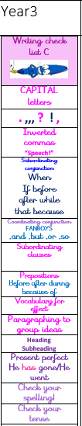  Used by children and staff to assess extended pieces of writing. Ladders are labelled A, B, C etc to allow children to work on ladders that meet their needs if they are working below age related expectation.
Year 3 Knowledge Checklist

(Subordination) with range of subordinating conjunctions  -‘ing’ clauses as openers e.g. Sighing, the boy finished his homework.  Grunting, the pig lay down to sleep.  With support use relative clauses using: who/whom/which/whose/  that e.g.  The girl, whom I remember, had long black hair.  The boy, whose name is George, thinks he is very brave.  The Clifton Suspension bridge, which was finished in 1864, is a popular tourist attraction.  Sentence of three for description e.g. The cottage was almost invisible, hiding under a thick layer of snow and glistening in the sunlight.  Rainbow dragons are covered with many different coloured scales, have enormous, red eyes and swim on the surface of the water.  Pattern of three for persuasion e.g. Visit, Swim, Enjoy!  Topic sentences to introduce non- fiction paragraphs e.g.  Dragons are found across the world.  Dialogue –powerful speech verbs  e.g. “Hello,” she whispered. | Use of determiners a or an according to whether next word begins with a vowel  e.g. a rock, an open box  Use of the perfect form of verbs to mark relationships of time and cause  e.g. I have written it down so I can check what it said.  Use of present perfect instead of simple past. He has left his hat behind, as opposed to He left his hat behind. |  | Subordinating conjunction Clause Subordinate clause  Adverb Preposition Direct speech Inverted commas Prefix  Consonant/Vowel Determiner Synonyms Relative clause Relative pronoun Imperative

Year 4 Knowledge Checklist
Sentence construction | Word structure/ Language | Punctuation | Terminology | Punctuation ladder
Consolidate Year 3 list Introduce:  Standard English for verb inflections instead of local spoken forms  Long and short sentences: Long sentences to enhance description or information  Short sentences to move events on quickly e.g. It was midnight. It’s great fun.  Simile openers  e.g. As curved as a ball, the moon shone brightly in the night sky. Like a wailing cat, the ambulance screamed down the road.  Secure use of simple / embellished simple sentences  Secure use of compound sentences (Coordination) using coordinating conjunctions and / or / but / so / for/ yet  Use relative clauses using: who/whom/which/whose/ that e.g.  The girl, whom I remember, had long black hair.  The boy, whose name is George, thinks he is very brave.  The Clifton Suspension bridge, which was finished in 1864, is a popular tourist attraction. | Consolidate Year 3 list Introduce:  Prepositions  at underneath since towards beneath beyond  Conditionals  could, should, would  Comparative and Superlative adjectives e.g.  small smaller smallest good better best  Proper nouns refers to a particular person or thing  e.g. Monday, Jessica, October, England  The grammatical  difference between plural and  possessive –s  Standard English forms for verb inflections instead of local spoken forms e.g. we  were instead of we  was, or I did instead of I done) | Consolidate Year 3 list Introduce:  Commas to mark  clauses and to mark off fronted adverbials.  Full punctuation for direct speech:  Each new speaker on a new line Comma between direct speech and reporting clause e.g. “It’s late,” gasped Cinderella!  Apostrophes to mark singular and plural possession  e.g. the girl’s name, the boys’ boots as opposed to s to mark a plural | Consolidate:  Punctuation: Letter  Word Sentence Statement question exclamation command Full stops Capital letter  Question mark Exclamation mark ‘Speech marks’ Direct speech Inverted commas Bullet points Apostrophe (contractions only)  Commas for sentence of 3 – description, action  Colon – instructions Singular/ plural Suffix/ Prefix Word family Consonant/Vowel  Adjective / noun / noun phrase Verb / Adverb  Bossy verbs -imperative Tense (past, present, future) Conjunction  Preposition Determiner/ generaliser Clause  Subordinate clause Relative clause Relative pronoun  Coordinating conjunction Subordinating conjunction | 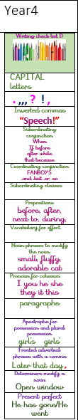  Used by children and staff to assess extended pieces of writing. Ladders are labelled A, B, C etc to allow children to work on ladders that meet their needs if they are working below age related expectation.

Develop complex sentences: (Subordination)  Main and subordinate clauses with range of subordinating conjunctions.  -‘ed’ clauses as openers e.g. Frightened, Tom ran straight home to avoid being caught.  Exhausted, the Roman soldier collapsed at his post.  Expanded -‘ing’ clauses as openers  e.g.  Grinning menacingly, he slipped the treasure into his rucksack.  Drop in –‘ing’ clause e.g.  Jane, laughing at the teacher, fell off her chair. The tornedo, sweeping across the city, destroyed the houses.  Sentence of three for action e.g.  Sam rushed down the road, jumped on the bus and sank into his seat.  The Romans enjoyed food, loved marching but hated the weather.  Repetition to persuade e.g.  Find us to find the fun  Dialogue - verb + adverb - “Hello,” she  whispered, shyly.  Appropriate choice of pronoun or noun within a sentence to avoid ambiguity and repetition  Verb, person Sentence  Personification of the weather  Sentence |  |  | Alliteration Simile – ‘as’/ ‘like’ Synonyms  Introduce:  Pronoun  Possessive pronoun Adverbial  Fronted adverbial Apostrophe – plural Possession | Used by children and staff to assess extended pieces of writing. Ladders are labelled A, B, C etc to allow children to work on ladders that meet their needs if they are working below age related expectation.

Year 5 Knowledge Checklist
Sentence construction | Word structure/ Language | Punctuation | Terminology | Punctuation ladder
Consolidate Year 4 list Introduce:  Secure use of simple / embellished simple sentences  Secure use of compound sentences Relative clauses beginning with  who, which, that, where, when,  whose or an omitted relative pronoun.  Develop complex sentences: (Subordination)  Main and subordinate clauses with full range of conjunctions:  Expanded –ed clauses as openers e.g. Encouraged by the bright weather, Jane set out for a long walk.  Terrified by the dragon, George fell to his knees.  Elaboration of openers using adverbial phrases e.g.  Beyond the dark gloom of the cave, Zach saw the wizard move.  Throughout the night, the wind howled like an injured creature.  Drop in –‘ed’ clause e.g.  Poor Tim, exhausted by so much effort, ran home.  The lesser known Bristol dragon, recognised by purple spots, is rarely seen. | Consolidate Year 4 list Introduce:  Metaphor  Personification Onomatopoeia  Empty words e.g. Someone, somewhere was out to get him.  Developed use of technical language  Converting nouns or adjectives into verbs using suffixes e.g. – ate; –ise; –ify  Verb prefixes e.g.  dis–, de–, | Consolidate Year 4 list Introduce:  Rhetorical question Dashes  Brackets / dashes /commas for parenthesis  Colons  Use of commas to clarify meaning or avoid ambiguity | Consolidate:  Punctuation: Sentence statement question exclamation command  Full stops/ Capitals Question mark Exclamation mark ‘Speech marks’ Direct speech Inverted commas Apostrophe contractions/ possession  Commas for sentence of three – description, action Colon – instructions Parenthesis / bracket / dash Singular/ plural  Suffix/ Prefix Word family Consonant/Vowel  Adjective / noun / noun phrase Verb / Adverb  Imperative- bossy verbs Tense (past, present, future) Conjunction  Preposition Determiner/ generaliser  Pronoun – relative/ possessive Clause  Subordinate/ relative clause Adverbial  Fronted adverbial Alliteration Simile – ‘as’/ ‘like’ Synonyms | 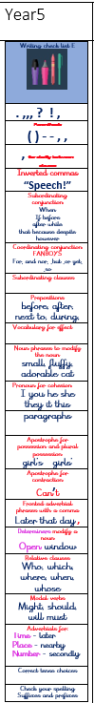

Sentence reshaping techniques e.g. lengthening or shortening  sentence for meaning and /or effect  Moving sentence chunks (how, when, where) around for different effects e.g.  The siren echoed loudly ….through the lonely streets ….at midnight  Use of rhetorical questions Stage directions in speech (speech + verb + action) e.g.  “Stop!” he shouted, picking up the stick  and running after the thief.  Indicating degrees of possibility using modal verbs e.g. might, should, will, must or adverbs perhaps, surely 2 pairs sentence O.(I.) sentence NOUN, which/who, where sentence 3 bad-(dash) question? sentence  P.C. sentence  The more, the more sentence Irony sentence |  |  | Introduce:  Relative clause/pronoun Modal verb  Parenthesis Bracket- dash Determiner Cohesion Ambiguity Metaphor Personification Onomatopoeia Rhetorical question  Tense: present and past progressive; | Used by children and staff to assess extended pieces of writing. Ladders are labelled A, B, C etc to allow children to work on ladders that meet their needs if they are working below age related expectation.

Year 6 Knowledge Checklist
Sentence construction | Word structure/ Language | Punctuation | Terminology | Punctuation ladder
Consolidate Year 5 list Introduce:  Secure use of simple / embellished simple sentences  Secure use of compound sentences  Secure use of complex sentences: (Subordination) Main and subordinate  clauses with full range of conjunctions  Active and passive verbs to create effect and to affect presentation of information e.g.  Active: Tom accidently dropped the glass.  Passive: The glass was accidently dropped by Tom.  Active: The class heated the water.  Passive: The water was heated.  Developed use of rhetorical questions for persuasion  Expanded noun phrases to convey complicated information concisely e.g.  the boy that jumped over the fence is over there, or the fact that it was raining meant the end of sports day.  The difference between structures typical of informal speech and structures appropriate for formal speech and writing | Consolidate Year 5 list Introduce:  Build in literary feature to create effects e.g.  alliteration, onomatopoeia, similes and metaphors  The difference between vocabulary typical of informal speech and vocabulary appropriate for formal speech and writing e.g. said versus reported, alleged, or claimed in formal speech or writing.  How words are related as synonyms and  antonyms e.g. big/ large / little | Consolidate Year 5 list Introduce:  Use of the semi-colon,  colon and dash to indicate a stronger subdivision of a  sentence than a comma.  Use of colon to introduce a list and semi-colons within lists.  Punctuation of bullet points to list information.  How hyphens can be used to avoid ambiguity e.g. man eating shark versus man-eating shark, or recover versus re-cover | Consolidate:  Punctuation: Sentence statement question exclamation command  Full stops/ Capitals Question mark Exclamation mark ‘Speech marks’ Direct speech Indirect speech Inverted commas Apostrophe contractions/ possession  Commas for sentence of three – description, action Colon – instructions Parenthesis / bracket / dash Singular/ plural  Suffix/ Prefix Word family Consonant/Vowel  Adjective / noun / noun phrase Verb / Adverb  Imperative- bossy verbs Tense (past, present, future) Conjunction / connective Preposition  Determiner/ generaliser Pronoun – relative/ possessive Clause  Subordinate/ relative clause Adverbial  Fronted adverbial Rhetorical question  Present and past progressive present perfect; past perfect | 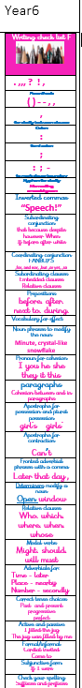

question tags) e.g. He’s your friend, isn’t he?, or the use of the subjunctive in some very formal writing and speech) as in If I were you. |  |  | Cohesion Ambiguity Alliteration Simile – ‘as’/ ‘like’ Synonyms  Introduce:  Active and passive voice Subject and object Hyphen  Synonym, antonym Colon/ semi-colon Bullet points Ellipsis  Subjunctive | Used by children and staff to assess extended pieces of writing. Ladders are labelled A, B, C etc to allow children to work on ladders that meet their needs if they are working below age related expectation.

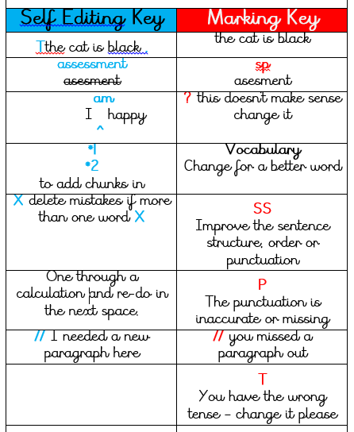 | 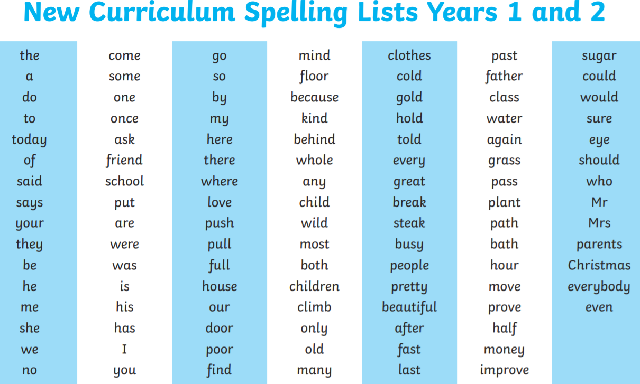
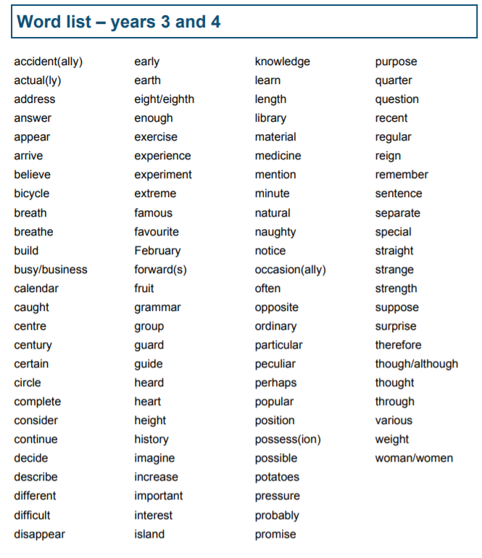 | 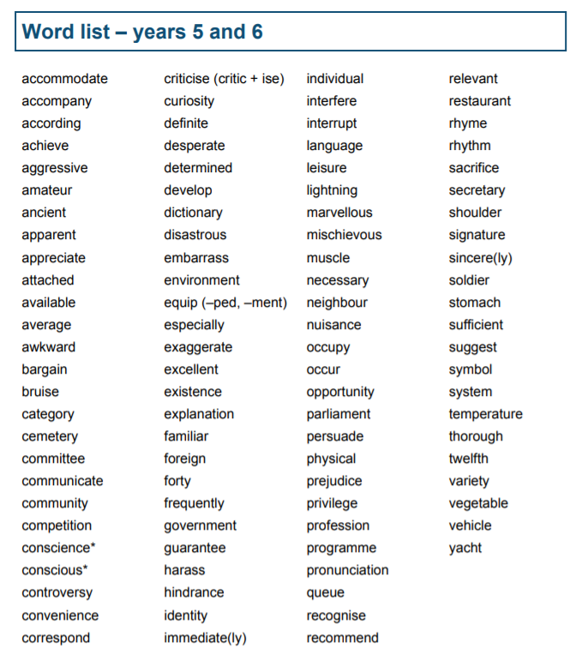
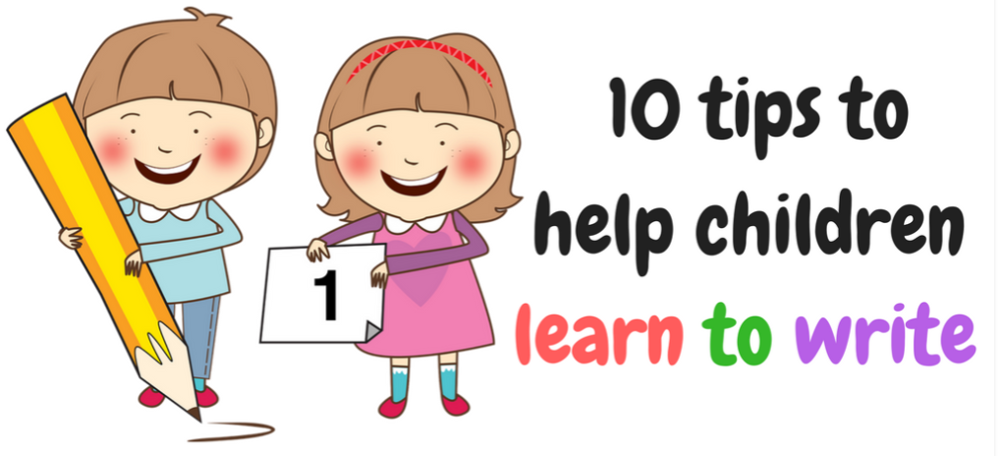
Writing is definitely an important skill of life which is hard to learn and master. Here are few simple techniques, if followed properly children will learn writing more quickly and in fun way.
- Provide lots of writing material to your children like paper, pencils, colours and crayons.
- Let them scribble as much as they want. This helps them get used to of writing and express their thoughts. It will also help build children hand muscles and improve their pencil control.
- Make a separate place for writing in your home where children can write away from distraction.
- Ask them lots of question once a child finishes drawing like what they have made? What is the boy doing? Can you tell me a story about this? etc.
- Just practice, practice and practice. Writing needs lots and lots of practice. If a child is finding it hard let them trace over the letters. By repeating this activity, your child will begin to understand how to form letters.
- Encourage your child to write their name. While they write to point out to each letter so that they recognise it properly. Be very patient as it does take time, but stay consistent and keep trying. This is very important as this is the first skill child needs to know when they start reception.
- Praise your child as much as you can. Find good things in your child writing. Always remember that simple words of encouragement can do wonders.
- Reading plays a huge role in writing skill, as they both complement each other. The more your child reads, the more ideas he will have to write down. This can include magazine, comics, books they read to you and books they have read to them!
- Pointing words as you read them in stories or writing words said in a conversation will help them understand the link between spoken words and written text. This works all the way to year six, picking out interesting vocabulary and exploring it meaning and using it in their speaking will support them in doing it in their writing.
- As your child gets older encourage them to write letters and card to other family members. This will help them to build their confidence and vocabulary.

Underlined targets are KPIs (Key Progress Indicator)
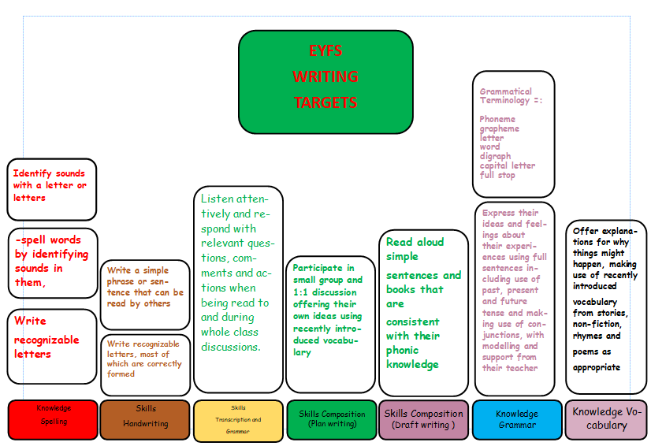
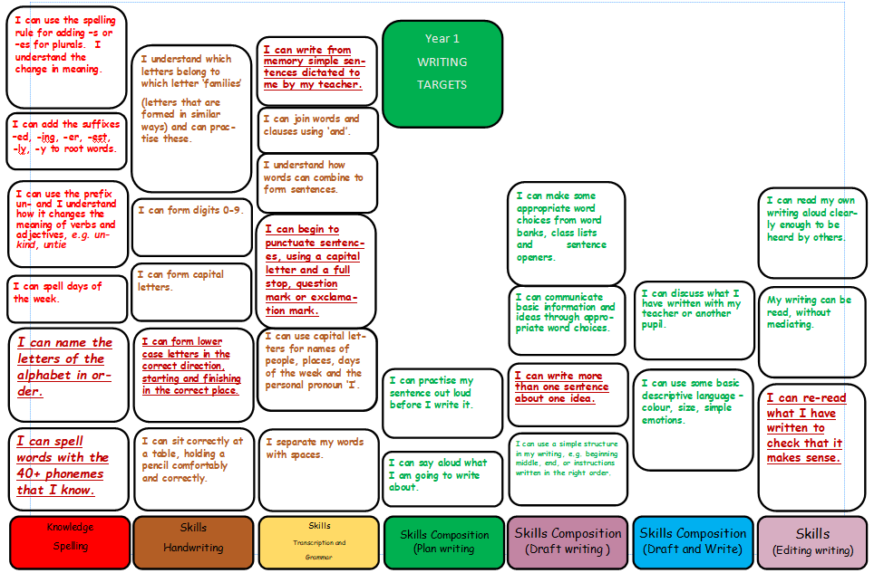

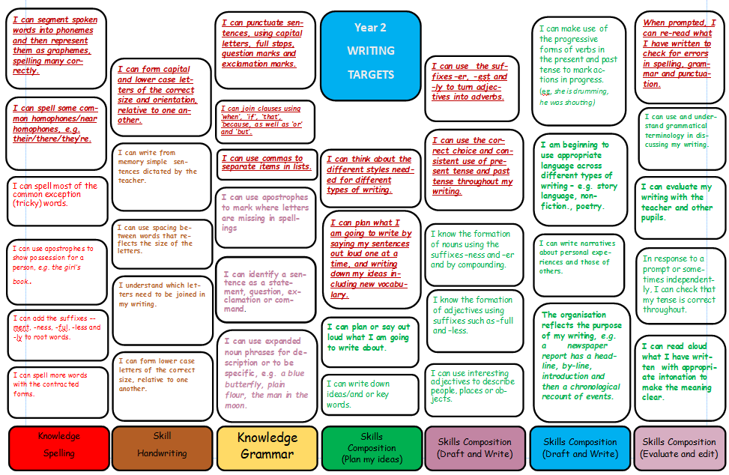
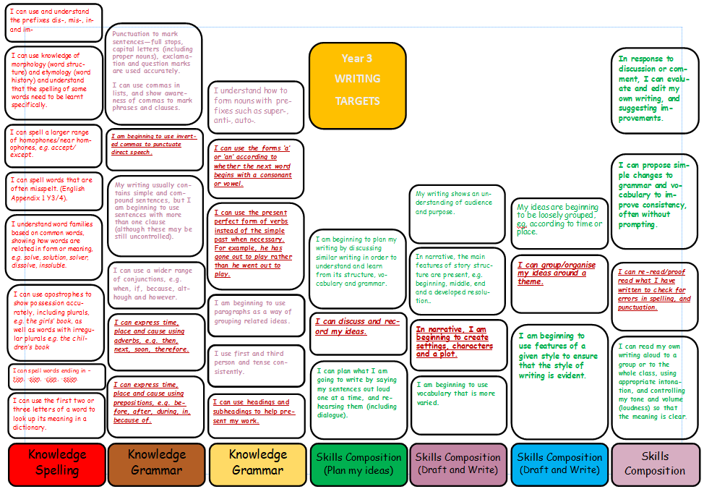
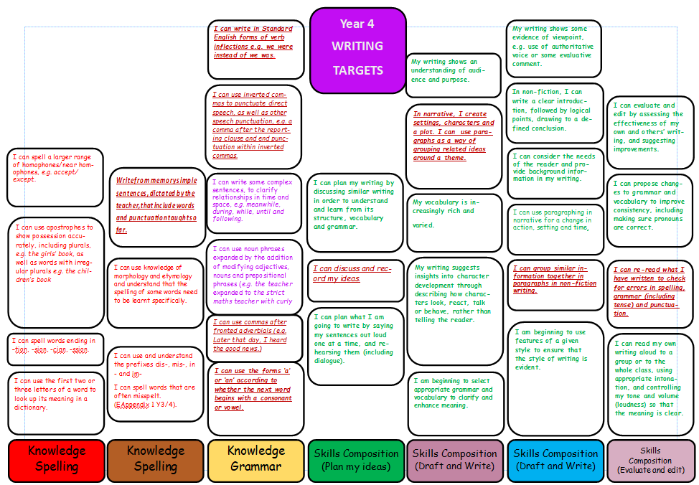
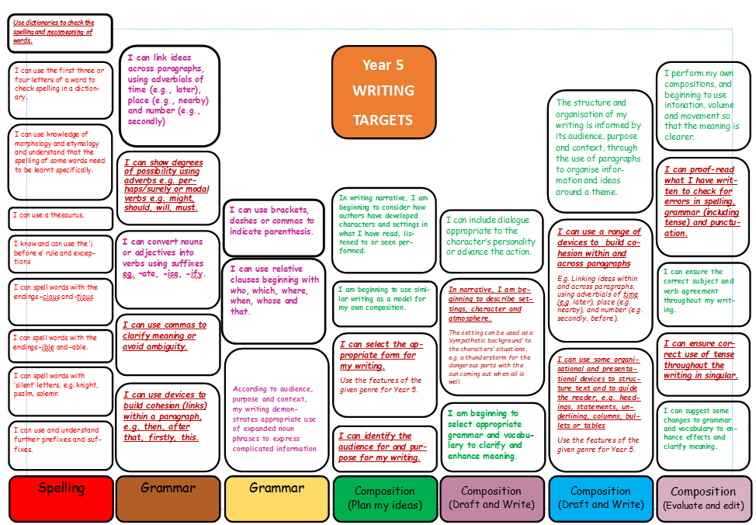

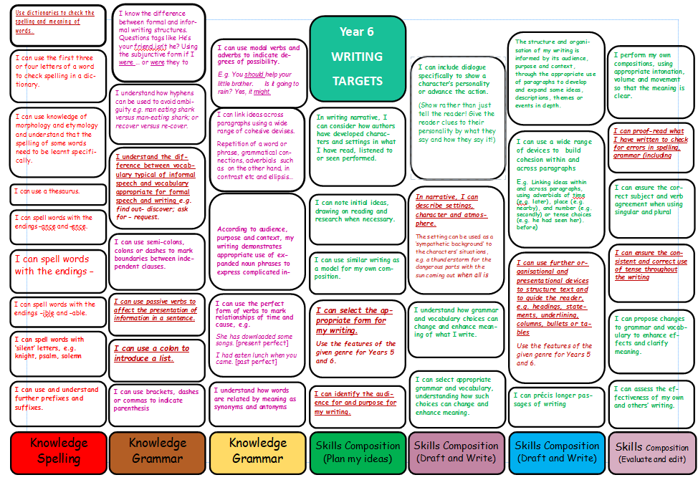
PROGRESSION IN GENRE TEXT TYPES
Progression in Information Texts
 | Research skills  (on page and on screen) | Creating information texts  (on page and on screen)
EYFS | - Track the words in text in the right order, page by page, left to right, top to bottom  - Learn order of alphabet through alphabet books, rhymes and songs | - Distinguish between writing and drawing and write labels for pictures and drawings.  - Attempt writing for various purposes, using features of different forms, e.g. lists, stories and instructions
Y1 | - Pose questions before reading non-fiction to find answers.  - Secure alphabetic letter knowledge and order and use simplified dictionaries.  - Initially with adult help and then independently, choose a suitable book to find the answers by orally predicting what a book might be about from a brief look at both front and back covers, including blurb, title, illustrations. Read and use captions, labels and lists. Begin to locate parts of text that give particular information, e.g. titles, contents page, index, pictures, labelled diagrams, charts, and locate information using page numbers and words by initial letter.  - Record information gleaned from books, (e.g). as lists, a completed chart, extended captions for display, a fact file on IT. | - Convey information and ideas in simple non-narrative forms such as labels for drawings and diagrams, extended captions and simple lists for planning or reminding.  - Independently choose what to write about, orally rehearse, plan and follow it through.
Y2 | - Pose and orally rehearse questions ahead of writing and record these in writing, before reading. Recognise that non-fiction books on similar themes can give different information and present similar information in different ways.  - Use contents pages and alphabetically ordered texts (e.g.) dictionaries, encyclopaedias, indexes, directories, registers. Locate definitions/explanations in dictionaries and glossaries.  - Scan texts to find specific sections (e.g. key words or phrases, subheadings) and skim-read title, contents page, illustration, chapter headings and sub-headings to speculate what a book might be about and evaluate its usefulness for the research in hand.  - Scan a website to find specific sections e.g. key words or phrases, subheadings. Appraise icons, drop down menus and other hyperlinks to speculate what it might lead to and evaluate its usefulness for the research in hand.  - Close read text to gain information, finding the meaning of unknown words by deducing from text, asking someone, or referring to a dictionary or encyclopaedia.  - Make simple notes from non-fiction texts, e.g. key words and phrases, page references, headings, to use in subsequent writing | - Write simple information texts incorporating labelled pictures and diagrams, charts, lists as appropriate.  - Draw on knowledge and experience of texts in deciding and planning what and how to write.  - Maintain consistency in non-narrative, including purpose and tense  - Create an alphabetically ordered dictionary or glossary of special interest words.  - Design and create a simple ICT text
Y3 | - Before researching, orally recall to mind, existing knowledge on the subject and reduce the options for enquiry by posing focused questions. Compose questions to ask of the text.  - Have a secure understanding of the purpose and organisation of the dictionary (i.e. know the quartiles of the dictionary, ‘m’ lies around halfway mark,‘t’ towards the end). Use second place letter to locate and sequence in alphabetical order. Understand the term definition; use dictionaries to learn or check the definitions of words and a thesaurus to find synonyms.  - Begin to use library classification to find reference materials and scan indexes, directories and IT sources to locate information quickly and accurately. Recognise the differences in presentation between texts e.g. between fiction and non-fiction, between books and IT-based sources, between magazines, leaflets and reference texts.  - Within a text, routinely locate information using contents, index, headings, sub-headings, page numbers, bibliographies, hyperlinks, icons and drop down menus. Find and mark the key idea in a section of text.  - Make clear notes by identifying key words, phrases or sentences in reading and making use of simple formats to capture key points, e.g. flow chart, ‘for’ and ‘against’ columns, matrices to complete in writing or on screen. Make a simple record of information from texts read, e.g. by listing words, drawing together notes from more than one source.  - Begin to use graphic organisers as a tool to support collection and organisation of information. | - Recount the same event in a variety of ways, e.g. in the form of a story, a letter, a news report.  - Decide how to present information and make informed choices by using structures from different text types.  - Create alphabetically ordered texts incorporating information from other subjects, own experience or derived from other information books.  - Use computer to bring information texts to published form with appropriate layout, font etc.  - Create multi-media information texts.  - Write ideas, messages in shortened forms such as notes, lists, headlines, telegrams and text messages understanding that some words are more essential to meaning than others.  - Summarise orally in one sentence the content of a passage or text, and the main point it is making.
Y4 | - Prepare for factual research by reviewing what is known, what is needed, what is available and where one might search.  - Routinely use dictionaries and thesaurus and use 3rd and 4th place letters to locate and sequence words in alphabetical order.  - Scan texts in print or on screen to locate key words or phrases, headings, lists, bullet points, captions and key sentences (to appraise their usefulness in supporting the reader to gain information effectively. Collect information from a variety of sources.  - Identify how paragraphs are used to organise and sequence information. Mark and annotate headings, key sentences and words in printed text or on screen.  - Make short notes, e.g. by abbreviating ideas, selecting key words, listing or in diagrammatic form. | - Fill out brief notes into connected prose.  - Present information from a variety of sources in one simple format, e.g. chart, labelled diagram, graph,matrix.  - Begin to use graphic organisers as a tool to support writing up of information  - Develop and refine ideas in writing using planning and problem-solving strategies  - Edit down and reword a sentence or paragraph by deleting the less important elements, e.g. repetitions, asides, secondary considerations and explain the reasons for the editorial choices.
Y5 | - Routinely prepare for factual research by reviewing what is known, what is needed, what is available and where one might search.  - Use dictionaries and other alphabetically ordered texts efficiently.  - Appraise potentially useful texts quickly and effectively. Evaluate texts critically by comparing how different sources treat the same information. Begin to look for signposts that indicate the reliability of a factual source.  - Locate information in a text in print or on screen confidently and efficiently through using contents, indexes, sections, headings +IT equivalent; skimming to gain overall sense of text; scanning to locate specific information; close reading to aid understanding.  - Sift through passages for relevant information and present ideas in note form that are effectively grouped and linked. Use simple abbreviations while note taking. Understand what is meant by ‘in your own words’ and when it is appropriate to copy, quote and adapt. Make notes for different purposes, e.g. noting key points as a record of what has been read, listing cues for a talk. | - Convert personal notes into notes for others to read, paying attention to appropriateness of style, vocabulary and presentation.  - Create plans for information texts drawing on knowledge of text types to decide form and style for different elements.  - Create an information text with a variety of elements, e.g. labelled explanatory diagram, reporting chart, recount.  - create multi-layered texts, including use of hyperlinks, linked web pages  - Record and acknowledge sources in own writing.  - Summarise a passage, chapter or text in a specific number of words.  - Read a passage and retell it “in your own words”
Y6 | - Having pooled information on a topic, construct and follow a plan for researching further information. Routinely appraise a text quickly, deciding on its value, quality or usefulness. Evaluate the status of source material, looking for possible bias and comparing different sources on the same subject. Recognise (when listening or reading) rhetorical devices used to argue, persuade, mislead and sway the reader.  - Evaluate the language, style and effectiveness of examples of non-fiction writing such as periodicals, reviews, reports, leaflets.  - Read examples of official language such as consumer information and legal documents. Identify characteristic features of layout such as use of footnotes, instructions, parentheses, headings, appendices and asterisks. Understand the way standard English varies in different contexts, e.g. why legal language is necessarily highly formalised, why questionnaires must be specific. | - In writing information texts, select the appropriate style and form to suit a specific purpose and audience, drawing on knowledge of different non-fiction text types.  - Establish, balance and maintain viewpoints  - Use the conventions and language of debate when orally rehearsing a balanced argument.  - Revise own non-fiction writing to reduce superfluous words and phrases.  - Discuss and explain differences in the use of formal language and dialogue  - Listen for language variations in formal and informal contexts  - Identify the ways spoken language varies

Progression in Instructional/Procedural Texts
EYFS | Listen to and follow single instructions, and then a series of two and three instructions  Give oral instructions when playing.  Read and follow simple classroom instructions on labels with additional pictures or symbols.  Attempt to write instructions on labels, for instance in role play area
Y1 | Listen to and follow a single more detailed instruction and a longer series of instructions.  Think out and give clear single oral instructions.  Routinely read and follow written classroom labels carrying instructions.  Read and follow short series of instructions in shared context.  Contribute to class composition of instructions with teacher scribing.  Write two or more consecutive instructions independently
Y2 | Listen to and follow a series of more complex instructions.  Give clear oral instructions to members of a group.  Read and follow simple sets of instructions such as recipes, plans, constructions which include diagrams. Analyse some instructional texts and note their function, form and typical language features:  statement of purpose, list of materials or ingredients, sequential steps,  direct/imperative language  use of adjectives and adverbs limited to giving essential information  emotive/value-laden language not generally used  As part of a group with the teacher, compose a set of instructions with additional diagrams. Write simple instructions independently e.g. getting to school, playing a game
Y3 | Read and follow instructions.  Give clear oral instructions to members of a group.  Read and compare examples of instructional text, evaluating their effectiveness. Analyse more complicated instructions and identify organisational devices which make them easier to follow, e.g. lists, numbered, bulleted points, diagrams with arrows, keys.  Research a particular area ( e.g. playground games) and work in small groups to prepare a set of oral instructions. Try out with other children, giving instruction and listening and following theirs. Evaluate effectiveness of instructions.  Write clear written instructions using correct register and devices to aid the reader.
Y4/Y5 | In group work, give clear oral instructions to achieve the completion of a common task. Follow oral instructions of increased complexity.  Evaluate sets of instructions (including attempting to follow some of them) for purpose, organisation and layout, clarity and usefulness.  Identify sets of instructions which are for more complex procedures , or are combined with other text types (e.g. some recipes).Compare these in terms of audience/purpose and form (structure and language features).  Write a set of instructions (using appropriate form and features) and test them out on other people, revise and try them out again.
Y6 | Choose the appropriate form of writing and style to suit a specific purpose and audience drawing on knowledge of different non-fiction text types.  Use the language conventions and grammatical features of the different types of text as appropriate.

Progression in Explanatory Texts
EYSF | Talk about why things happen and how things work; ask questions and speculate.  Listen to someone explain a process and ask questions.  Give oral explanations e.g. their or another’s motives; why and how they made a construction.
Y1 | Read captions, pictures and diagrams on wall displays and in simple books that explain a process. Draw pictures to illustrate a process and use the picture to explain the process orally.
Y2 | After carrying out a practical activity, (e.g.) experiment, investigation, construction task) contribute to creating a flowchart or cyclical diagram to explain the process, as member of group with the teacher. After seeing and hearing an oral explanation of the process, explain the same process orally also using flowchart, language and gestures appropriately.  Read, with help, flowcharts or cyclical diagrams explaining other processes and then read others independently.  Following other practical tasks, produce a simple flowchart or cyclical diagram independently.
Y3 | Create diagrams such as flow charts to summarise or make notes of stages in a process (e.g. in science, D&T or geography), ensuring items are clearly sequenced.  Explain processes orally, using these notes, ensuring relevant details are included and accounts ended effectively.
Y4 | Read and analyse explanatory texts to identify key features. Distinguish between explanatory texts, reports and recounts while recognising that an information book might contain examples of all these forms of text or a combination of these forms  Orally summarise processes carried out in the classroom and on screen in flowcharts or cyclical diagrams as appropriate.  Contribute to the shared writing of an explanation where the teacher acts as scribe and models the use of paragraphs, connectives and the other key language and structural features appropriate to explanatory writing:  - purpose: to explain a process or to answer a question  - structure: introduction, followed by sequential explanation, organised into paragraphs  - language features: usually present tense; use of connectives of time and cause and effect; use of passive voice  - presentation: use of diagrams and other illustrations, paragraphing, connectives, subheadings, numbering  After oral rehearsal, write explanatory texts independently from a flowchart or other diagrammatic plan, using the conventions modelled in shared writing.
Y5 | Read and analyse a range of explanatory texts, investigating and noting features of impersonal style: complex sentences; use of passive voice; technical vocabulary; use of words/phrases to make sequential, causal or logical connections.  Engage in teacher demonstration of how to research and plan a page for a reference book on one aspect of a class topic using shared note-making and writing of the page, using an impersonal style, hypothetical language (if...then, might, when the...) and causal and temporal connections (e.g. while, during, after, because, as a result, due to, only when, so) as appropriate.  In shared writing and independently plan, compose, edit and refine explanatory texts, using reading as a source, focusing on clarity, conciseness and impersonal style.
Y6 | Choose the appropriate form of writing and style to suit a specific purpose and audience drawing on knowledge of different non-fiction text types. Use the language conventions and grammatical features of the different types of text, as appropriate.

 | Progression in Discussion Texts
EYFS | Experience and recognise that others sometimes think, feel and react differently from themselves.  Talk about how they and others might respond differently to the same thing (e.g. like a particular picture or story when someone else doesn’t)  Give oral explanations e.g. their or another’s preferences, e.g. what they like to eat and why.
Y1 | Through talk and role play explore how others might think, feel and react differently from themselves and from each other.  In reading explore how different characters might think, feel and react differently from themselves and from each other.
Y2 | Through reading and in life situations, recognise, that different people (characters) have different thought,/feelings about, views on and responses to particular scenarios (e.g. that the wolf would see the story of the Red Riding Hood differently to the girl herself.)  Explore different views and viewpoints.
Y3 | Through reading explore how different views might be expressed/explained/justified (e.g. the different view of characters in a particular book, the different view of people writing to a newspaper.)  Through role play and drama explore how different views might be expressed/explained/justified (e.g. the different view of characters in a particular book, the different view of people in a simulated ‘real life’ scenario.)
Y4 | In exploring persuasive texts, and those presenting a particular argument (see Progression in Persuasion), begin to recognise which present a single (biased) viewpoint and which try to be more objective and balanced.  Continue to explore the expression of different views through discussion, role play and drama.
Y5 | In exploring persuasive texts, and those presenting a particular argument (see Progression in Persuasion), distinguish and discuss any texts which seems to be trying to present a more balanced or reasoned view, or which explore more than one possible perspective on an issue.  Experiment with the presentation of various views (own and others, biased and balanced) though discussion, debate and drama.
Y6 | Through reading, identify the language , grammar, organisational and stylistic features of balanced written discussions which:  - summarise different sides of an argument  - clarify the strengths and weaknesses of different positions  - signal personal opinion clearly  - draw reasoned conclusions based on available evidence  Recognise and understand the distinction between the persuasive presentation of a particular view and the discursive presentation of a balanced argument.  First explore orally and then write a balanced report of a controversial issue:  - summarising fairly the competing views  - analysing strengths and weaknesses of different positions  - drawing reasoned conclusions where appropriate  - using formal language and presentation as appropriate  Use reading to:  - investigate conditionals, e.g. using if…then, might, could, would, and their persuasive uses, e.g. in deduction, speculation, supposition  - build a bank of useful terms and phrases for persuasive argument, e.g. similarly… whereas…  Overall, help to build the ability to choose the appropriate style and form to suit a specific purpose and audience, drawing on knowledge of different non-fictional text types and adapting, conflating and combining these where appropriate.

Progression in Narrative
 | Listening to and reading a range of stories on page and screen which provoke different responses:  Story structure  Viewpoint: author; narrator  Character & dialogue  Setting | Creating stories orally, on page and screen, that will impact on listeners and readers in a range of ways:  Telling stories  Writing
FS | - Listen to stories being told and read. Know when a story has begun and ended. Recognise simple repeatable story structures and some typical story language, for example, ‘Once upon a time…’  - Be aware that books have authors; someone is telling the story.  - Stories are about characters; identify and describe their appearance referring to names and illustrations; notice when characters are speaking in the story by joining in, e.g. with a repeated phrase.  - Stories happen in a particular place; identify settings by referring to illustrations and descriptions. | - Turn stories into play using puppets, toys, costumes and props; imagine and re-create roles; re-tell narratives using patterns from listening and reading; tell a story about a central character; experiment with story language by using familiar words and phrases from stories in re-telling and play.  - Attempt own writing for various purposes, using features of different forms, including stories.
Y1 | - Identify the beginning, middle and end in stories and use familiarity with this structure to make predictions about story endings; recall the main events.  - Listen with sustained concentration and then talk about how the author created interest or excitement in the story; the ‘voice’ telling the story is called the narrator.  - Recognise main characters and typical characteristics, for example, good and bad characters in traditional tales; identify the goal or motive of the main character and talk about how it moves the plot on; notice how dialogue is presented in text and begin to use different voices for particular characters when reading dialogue aloud.  - Settings can be familiar or unfamiliar and based on real-life or fantasy. Respond by making links with own experience and identify ‘story language’ used to describe imaginary settings. | - Re-tell familiar stories and recount events; include main events in sequence, focusing on who is in the event, where events take place and what happens in each event; use story language, sentence patterns and sequencing words to organise events, (e.g.) then, next etc.; recite stories, supported by story boxes, pictures etc.; act out stories and portray characters and their motives.  - Use patterns and language from familiar stories in own writing; write complete stories with a simple structure: beginning – middle – end, decide where it is set and use ideas from reading for some incidents and events.
Y2 | - Identify the sequence: opening – something happens – events to sort it out – ending; identify temporal connectives and talk about how they are used to signal the passing of time; make deductions about why events take place in a particular order by looking at characters’ actions and their consequences.  - Begin to understand elements of an author’s style, e.g. books about the same character or common themes;  - Understand that we know what characters are like from what they do and say as well as their appearance; make predictions about how they might behave; notice that characters can change during the course of the story; the way that characters speak reflects their personality; the verbs used for dialogue tell us how a character is feeling, e.g. sighed, shouted, joked.  - Settings are created using descriptive words and phrases; particular types of story can have typical settings – use this experience to predict the events of a story based on the setting described in the story opening. | - Re-tell familiar stories using narrative structure and dialogue from the text; include relevant details and sustain the listener’s interest; tell own real and imagined stories; explore characters’ feelings and situations using improvisation; dramatise parts of own or familiar stories and perform to class or group.  - Imitate familiar stories by borrowing and adapting structures; write complete stories with a sustained, logical sequence of events; use past tense and 3rd person consistently; include setting; create characters, e.g. by adapting ideas about typical story characters; include some dialogue; use phrases drawn from story language to add interest, (e.g.) she couldn’t believe her eyes.
Y3 | - Consolidate understanding of sequential story structure: identify common, formal elements in story openings and endings and typical features of particular types of story; notice common themes, similar key incidents and typical phrases or expressions. Note the use of language or music or camera angle to set scenes, build tension, create suspense.  - Recognise that authors make decisions about how the plot will develop and use different techniques to provoke readers’ reactions; notice the difference between 1st and 3rd person accounts; take part in dramatised readings using different voices for the narrator and main characters.  - Identify examples of a character telling the story in the 1st person; make deductions about characters’ feelings, behaviour and relationships based on descriptions and their actions in the story; identify examples of stereotypical characters; make judgements about a character’s actions, demonstrating empathy or offering alternative solutions to a problem; analyse the way that the main character(s) usually talks and look for evidence of the relationship between characters based on dialogue.  - Settings are used to create atmosphere; look at examples of scene changes that move the plot on, relieve or build up the tension. | - Tell stories based on own experience and oral versions of familiar stories; include dialogue to set the scene and present characters; vary voice and intonation to create effects and sustain interest; sequence events clearly and have a definite ending; explore relationships and situations through drama.  - Write complete stories with a full sequence of events in narrative order; include a dilemma or conflict and resolution; write an opening paragraph and further paragraphs for each stage of the story; use either 1st or 3rd person consistently; use conventions for written dialogue and include some dialogue that shows the relationship between two characters.
Y4 | - Develop understanding of story structure: recognise the stages of a story: introduction – build-up - climax or conflict – resolution; appreciate that chronology does not always run smoothly, (e.g.) some events are skimmed over, others are told in more depth.  - Develop awareness that the author sets up dilemmas in the story and devises a solution. Make judgements about the success of the narrative, (e.g.) do you agree with the way that the problem was solved? Understand that the author or director creates characters to provoke a response in the reader, (e.g.) sympathy, dislike; discuss whether the narrator has a distinctive ‘voice’ in the story.  - Identify the use of figurative and expressive language to build a fuller picture of a character; look at the way that key characters respond to a dilemma and make deductions about their motives and feelings – discuss whether their behaviour was predictable or unexpected; explore the relationship between what characters say and what they do – do they always reveal what they are thinking?  - Authors can create entire imaginary worlds; look for evidence of small details that are used to evoke time, place and mood. Look for evidence of the way that characters behave in different settings. | - Plan and tell own versions of stories; tell effectively, e.g. using gestures, repetition, traditional story openings and endings; explore dilemmas using drama techniques, (e.g.) improvise alternative courses of action for a character.  - Plan complete stories by identifying stages in the telling: introduction – build-up – climax or conflict - resolution; use paragraphs to organise and sequence the narrative and for more extended narrative structures; use different ways to introduce or connect paragraphs, ( e.g.) Some time later…, Suddenly…, Inside the castle…; use details to build character descriptions and evoke a response; develop settings using adjectives and figurative language to evoke time, place and mood.
Y5 | - Recognise that story structure can vary in different types of story and that plots can have high and low points; notice that the structure in extended narratives can be repeated with several episodes building up to conflict and resolution before the end of the story. Analyse more complex narrative structures and narratives that do not have a simple linear chronology, (e.g.) parallel narratives, ‘time slip’.  - Authors have particular styles and may have a particular audience in mind; discuss the author’s perspective on events and characters, (e.g.) the consequences of a character’s mistakes – do they get a second chance? ; author’s perspective and narrative viewpoint is not always the same - note who is telling the story, whether the author ever addresses the reader directly; check whether the viewpoint changes at all during the story; explore how the narration relates to events.  - Look for evidence of characters changing during a story and discuss possible reasons, (e.g.) in response to particular experiences or over time, what it shows about the character and whether the change met or challenged the reader’s expectations; recognise that characters may have different perspectives on events in the story; look for evidence of differences in patterns of relationships, customs, attitudes and beliefs by looking at the way characters act and speak and interact in older literature.  - Different types of story can have typical settings. Real-life stories can be based in different times or places, (e.g.) historical fiction – look for evidence of differences that will affect the way that characters behave or the plot unfolds. | - Plan and tell stories to explore narrative viewpoint, ( e.g.) re-tell a familiar story from the point of view of another character; demonstrate awareness of audience by using techniques such as recap, repetition of a catchphrase, humour; use spoken language imaginatively to entertain and engage the listener.  - Develop particular aspects of story writing: experiment with different ways to open the story; add scenes, characters or dialogue to a familiar story; develop characterisation by showing the reader what characters say and do and how they feel and react at different points in the story.  Plan and write complete stories; organise more complex chronological narratives into several paragraph units relating to story structure; adapt for narratives that do not have linear chronology, (e.g.) portray events happening simultaneously (Meanwhile…); extend ways to link paragraphs in cohesive narrative using adverbs and adverbial phrases; adapt writing for a particular audience; aim for consistency in character and style.
Y6 | - Identify story structures typical to particular fiction genres; recognise that narrative structure can be adapted and events revealed in different ways, (e.g.) stories within stories, flashbacks, revelations; analyse the paragraph structure in different types of story and note how links are made; make judgements in response to story endings, (e.g.) whether it was believable, whether dilemmas were resolved satisfactorily.  - Look at elements of an author’s style to identify common elements and then make comparisons between books; consider how style is influenced by the time when they wrote and the intended audience; recognise that the narrator can change and be manipulated, (e.g.) a different character takes over the story-telling, the story has 2 narrators – talk about the effect that this has on the story and the reader’s response.  - Identify stock characters in particular genres and look for evidence of characters that challenge stereotypes and surprise the reader, e.g. in parody; recognise that authors can use dialogue at certain points in a story to, (e.g.) explain plot, show character and relationships, convey mood or create humour.  - Different episodes (in story and on film) can take place in different settings; discuss why and how the scene changes are made and how they effect the characters and events; recognise that authors use language carefully to influence the reader’s view of a place or situation. | - Plan and tell stories to explore different styles of narrative; present engaging narratives for an audience.  - Plan quickly and effectively the plot, characters and structure of own narrative writing; use paragraphs to vary pace and emphasis; vary sentence length to achieve a particular effect; use a variety of techniques to introduce characters and develop characterisation; use dialogue at key points to move the story on or reveal new information.  Create a setting by: using expressive or figurative language; describing how it makes the character feel; adding detail of sights and sounds;  Vary narrative structure when writing complete stories, (e.g.) start with a dramatic event and then provide background information; use two narrators to tell the story from different perspectives; use the paragraph structure of non-linear narratives as a model for own writing; plan and write extended narrative.

Progression in Non-chronological Reports
EYFS | Describe something/someone (possibly after drawing it/them). Develop the description in response to prompts or questions (what does she like to eat? Has she a favourite toy? Ask similar probing questions to elicit a fuller description from someone else.  In a shared reading context read information books and look at/re-read the books independently. Experiment with writing labels, captions and sentences for pictures or drawings in a variety of play, exploratory and role-play situations.
Y1 | Find out about a subject by listening and following text as information books are read, watching a video.  Contribute to a discussion on the subject as information is assembled and the teacher writes the information.  Assemble information on a subject in own experience, (e.g.) food, pets.  Write a simple non-chronological report by writing sentences to describe aspects of the subject.
Y2 | After a practical activity or undertaking some research in books or the web, take part in a discussion in another curriculum subject, generalising from repeated occurrences or observations. Distinguish between a description of a single member of a group and the group in general e.g. a particular dog and dogs in general. Read texts containing information in a simple report format, e.g. There are two sorts of x...; They live in x...; the As have x..., but the B’s etc.  Assemble information on another subject and use the text as a template for writing a report on it, using appropriate language to present, and categorise ideas.
Y3 | Analyse a number of report texts and note their function, form and typical language features:  - introduction indicating an overall classification of what is being described  - use of short statement to introduce each new item  - language (specific and sometimes technical) to describe and differentiate  - impersonal language  - mostly present tense  Teacher demonstrates research and note-taking techniques using information and ICT texts on a subject and using a mind map to organise the information.  Distinguish between generalisations and specific information and between recounts and reports, using content taken from another area of the curriculum.  Analyse broadcast information to identify presentation techniques and notice how the language used signals change.  Teacher demonstrates how to write non-chronological report using notes in a mind map; draws attention to importance of subject verb agreements with generic participants (e.g.) family is…., people are…  Write own report independently based on notes from several sources.
Y4  /  Y5 | Collect information to write a report in which two or more subjects are compared, (e.g.) spiders and beetles; solids, liquids and gases, observing that a grid rather than a spidergram is appropriate for representing the information.  Draw attention to the precision in the use of technical terminology and how many of the nouns are derived from verbs  Teacher demonstrates the writing of a non-chronological report, including the use of organisational devices to aid conciseness such as numbered lists or headings.  Plan, compose, edit and refine short non-chronological comparative report focusing on clarity, conciseness and impersonal style.
Y6 | Secure understanding of the form, language conventions and grammatical features of non-chronological reports. Write reports as part of a presentation on a non-fiction subject. Choose the appropriate style and form of writing to suit a specific purpose and audience, drawing on knowledge of different non-fiction text types.

Progression in Persuasion Texts
EYFS | Talk about how they respond to certain words, stories and pictures by behaving or wanting to behave in particular ways (e.g. pictures of food that make them want to eat things)  Watch and listen when one person is trying to persuade another to do something or go somewhere. Recognising what is happening.  Give oral explanations (e.g.) their or another’s motives; why and how they can persuade or be persuaded.
Y1 | Read captions, pictures, posters and adverts that are trying to persuade. Begin to recognise what they are trying to do and some of the ways they do it.  Through games and role play begin to explore what it means to persuade or be persuaded, and what different methods might be effective.
Y2 | As part of a wide range of reading, explore simple persuasive texts (posters, adverts, etc.) and begin to understand what they are doing and how.  Evaluate simple persuasive devices (e.g.) Say which posters in a shop or TV adverts would make them want to buy something, and why)  Create simple signs posters and adverts (involving words and/or other modes of communication) to persuade others to do, think or buy something.  Continue to explore persuading and being persuaded in a variety of real life situations through role-play and drama.
Y3 | Read and evaluate a wider range of simple persuasive texts, explaining and evaluating responses orally.  Begin to use words, pictures and other communication modes to persuade others when appropriate to particular writing purpose.  Through role play and drama explore particular persuasive scenarios (e.g. a parent persuading a reluctant child to go to bed.) and discuss the effectiveness of different strategies used.
Y4 | Read and analyse a range of persuasive texts to identify key features (e.g. letters to newspapers, discussions of issues in books, such as animal welfare or environmental issues). Distinguish between texts which try to persuade and those that simply inform, whilst recognising that some texts might contain examples of each of these.  Analyse how a particular view can most convincingly be presented, e.g. ordering points to link them together so that one follows from another; how statistics, graphs, images, visual aids, etc. can be used to support or reinforce arguments  From examples of persuasive writing, investigate how style and vocabulary are used to convince the reader.  Evaluate advertisements for their impact, appeal and honesty, focusing in particular on how information about the product is presented: exaggerated claims, tactics for grabbing attention, linguistic devices such as puns, jingles, alliteration, invented words  Both orally and in and writing to assemble and sequence points in order to plan the presentation of a point of view, e.g. on hunting, school rules using more formal language appropriately.  Use writing frames if necessary to back up points of view with illustrations and examples  To present a point of view both orally and in writing,( e.g. in the form of a letter, a report or presentation) linking points persuasively and selecting style and vocabulary appropriate to  the listener/reader; begin to explore how ICT other use of multimodality might support this. (e.g. showing pictures.)  Design an advertisement, such as a poster or radio jingle, on paper or screen, e.g. for a school fête or an imaginary product, making use of linguistic and other features learnt from reading examples  Explore the use of connectives, e.g. adverbs, adverbial phrases, conjunctions,  to structure a persuasive argument, e.g. ‘if…, then’; ‘on the other hand…’; ‘finally’; ‘so’
Y5 | Read and evaluate letters, e.g. from newspapers or magazines, intended to inform, protest, complain, persuade, considering (i) how they are set out, and (ii) how language is used, e.g. to gain attention, respect, manipulate  Read other examples ( e.g. newspaper comment, headlines, adverts, fliers) to compare writing which informs and persuades, considering for example the deliberate use of ambiguity, half-truth, bias; how opinion can be disguised to seem like fact  Select and evaluate a range of texts, in print and other media, on paper and on screen, for persuasiveness, clarity, quality of information  From reading, to collect and investigate use of persuasive devices such as words and phrases, e.g. ‘surely’, ‘it wouldn’t be very difficult…’; persuasive definitions, e.g. ‘no one but a complete idiot…’, ‘every right-thinking person would…’, ‘the real truth is…’; rhetorical questions, e.g. ‘are we expected to…?’, ‘where will future audiences come from…?’; pandering, condescension, concession, e.g. ‘Naturally, it takes time for local residents…’; deliberate ambiguities, e.g. ‘probably the best…in the world’ ‘known to cure all…’, ‘the professional’s choice’  Draft and write individual, group or class persuasive letters for real purposes, e.g. put a point of view, comment on an emotive issue, protest; to edit and present to finished state  Write a commentary on an issue on paper or screen (e.g. as a news editorial or leaflet), setting out and justifying a personal view; to use structures from reading to set out and link points, e.g. numbered lists, bullet points  Construct an argument in note form or full text to persuade others of a point of view and: present the case to the class or a group; use standard English appropriately; evaluate its effectiveness. Explore how ICT or other use of multimodality might support this. (e.g. develop a PowerPoint presentation.)  Understand how persuasive writing can be adapted for different audiences and purposes, e.g. by using formal language where appropriate, and how it can be incorporated into or combined with other text types.
Y6 | Through reading and analysis, recognise how persuasive arguments are constructed to be effective through, for example:  - the expression, sequence and linking of points  - providing persuasive examples, illustration and evidence  - pre-empting or answering potential objections  - appealing to the known views and feelings of the audience  Orally and in writing, construct effective persuasive arguments:  - using persuasive language techniques to deliberately influence the listener.  - developing a point logically and effectively  - supporting and illustrating points persuasively (using ICT and multi-modality where and when appropriate)  - anticipating possible objections  - harnessing the known views, interests and feelings of the audience  - tailoring the writing to formal presentation where appropriate  Use reading to:  - investigate conditionals, e.g. using if…then, might, could, would, and their persuasive uses, e.g. in deduction, speculation, supposition  - build a bank of useful terms and phrases for persuasive argument, e.g. similarly… whereas…  Overall, participate in whole class debates using the conventions and language of debate including standard English. In oral and written texts help to build the ability to choose the appropriate style and form to suit a specific purpose and audience, drawing on knowledge of different non-fictional text types and adapting, conflating and combining these where appropriate.

Progression in Recount Texts
This progression should be considered in relation to progression in narrative as the study of non-fiction and fiction recounts complement each other.
EYFS | Informally recount incidents in own life to other children or adults and listen to others doing the same. Experiment with writing in a variety of play, exploratory and role-play situations.  Write sentences to match pictures or sequences of pictures illustrating an event.  Use experience of simple recounts as a basis for shared composition with an adult such as retelling, substituting or extending, leading to simple independent writing.
Y1/Y2 | Describe incidents from own experience in an audible voice using sequencing words and phrases such as ‘then’, ‘after that’; listen to other’s recounts and ask relevant questions.  Read personal recounts and begin to recognise generic structure, e.g. ordered sequence of events, use of words like first, next, after, when.  Write simple first person recounts linked to topics of interest/study or to personal experience, using the language of texts read as models for own writing, maintaining consistency in tense and person.
Y3/Y4 | Watch or listen to third person recounts such as news or sports reports on television, radio or podcast . Identify the sequence of main events. Read examples of third person recounts such as letters, newspaper reports and diaries and recount the same event in a variety of ways, such as in the form of a story, a letter, a news report ensuring agreement in the use of pronouns.  Write newspaper style reports, e.g. about school events or an incident from a story, using a wider range of connectives, such as meanwhile, following, afterwards and including detail expressed in ways which will engage the reader Girls with swirling hijabs danced to the ….  Include recounts when creating paper or screen based information texts.
Y5 | Identify the features of recounted texts such as sports reports, diaries, police reports, including introduction to set the scene, chronological sequence, varied but consistent use of past tense, e.g. ‘As he was running away he noticed . . . ‘, possible supporting illustrations, degree of formality adopted and use of connectives.  Use the language features of recounts including formal language when recounting events orally.  Write recounts based on the same subject such as a field trip, a match or a historical event for two contrasting audiences such as a close friend and an unknown reader.
Y6 | Distinguish between biography and autobiography, recognising the effect on the reader of the choice between first and third person, distinguishing between fact, opinion and fiction, distinguishing between implicit and explicit points of view and how these can differ.  Develop the skills of biographical and autobiographical writing in role, adapting distinctive voices, e.g. of historical characters, through preparing a CV; composing a biographical account based on research or describing a person from different perspectives, e.g. police description, school report, newspaper obituary. When planning writing, select the appropriate style and form to suit a specific purpose and audience, drawing on knowledge of different non-fiction text types. Use the language conventions and grammatical features of the different types of text as appropriate.
Progression in Poetry
Year | Reading Poetry:-  - subject matter and theme;  - language use; style  - pattern | Performing Poetry:-  - use of voice;  - presentation | Creating Poetry: -  - original playfulness with language and ideas;  - detailed recreation of closely observed experience;  - using different patterns
EYFS | - listen to poems being read and talk about likes and dislikes – including ideas or puzzles, words, and patterns | - join in with class rhymes and poems,  - copy actions | - enjoy making up funny sentences and playing with words;  - look carefully at experiences and choose words to describe;  - make word collections or use simple repeating patterns
Year 1 | - discuss own response and what the poem is about;  - talk about favourite words or parts of a poem;  - notice the poem’s pattern | - perform in unison, following the rhythm and keeping time  - imitate and invent actions | - invent impossible ideas, e.g. magical wishes;  - observe details of first hand experiences using the senses and describe;  - list words and phrases or use a repeating pattern or line.
Year 2 | - talk about own views, the subject matter and possible meanings;  - comment on which words have most effect, noticing alliteration;  - discuss simple poetry patterns | - perform individually or together; speak clearly and audibly.  - use actions and sound effects to add to the poem’s meaning | - experiment with alliteration to create humorous and surprising combinations;  - make adventurous word choices to describe closely observed experiences;  - create a pattern or shape on the page; use simple repeating phrases or lines as models
Year 3 | - describe the effect a poem has and suggest possible interpretations;  - discuss the choice of words and their impact, noticing how the poet creates ‘sound effects’ by using alliteration, rhythm or rhyme and creates pictures using similes;  - explain the pattern of different simple forms | - perform individually or chorally; vary volume, experimenting with expression and use pauses for effect  - use actions, voices, sound effects and musical patterns to add to a performance | - invent new similes and experiment with word play;  - use powerful nouns, adjectives and verbs; experiment with alliteration;  - write free verse; borrow or create a repeating pattern

Year 4 | - describe poem’s impact and explain own interpretation by referring to the poem;  - comment on the use of similes and expressive language to create images, sound effects and atmosphere;  - discuss the poem’s form and suggest the effect on the reader | - vary volume, pace and use appropriate expression when performing  - use actions, sound effects, musical patterns and images to enhance a poem’s meaning | - use language playfully to exaggerate or pretend;  - use similes to build images and identify clichés in own writing;  - write free verse; use a repeating pattern; experiment with simple forms
Year 5 | - discuss poet’s possible viewpoint, explain and justify own response and interpretation;  - explain the use of unusual or surprising language choices and effects, such as onomatopoeia and metaphor; comment on how this influences meaning;  - explore imagery including metaphor and personification;  - compare different forms and describe impact | - vary pitch, pace, volume, expression and use pauses to create impact;  - use actions, sound effects, musical patterns, images and dramatic interpretation | - invent nonsense words and situations and experiment with unexpected word combinations;  - use carefully observed details and apt images to bring subject matter alive; avoid cliché in own writing;  - write free verse; use or invent repeating patterns; attempt different forms, including rhyme for humour
Year 6 | - interpret poems, explaining how the poet creates shades of meaning; justify own views and explain underlying themes  - explain the impact of figurative and expressive language, including metaphor;  - comment on poems’ structures and how these influence meaning | - vary pitch, pace volume, rhythm and expression in relation to the poem’s meaning and form  - use actions, sound effects, musical patterns, images and dramatic interpretation, varying presentations by using ICT | - use language imaginatively to create surreal, surprising, amusing and inventive poetry;  - use simple metaphors and personification to create poems based on real or imagined experience;  - select pattern or form to match meaning and own voice

Read Write Inc, Speed sounds
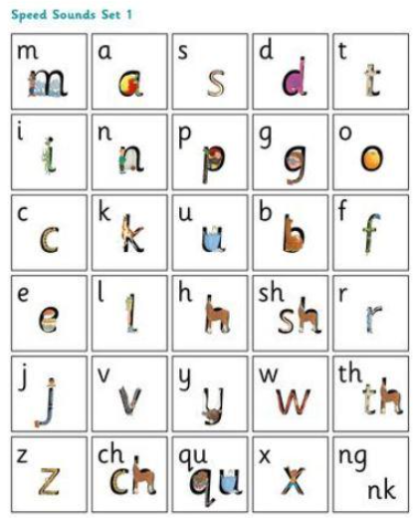 | 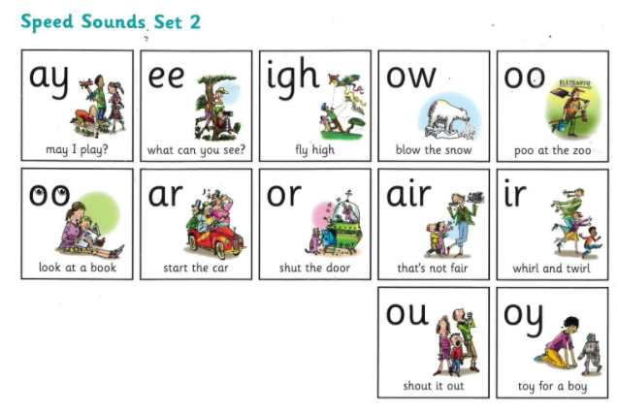 | 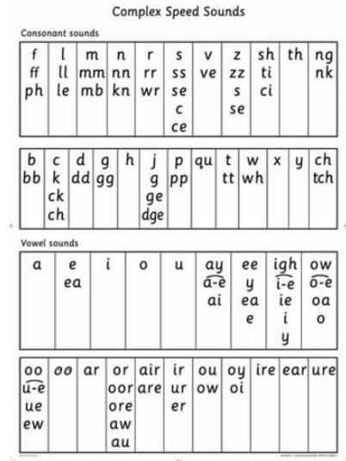

Using Higher Level Vocabulary: Fiction Writing
confident
certain
optimistic
in no doubt
convinced
positive
sanguine

nervous
anxious
apprehensive
worried
tense
uneasy
jittery

big
massive
gigantic
almighty
gargantuan
humongous
enormous

brave
valiant
plucky
bold
fearless
courageous
audacious

quiet
peaceful
tranquil
still
silent
noiseless
calm

busy
lively
crowded
hectic
teeming
swarming
bustling

afraid
frightened
terrified
petrified
terror-stricken
scared witless
panic-stricken

angry
furious
livid
outraged
annoyed
incensed
fuming

ugly
repulsive
grotesque
repugnant
revolting
hideous
vile

beautiful
attractive
handsome
gorgeous
stunning
exquisite
winsome

scary
eerie
spine-chilling
unnerving
sinister
frightening
creepy

grand
stately
impressive
magnificent
regal
splendid
majestic

sad
miserable
dejected
crestfallen
depressed
despondent
heartbroken

happy
ecstatic
euphoric
thrilled
elated
delighted
overjoyed

horrible
unpleasant
nasty
obnoxious
insufferable
disagreeable
loathsome

nice
pleasant
likable
charming
delightful
amiable
good natured

unattractive
ugly
unappealing
unsightly
hideous
disgusting
horrible

attractive
breathtaking
magnificent
awe-inspiring
glorious
spectacular
beautiful

To describe feelings
To describe characters
To describe settings

