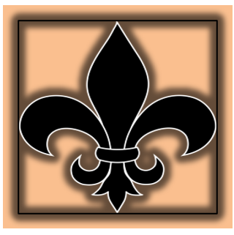St Mary’s Texts for Teaching Reading
 | EYFS | Year 1 | Year2 | Year 3 | Year 4 | Year 5 | Year 6
Autumn Term 1
Title |  |  | Fantastic Mr Fox By Roald Dah  l 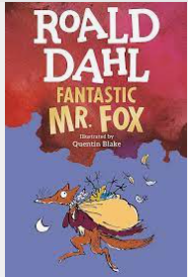 | 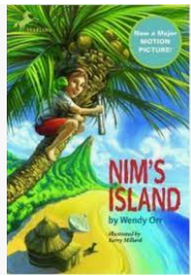  Nim’s Island by Wendy Orr | 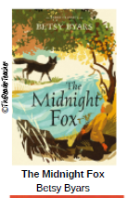 | The Lion the Witch and the Wardrobe by C.S. Lewis  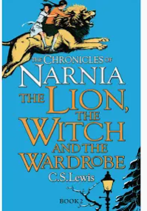 | 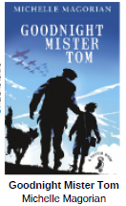
About the Book |  |  | three farmers trying to catch and kill Mr. Fox after they tire of him stealing food from them to feed his family. Mr. Fox outsmarts the farmers and in the end feeds all the animals while the farmers incisively and unsuccessfully wait to catch the fox. | Life is an adventure for a courageous youngster named Nim, who lives on an exotic island with her marine-biologist father. and a menagerie of animal friends. When Nim's father goes missing, she turns to the only person she knows who can help her: adventurer Alex Rover. But what she doesn't know is that Alex Rover is really Alexandra a timid recluse. Though faint of heart, Alexandra must find the courage within herself to come to Nim's aid. | Tom, a town boy, is horrified when his parents tell him he has to stay on Aunt Millie's farm while they are away. He finds country life every bit as strange and uncomfortable as he feared. But soon, he discovers a rare black fox with green eyes, living with her cubs in the forest. | Aslan takes the girls to the Witch's castle and revives the Narnians that the Witch had turned to stone. They join the Narnian forces battling the Witch's army. The Narnian army prevails, and Aslan kills the Witch. The Pevensie children are then crowned kings and queens of Narnia at Cair Paravel. | Set in WW2 William is evacuated from London and ends up with Tom, a lonely old man. They change each others life. Several tragedies occur throughout the book, include the abuse that William suffers in his mothers hands, Tom rescues William in many ways..
Genre |  |  | Fable | Humour fiction | Non linear fiction | Class literature Portal Fantasy | Class fiction Historical novel
themes |  |  | Fantastic Mr. Fox is a story about triumphing over cruel and selfish forces. The novel explores the importance of family and friends as well as the power of intelligence in overcoming strength. | courage is a choice we make and that you can be the hero of your own life story. | what it means to be human and relationships between humans and wildlife. | good vs. evil, betrayal and forgiveness, courage, making the right choices  transformation, the natural world, and magic | One of the most important themes, in life and in the novel, is friendship, especially the relationship between Mr. Tom and Willie. The two characters are bonded by the shared experience of loss and loneliness, which unites them.
Poetry |  |  | Class poet focus | Class poet focus | Class poet focus | Class Poet focus | Flander fields Class poet
Non -fiction |  |  |  |  |  | The body -hands digestion | Newspaper reports WW1
For pleasure |  |  | Roald Dahl Poetry | Charlotte’s Web | Peter pan abridge version | Benjamin Zephania Windrush child | Wonder by J.L Palacio
PSHE |  |  | The great big book of families By Mary Hofflman | Oliver by Brigitta Sif | Red: A crayons Story by Michael Hall | Where the Poppies now grow by Hilary Robinson | The Princess Boy by Cherly Kilodavis
Autumn term 2 |  |  | Year2 | Year 3 | Year 4 | Year 5 | Year 6
Title |  |  | 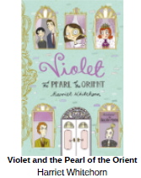 | 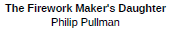  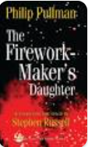 | 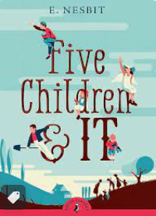 | 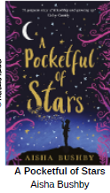 | 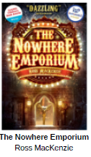
About the Book |  |  | When a new family move in next door, Violet is sure there's something strange about them. Then her eccentric, but lovely neighbour, Dee Dee Derota, has a precious jewel stolen. Could the new family be to blame? Violet is on the case to uncover the truth… | A young girl called Lila wants to become a firework-maker, like her father Lalchand. Despite her talents, Lalchand believes this is an unsuitable job for girls. Lila disagrees, and journeys to get Royal Sulphur from Razvani the Fire-Fiend at Mount Merapi, as all aspirant firework-makers must do. | When five siblings - Cyril, Anthea, Robert, Jane and their baby brother, the Lamb - discover a sand-fairy in their gravel pit, they are jolly surprised and a little delighted. Even better, the Psammead is able to grant them wishes, although the magic wears off at the day's end. | Thirteen-year-old Safiya is an avid gamer with a big imagination, who feels both misunderstood and distanced from her mum since her parents split up. | What happened in the Nowhere Emporium?  Daniel ends up in the Nowhere Emporium which can travel through time and place and takes control of a 'Book of Wonders' where he is able to magically effect the happenings within.
Genre |  |  | Mystery | Non-linear adventure fiction | Archaic Text classic | Fantasy fiction DIVERSITY | Fantasy fiction
themes |  |  | Friendship self belief even when underestimated | the importance of perseverance, as well as talent and luck, when following your dreams. | Wishing wisely avarice | family, friendship and finding out who you are, full of emotion and a secret fantasy world to discover. race and the treatment of Aboriginal peoples | Bullying, Life and Death, Creativity and Imagination, friendship, Love and Courage
Poetry |  |  | Class poet focus | Class poet focus | Class poet focus | Class Poet focus | Flander fields Class poet
Non -fiction
For pleasure |  |  | Book with no picture by BJ Novack | Topsy Turvey World by W.B Rands | The Velveteen Rabbit by Margery Williams | A Christmas Carol by Charles Dickens Abridge version Michael Morpurgo | War Horse Michael Morpurgo
PSHE |  |  | The first Slodge by Jeanne Willis | This is our house by Michael Rosen | Dogs don’t do Ballet by Anna Kemp | Rose Blanche by Ian McEwan | The Whisperer by Nick Butterworth
Spring term 1 |  |  | Year2 | Year 3 | Year 4 | Year 5 | Year 6
Title |  |  | 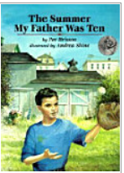 | 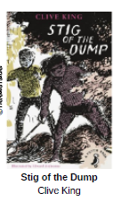 | 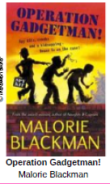 | 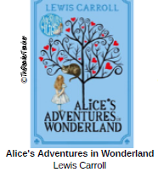  Focus Jabberwocky | 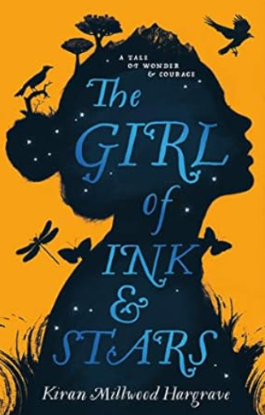
About the Book |  |  | That was the summer the boy lost a baseball under a tomato plant in Mr. Bellavista's garden. And someone tossed a tomato back instead of the baseball. A lively battle took place, which seemed like great fun at the time, but in the end Mr. Bellavista's garden had been destroyed. In a touching story of one boy's efforts to make amends, we see the rebuilding of a garden and the forming of a relationship across generations. | Nobody believes Barney when he says he's discovered a boy living wild in the dump. But for Barney, Stif is totally real. They become great friends, learn each other's ways and embark on a series of exciting adventures. | Beans calls her dad 'Gadgetman' because of the weird and wonderful gadgets he comes up with - everything from exploding biscuits to Spy Kits. But when Gadgetman accidentally invents a device that could be used to steal millions of pounds, the wrong people find out and Gadgetman is kidnapped! | Alice goes down a rabbit hole to find the mysterious underground Wonderland. She encounters fabulous creatures that defy all reasonable expectations. After numerous incoherent adventures involving a Hatter, a Hare and the Queen of Hearts, she wakes up in time for tea. | Forbidden to leave her island, Isabella dreams of the faraway lands her cartographer father once mapped.  When her friend disappears, she volunteers to guide the search. The world beyond the walls is a monster-filled wasteland – and beneath the dry rivers and smoking mountains, a fire demon is stirring from its sleep.  Soon, following her map, her heart and an ancient myth, Isabella discovers the true end of her journey: to save the island itself.
Genre |  |  | Non-linear | Classic fiction | Spy-fiction | Classic fiction literary nonsense genre | Mystery DIVERSITY
themes |  |  | Personal responsibility  how to handle a mistake | unusual friendships, loyalty, bravery. | Diversity friendship resilience | Communication Breakdown. From the beginning of her stay in Wonderland, Alice finds she has trouble communicating with the creatures she meets. Growing Up (and Down) ...  Identity. Rules versus Good Behaviour. Self-Reliance. Victorian Society. | kindness, bravery, friendship and loyalty, choice making
Poetry |  |  | Class poet focus | Class poet focus | Class poet focus | The Jabberwocky by Lewis Carroll | Class poet The Highway man
Non -fiction
For pleasure |  |  | Where the Wild things are by Morris Sendak | The Mysteries of Harris Burdick by Chris Van Allsburg | The Legend of Captain Crows Teeth by Eion Culfer | Journey to the centre of the Earth By Jules Verne | Mutating Mansion by Luke Temple
PSHE |  |  | The odd egg by Emily Gravett | Two Monsters by David McKee | King and King by Linda De Hann | How to heal a broken wing by Bob Graham | The Island by Armin Greder
Spring term 2 |  |  | Year2 | Maurice SendakYear 3 | Year 4 | Year 5 | Year 6
Title |  |  | 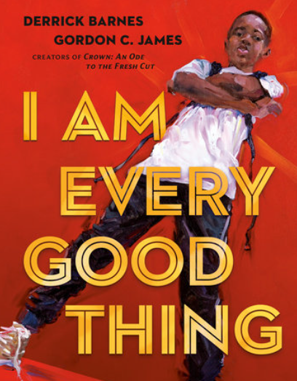 | 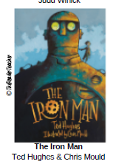 | 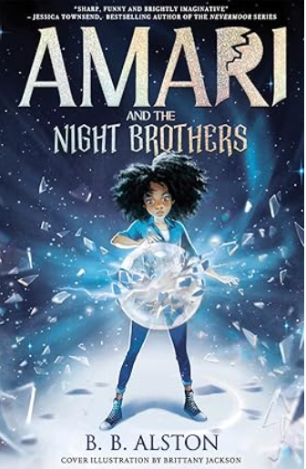  B.B Alston | 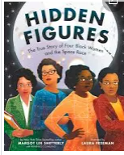  Margot-Lee Shetterly | 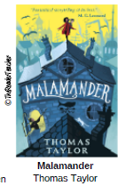
About the Book |  |  | What is the theme of I am every good thing. encourages readers to celebrate everything that makes them the person they are. Kids learn they can be a leader, an explorer, the life of the party, and an undisputed champion.30 Aug 2020 | The Iron Man tells the story of a gigantic metal robot who appears out of nowhere, crashing onto the beach and shattering into many parts. He is discovered by Hogarth, a young boy. The Iron Man proceeds to devour farm machinery, until the farmers rise up against him. | Twelve-year-old Amari is super worried about her missing older brother, Quinton. On top of that, she loses her school scholarship that covers a tuition her mom can't afford to pay. But then she receives a mysterious package—sent from Quinton himself—that invites her to spend the summer at … a magical training camp! | Hidden Figures is set between the 1930s and 1960s, and describes the barriers for Black women in science at that time. This book contains biographical information about four influential mathematicians and engineers, all of whom contributed to the space race while working for NASA. Margot Lee Shetterly's father worked as a research scientist for NASA at the same time, and he knew many of the book's characters. | The story is of two parentless children and their quest for the Malamander's magical egg, which is only laid on a particular winter's night once a year and is then devoured by the monster after the non-appearance of its mate.
Genre |  |  | Modern fiction  DIVERSITY | Complexity of plot science fiction/fairytale | Children’s classic fiction DIVERSITY | Biographical historical  DIVERSITY | Fantasy fiction
themes |  |  | Overcoming challenges  Letting nothing stop you | Bravery, prejudice, irrational fear, inclusion, teaching children not to fear people who are different to themselves, but to learn to understand and accept them. It is also critical of warfare and violence, showing how intelligence can succeed where weaponry fails. | The book's most powerful theme is prejudice, particularly racial prejudice. Amari is a black girl from the projects and everywhere she goes she faces prejudice. In the known world she is bullied, | Braverly, trend busting, racial segregation and courage | Loss, Family and belonging, friendship, trying to find identity
Poetry |  |  | Class poet focus | Class poet focus | Class poet focus | Class Poet focus | Class poet
Non -fiction
For pleasure |  |  | The Three little wolves and the big bad pig by Eugene Trivizas | The tunnel by Anthony Brown | Something told the wild geese by Rachel Field | Cosmic by Frank Cottrell Boyce | The call of the wild by Jack London
PSHE |  |  | Just because by Rebecca Elliot | The Hueys in a New Jumper by Oliver Jeffers | The way back home by Oliver Jeffers | The Artist Who Painted a Blue Horse by Eric Carle | Love you forever by Robert Munsch
Summer 1 |  |  | Year2 | Year 3 | Year 4 | Year 5 | Year 6
Title |  |  | 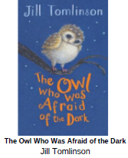 | 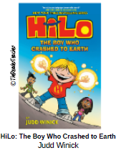 | 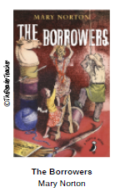 | 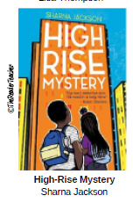 | Journey to Jo’burg  by Beverley Naidoo  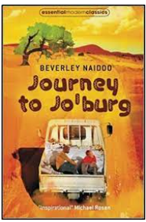
About the Book |  |  | Plop the Baby Barn Owl is afraid of the dark. He is so scared he won't even go hunting with his family. So Mrs Barn Owl sends him down from his nest-hole, where he will meet a series of friends who will convince him that perhaps there is a little bit of magic in the dark after all. | A boy crash lands to earth with no memory of who he is or why he is here. Can his new friends help him to regain his memory before it is too late? | The Borrowers are tiny people who live in the secret places of old houses - behind the mantlepiece, inside the harpsichord, under the kitchen clock. They borrow everything from humans, existing on the scraps they collect from the homes they live in. | Summer in London is hot, the hottest on record, and there's been a murder in THE TRI: the high-rise home to resident know-it-alls, Nik and Norva. Who better to solve the case? Armed with curiosity, home-turf knowledge and unlimited time - until the end of the summer holidays anyway. The first whodunnit in a new mystery series by Sharna Jackson. | What happens in Journey to Jo Burg?  When their baby sister becomes dangerously ill, thirteen-year-old Naledi and her younger brother journey to Johannesburg, South Africa where their mother works as a maid for a white family. Written from an African point of view, this novel describes the conditions many African children face in South Africa.
Genre |  |  | fiction | Non-Linea text | Fantasy fiction | Mystery DIVERSITY | Cultural/Historical Fiction DIVERSITY
themes |  |  | learning to overcome fears | His friendship with Hilo and Gina is touching and profound; when he starts to see himself through their eyes, he realises that he is anything but ordinary to them. The theme of friendship runs throughout the book | The Importance of Family in the Struggle for Survival  Prejudice  The solidarity of the family, relying on but each other | Empathy and Kindness  Family Feelings  The Urban Environment | Their journey illustrates at every turn the grim realities of apartheid – the pass laws, bantustans, racism, the breakdown of family life.
Poetry |  |  | Class poet focus | Class poet focus | Class poet focus | Class Poet focus | Class poet
Non -fiction
For pleasure |  |  | The Cat in the Hat Dr Seuss | The world according to Humphrey by Betty G Bimley | Ducks Ditty by Kenneth Graham poem | Skellig by David Almond | The Pobble Who Had No Toes (poem) Edward Lear  Sky in the Pie (poem) Roger McGough
PSHE |  |  | Blown Away by Rob Biddulph | Beguu by Alexis Deacon | The Flower by John Light | And Tango Makes Three by Justin Richardson | Dreams of Freedom by Amnesty International
Summer 2 |  |  | Year2 | Year 3 | Year 4 | Year 5 | Year 6
Title |  |  | 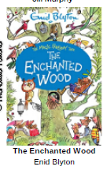 | 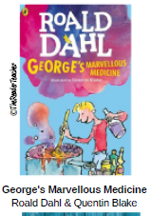 | 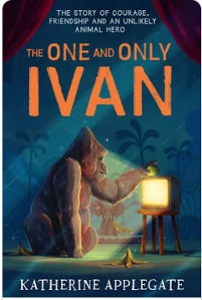 | 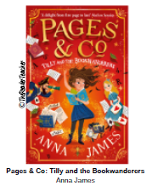 | 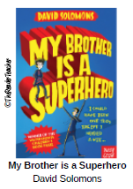
About the Book |  |  | When Joe, Beth and Frannie move to a new home, an Enchanted Wood is on their doorstep. And when they discover the Faraway Tree, that is the beginning of many magical adventures! They meet some new friends Moonface, Saucepan Man and Silky the fairy as they discover which new land is at the top of the Faraway Tree. | The story is about a 8 year old George Kranky who lives on a farm with his mom, dad and his maternal grandma. George's grandmother bosses him around and bullies him. He is supposed to give her medicine at eleven o'clock. So he decided to make a magic medicine to replace his grandma's normal medicine. | Based on a true story, but told in Ivan's own voice using simple language and short chapters, this is a story about friendship, compassion for animals, the promises we make, and the things we will do to help someone in need. | A charming and exciting adventure about a bookish young heroine, a mysterious librarian, and a magical bookshop that will delight book lovers everywhere. The book wandering adventure features Tilly Pages as she journeys to France to wander inside a peculiar book of fairytales. | Luke Parker was just your average eleven year-old comic book aficionado until the fateful day when his boring, do-gooding, help-sold-ladies-across-the-street brother Zack got turned into a superhero. Luke can't believe the unfairness of it all-
Genre |  |  | Fantasy fiction | Fantasy fiction | Biographical fiction | Fantasy fiction | speculative fiction
themes |  |  | Friendship, bravery, adventure | Revenge moral of being kind, reap what you sew | Helping, justice, doing the right thing helping out someone in need friendship | Love of books, power of reading, imagination, family, friendship, and bravery. | handling the combined frustrations and affections of sibling relationships with sensitivity.
Poetry |  |  | Class poet focus | Class poet focus | Class poet focus | Class Poet focus | Flander fields Class poet
Non -fiction
For pleasure |  |  | Peter Rabbitt Beatrix Potter | The butterfly Lion by Michael Morpurgo | The Witches by Roald Dahl | Black Beauty abdrige by Anna Sewell | A long walk to the water by Linda Sue Parkes.
PSHE

Cultural Fiction is any creative work, chiefly any narrative work, portraying individuals, events, or places that are imaginary or in ways that are imaginary. Fictional portrayals are thus inconsistent with history, fact, or plausibility | Portal fantasy  It's definition is simple: it's a story that involves characters travelling through a “portal” (wardrobe/train platform/tornado/etc.) from our real world into some magical, fantasy realm. | speculative fiction  Superhero fiction is one of the most popular sub-genres of speculative fiction, and is made up of two categories of costumed crime fighters: superheroes with super-human powers and those characters without the powers. Superheroes rely on skill, cunning and training.

