
Catholic Social Teaching at St Mary’s Catholic Primary School
Rooted in Love
Catholic Social Teaching calls us all as Catholics to work for the common good, help build a just society, uphold the dignity of human life and work for justice and the dignity of all our brothers and sisters, especially those in the greatest need.
The school follows the Rooted in Love programme from Caritas to help children in their understanding and their journey with Catholic Social Teaching.
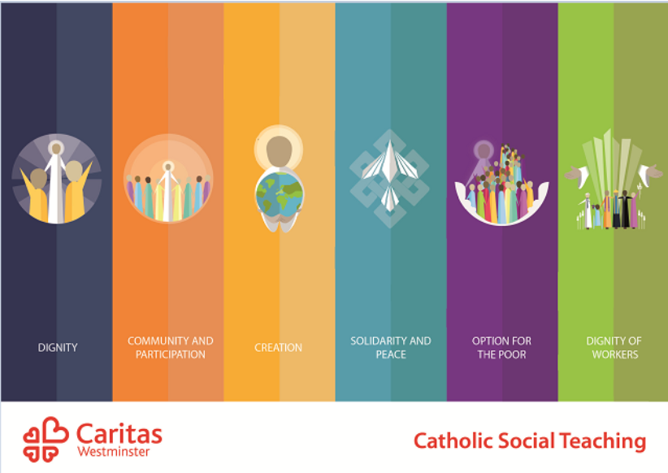

Rooted in Love is a Religious Education resource for primary schools, developed in partnership with the Diocese of Westminster Education Service. It addresses the objectives relating to Catholic Social teaching from the new Religious Education Directory, including prayer and liturgy ideas relating to the themes as well as suggestions for bringing this work to life in the Catholic life and mission of the school.
Each half-term the children from Early Years to year 6 learn about a different Catholic Social Teaching theme.
Half Term | Catholic Social Teaching Theme | Key Message
Autumn 1 | Care of Creation   | We believe in caring for our world.
Autumn 2 | Preferential Option for the Poor   | We believe in putting people in most need first.
Spring 1 | Solidarity and Peace   | We believe in showing we care and we believe in being peacemakers.
Spring 2 | Community and Participation   | We believe in taking part.
Summer 1 | Dignity of Workers   | We believe the rights of workers must be respected.
Summer 2 | Dignity   | We believe every person is special and created in God’s image.
This symbol is used to represent Love rooted in the word of God

This symbol will help the children to understand that every time they see this they will come back to the principles of CST and remember why we do what we do.
We are called to uphold the principles of Catholic Social Teaching.

Human Dignity – Everyone is Special
St Paul tells us that each person is a work of art, created by God and chosen for a unique purpose. Ephesians 2:10
At St Mary’s we recognise the human dignity of others by:
- living out our mission statement, ‘Love one another’
- fostering strong relationships
- showing forgiveness
- being kind and respectful
- treating people equally
- celebrating uniqueness. Everyone is important
- teaching British Values

The Common Good – Taking Part in our Communities
"You are not making a gift of your possessions to the poor person. You are handing over to them what is theirs." St Ambrose (340-397 AD)
At St Mary’s we show we are part of a community by:
- working together
- working for the common good
- participating and engaging
- being active members of our community
- engaging with our parish community by holding events such as our Advent afternoon tea
- raising money for and teaching about the work of CAFOD
- individual acts of kindness for those in need, eg providing coats, shoes, uniform or other home needs

Subsidiarity– All people should have a say
Blessed are they who maintain justice, who constantly do what is right- Psalm 106:3
Fear not for I am with you. I am your God. I will strengthen you. I will help you. I will uphold you with my righteous right hand. Isaiah 41:10
At St Mary’s we acknowledge our rights and responsibilities by:
- recognising our duties as members of a community
- standing up for what is right
- following our school rules

Distributive Justice – Being Fair
...we are agreed today that the earth is essentially a shared inheritance, whose fruits are meant to benefit everyone.’ Pope Francis, Laudato Si’
At St Mary’s we recognise the need to share the worlds resources fairly by:
- celebrating Fair Trade Fortnight
- by sharing our belongings

Stewardship – Caring for God’s Creation and Gifts
The ecological crisis is also a summons to profound interior conversion…Living our vocation to be protectors of God’s handiwork is essential to a life of virtue; it is not an optional or a secondary aspect of our Christian experience. Pope Francis - Laudato Si
At St Mary’s we show we care for creation by:
- taking responsibility for our environment
- making environmentally responsible choices
- having awe and wonder for the natural world

Solidarity – We are One Big Family
Blessed Pope Paul VI taught that "If you want peace, work for justice". The Gospel calls us to be peacemakers.
At St Mary’s we show solidarity by:
- raising awareness of social justice
- writing to our local leaders
- praying for others
- making connections
- making socially responsible choices

Promoting Peace – We can be God’s instruments of Peace
“Our common bonds of humanity demand that we live in harmony and that we promote what is good for one another. These ethical implications are the reason why solidarity is a basic key to peace.” St John Paul II
At St Mary’s we show we are people of peace by:
- creating a calm and welcoming environment
- treating each other kindly
- turning away from conflict
- rewarding good choices
- core rules and values modelled by all staff

Option for the poor – Some People need Extra Help
‘For I was hungry and you gave me something to eat, I was thirsty and you gave me something to drink, I was a stranger and you invited me in, I needed clothes and you clothed me, I was sick and you looked after me, I was in prison and you came to visit me.’ Matthew 25:35-40
At St Mary’s we show a preferential option for the poor and vulnerable by:
- fundraising for charitable causes, eg CAFOD, Mary’s Meals, Harvest food bank collection
- treating others with dignity and respect
- thinking of the needs of others. Supporting more vulnerable families, eg uniform donations, winter coats, book exchange, payment for trips, breakfast club support, free after-school clubs

Participation – The dignity of Work
Do the hard work of getting along with each other, treating each other with dignity and honour. (James 3:17)
And he said to him, “You shall love the Lord your God with all your heart and with all your soul and with all your mind. This is the great and first commandment. And a second is like it: You shall love your neighbour as yourself. On these two commandments depend all the Law and the Prophets.” Matthew 22:37-40
At St Mary’s we recognise the dignity of work by:
- respecting all workers
- contributing to society
- making responsible economic choices
- supporting wellbeing and workers' rights
- sharing our talents with others

