St Mary’s Catholic Primary School

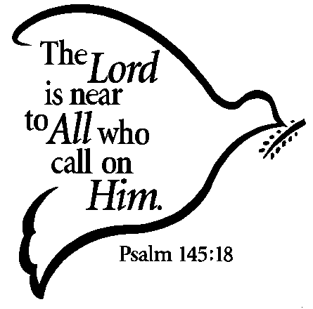

School Prayer Book
Year 6

What is prayer?
We pray when we talk and listen to God.
There are many different prayers we can use.
We can pray privately on our own or we can pray with others in a group.
We can pray within our family or with our friends.

Where can we pray?
We can pray anywhere: in church, at home, at school or any other place such as while travelling or waiting somewhere.
God is always ready to listen and talk to us.


Sign of the Cross
The sign of the cross is our most special Christian sign. We make the sign of the cross at the beginning and end of our prayers.

In the name of the Father and of the Son and of the Holy Spirit.
Amen


Hail Mary

The first part of the Hail Mary was said for the first time by the Angel Gabriel. The second part was said by Elizabeth when Mary went to visit her.

Hail Mary, full of grace, the Lord is with thee.
Blessed art thou amongst women,
and blessed is the fruit of thy womb, Jesus.
Holy Mary, Mother of God,
pray for us sinners now and at the hour of our death.
Amen

Our Father

When one of the disciples asked Jesus how to pray, He taught us the Our Father prayer.

Our Father,
Who art in heaven,
hallowed be Thy name;
Thy kingdom come;
Thy will be done on earth as it is in heaven.
Give us this day our daily bread;
and forgive us our trespasses
as we forgive those who trespass against us;
and lead us not into temptation,
but deliver us from evil.
Amen

Morning Prayer

Dear Lord,
I promise to use my words to speak in a kind way,
I promise to help others as I go throughout my day.
I promise to care for our earth with my healing heart and hands.
I promise to respect people in each and every land.
I promise to join together, as we unite the big and small,
I promise to do my part to create peace for one and all.
Amen


Prayer before lunch
Bless us, O Lord,
as we sit together,
Bless the food we eat today.
Bless the hands that make the food
Bless us, O Lord.
Amen

Home time Prayer
God our Father, I come to say
thank you for your love today.
Thank you for my family
and all the friends you give to me.
Guard me in the dark of night
and in the morning send your light.
Amen

Glory Be

In this prayer, we praise the Holy Trinity: God the Father, God the Son and God the Holy Spirit.

Glory be to the Father,
and to the Son,
and to the Holy Spirit,
as it was in the beginning,
is now, and ever shall be,
world without end.
Amen

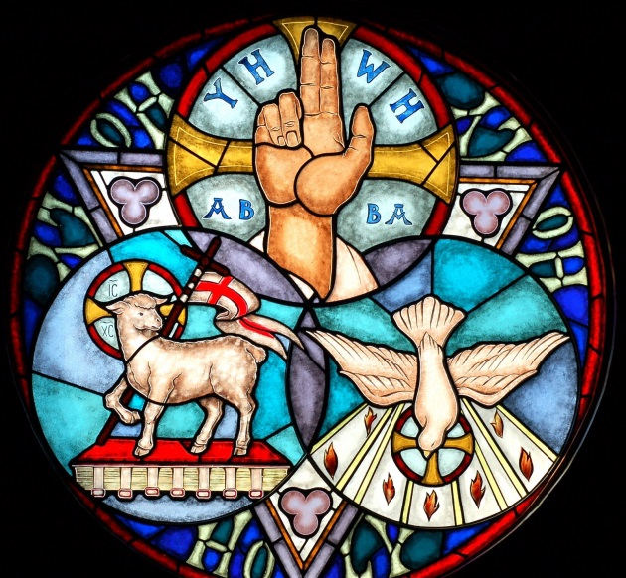

Prayer to my Guardian Angel

God gave each one of us an angel to look after us. We cannot see him but we can pray to him. This is a prayer to your Guardian angel.

Angel of God
my Guardian dear,
to whom God’s love commits me here.
Ever this day be at my side
to light and guard,
to rule and guide.
Amen

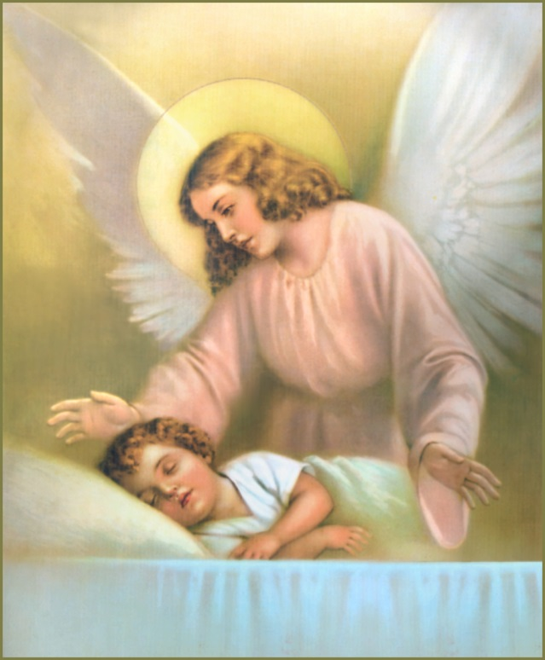

Eternal Rest

In this prayer, we pray for people who have died.

Eternal rest
Grant unto them, O Lord,
And let perpetual light shine upon them.
May they rest in peace.
Amen
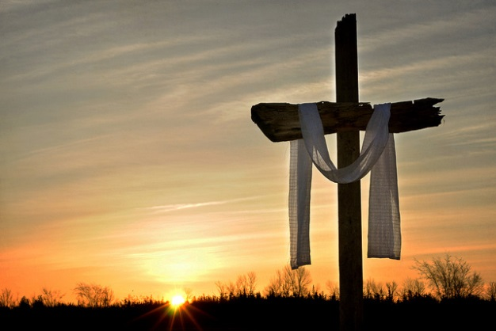

Act of Contrition
We say this prayer to show God we are sorry for the times we have not done the right thing.

O my God,
Because you are so good
I am very sorry that I have sinned against you
and by the help of your grace
I will not sin again.
Amen


The Confetior
This is another prayer we say to show God we are sorry. It is said during Mass.

I confess to almighty God
and to you my brothers and sisters,
that I have greatly sinned,
in my thoughts and in my words,
in what I have done and in what I have failed to do,
through my fault, through my fault, through my most grievous fault;
therefore I ask blessed Mary, ever-Virgin,
all the Angels and Saints,
and you, my brothers and sisters,
to pray for me to the Lord our God.
Amen

The Apostles’ Creed
The creed is a statement which lists all that we believe in as Christians. The word “Creed” means “I believe”. It is said during Mass.

I believe in God, the Father almighty Creator of heaven and earth,
and in Jesus Christ, his only Son, our Lord,
(at the words that follow, up to and including the Virgin Mary, all bow.)
who was conceived by the Holy Spirit, born of the Virgin Mary,
suffered under Pontius Pilate, was crucified, died and was buried;
he descended into hell; on the third day he rose again from the dead;
he ascended into heaven, and is seated at the right hand of God the Father almighty; from there he will come to judge the living and the dead.
I believe in the Holy Spirit, the holy catholic Church, the communion of saints,
the forgiveness of sins, the resurrection of the body, and life everlasting.
Amen
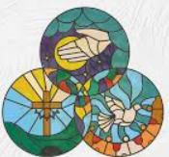
Prayer of St. Richard of Chichester
Day by day,
O dear Lord,
three things I pray:
to see you more clearly,
love you more dearly,
follow you more nearly,
day by day.
by day by day.
Amen
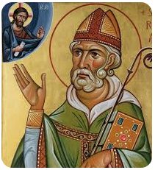
Come, Holy Spirit
In this prayer we pray for the Holy Spirit to fill us with the love, joy and peace of God.

O Come, Holy Spirit, fill the hearts of your faithful,
and enkindle in them the fire of your love.
Send forth your Spirit and they shall be created.
And you shall renew the face of the earth.
O God, who by the light of the Holy Spirit,
did instruct the hearts of your faithful,
grant that by that same Holy Spirit,
we may be truly wise, and ever rejoice in your consolation,
Through Christ our Lord.
Amen.
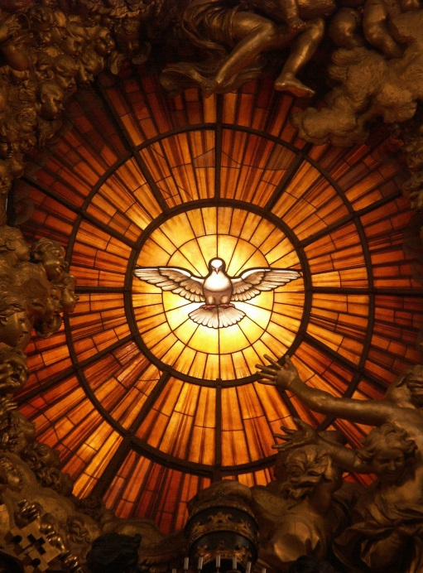

Act of Faith
My God, I believe in you and all your Church teaches,
because you have said it and your word is true.
You are the Christ The son of the living God.
You are my Lord and my God.
Lord, I believe, increase my faith.
Amen


Act of Hope
My God, I put my hope in you, because I am sure of your promises.
Deliver us Lord from every evil and grant us peace in our day
as we wait in joyful hope for the coming of Our Saviour Jesus Christ.
Amen

Act of Love
O my God, I love you with my whole heart and above all things
because you are infinitely good and perfect,
and I love my neighbour as myself for love of you.
Grant that I may love you more and more in this life,
and in the next for all eternity.
Amen.


The Magnificat
This is Mary’s special prayer of praise to God. She prayed this when she was told she was going to be the mother of Jesus.

My soul glorifies the Lord,
My spirit rejoices in God, my Saviour.
He looks on his servant in her loneliness;
henceforth all ages will call me blessed.
The Almighty works marvels for me.
Holy his name!

His mercy is from age to age,
on those who fear him.
He puts forth his arm in strength
and scatters the proud-hearted.
He casts the mighty from their thrones
and raises the lowly.

He fills the starving with good things,
sends the rich away empty.
He protects Israel, his servant,
remembering his mercy,
the mercy promised to our fathers,
to Abraham and his sons forever.
