St Mary’s Catholic Primary School
SEND Information Report 2025-2026

General information about our school
As a school St Marys Catholic Primary School sits in beautiful grounds of the main route through Madeley. The number of children on role is 182. Being a Catholic school the school prides itself on having a strong caring, child centred ethos, where all children are valued and nurtured and supported in achieving their very best. We are a single form entry school with an EYFS and Year 1 -Year 6 classes
Our school offer from children with Special Educational Needs and Disabilities can be found on our web page or a copy can be attained from our school office.

The kind of special needs for which provision is made for at St Mary’s.

Definition of Special Educational Needs and Disability
The Code of Practice (2014) states that a child or young person has a special educational need or disability if they have a learning difficulty or disability which calls for special educational provision to be made for him or her. A child of compulsory school age or a young person has a learning difficulty or disability if he or she:

Has a significantly greater difficulty in learning than the majority of others of the same age, or has a disability which prevents or hinders him or her from making use of educational facilities of a kind generally provided for others of the same age in mainstream schools

What is the Local Authority Local Offer?
SEND - Local offer
This is a comprehensive page with a lot of information, signposting and support for parents and school regarding all things to do with special needs, disability and autism.
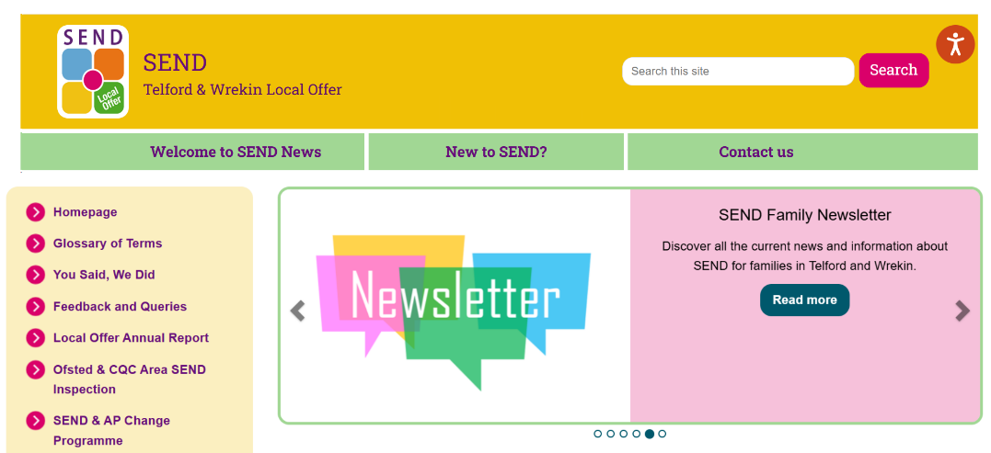
Areas of Need
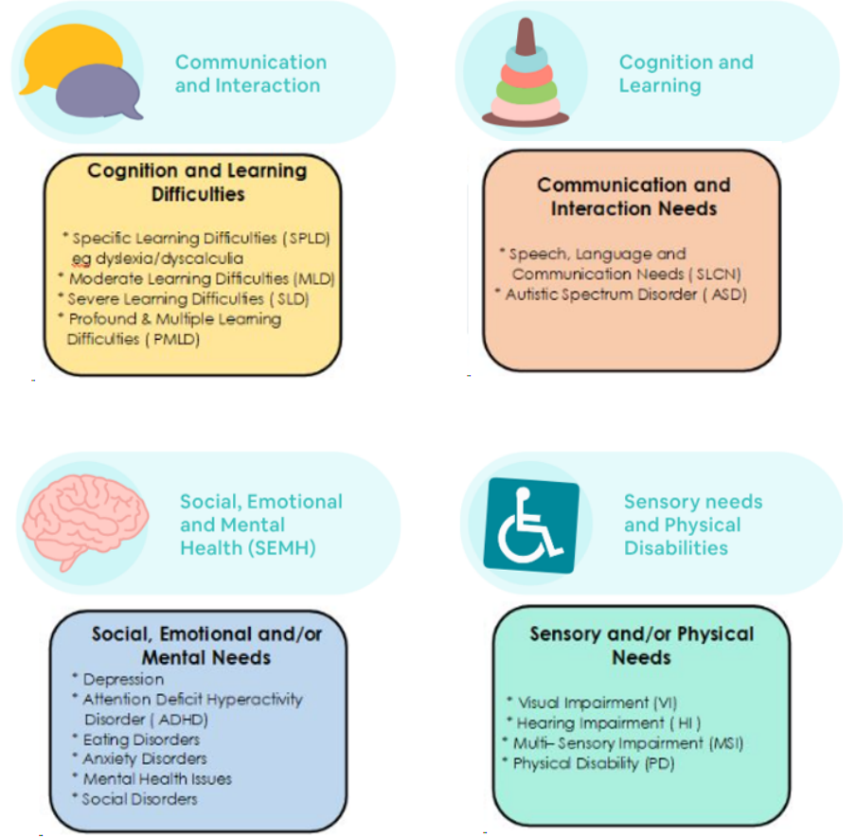
Who are the best people to talk to in this school about my child’s difficulties with learning/ special educational need or disability (SEND)?

If you have any concerns about your child, please feel free to discuss these with your child’s class teacher or the Special educational Needs and Disabilities co-ordinator is Mrs Helen Lambie.

The Class Teacher
Responsible for:
-Checking on the progress of your child and identifying, planning and delivering any additional help your child may need (this could be targeted work or additional support) and letting the Special Education Needs/Disabilities Co-ordinator (SENCo) know as necessary.
-Writing Pupil Progress targets via a provision maps, based on the smaller steps outlined in LSAT (learning Support Advisory Teacher), educational psychologist, or other professional report and sharing and reviewing these with parents at least once each term and planning for the next term. This is often done at parents evening.
-Personalised teaching and learning for your child as identified on the school’s provision map.
-Ensuring that the school’s SEND Policy is followed in their classroom and for all the pupils they teach with any special need or diability.
-Overseeing support that TAs provide for your child
-Ensuring that you are involved in supporting your child's learning.

The SENDCo (Special Educational Needs and Disability Co-ordinator) Mrs Helen Lambie
Responsible for
- Developing and reviewing the school’s SEN policy.
-Co-ordinating all the support for children with special educational needs or disabilities (SEND).
-Monitor and evaluate all intervention programmes, checking assessment and ensuring children are accessing the correct
-Providing specialist support for teachers and support staff in the school, so that they can help children with SEND in the school to achieve the best progress and outcomes possible.
- Make referrals for outside agency support.
- Ensure all outside agencies are liaised with and brokered as needed
Ensuring that parent and carers are:
-involved in supporting your child’s learning
-kept informed about the support your child is getting
-involved in reviewing how they are doing.
-Liaising with all the other people who may be coming in to school to help support your child’s learning, e.g. Speech and Language Therapy, Educational Psychology, LSAT etc.
-Updating the school’s SEND register (a system for ensuring that all the SEND needs of pupils in this school are known) and making sure that records of your child’s progress and needs are kept.
Ensure transition between year groups and school supports the child. Support children and parents in major transitions, for example secondary school.

The Head Teacher: Mrs Samantha Griffiths
Responsible for:
-The day-to-day management of all aspects of the school; this includes the support for children with SEND. - --The Head teacher will give responsibility to the SENCo and class teachers but is still responsible for ensuring that your child’s needs are met.
-The Head teacher must make sure that the Governing Body is kept up to date about issues relating to SEND.

The SEND Governor: Mrs Sue Maguire
Responsible for:
-Making sure that the necessary support is given for all children with SEND who attend the school.
-The review of the Inclusion and Equality policy
-Holding the school to account in order to have a positive impact on the outcomes of all pupils.

You can contact any of the above through the main school office on 01952 388255

Who are the other people providing services to children with SEND in our school?
School provision
- Fully trained Teaching Assistants working with either individual children or small groups. These small groups have been for speech and language development, social and emotional skills buildings, phonics, reading, writing and maths support
-other professionals like the speech and language therapist, school nurse, etc

Local Authority Provision delivered in school
- Learning Support Advisory Team (LSAT)
-Educational Psychology Service
-Parent Partnership Service
-Virtual School Team (for children in care)
-Family Intervention Worker: Strengthening family’s workers

Health Provision delivered in school
-School Nurse
-Physiotherapy
-Bee U CAMHs (Child and Adolescent Mental Health)
-Sensory Inclusion Team - Visually and Hearing impaired team
-Speech and Language therapist SALT
-Occupational Therapist (OT)
-Paediatricians (Community Child Health)

HELPFUL PARENTS WEBSITES
SENDIASS Telford SENDIASS | SENDIASS Telford offering advice for parents of children with SEND
PODS Home - Together We Can Make a Difference Offering support , workshops , Webinar training, clubs for children and lots more

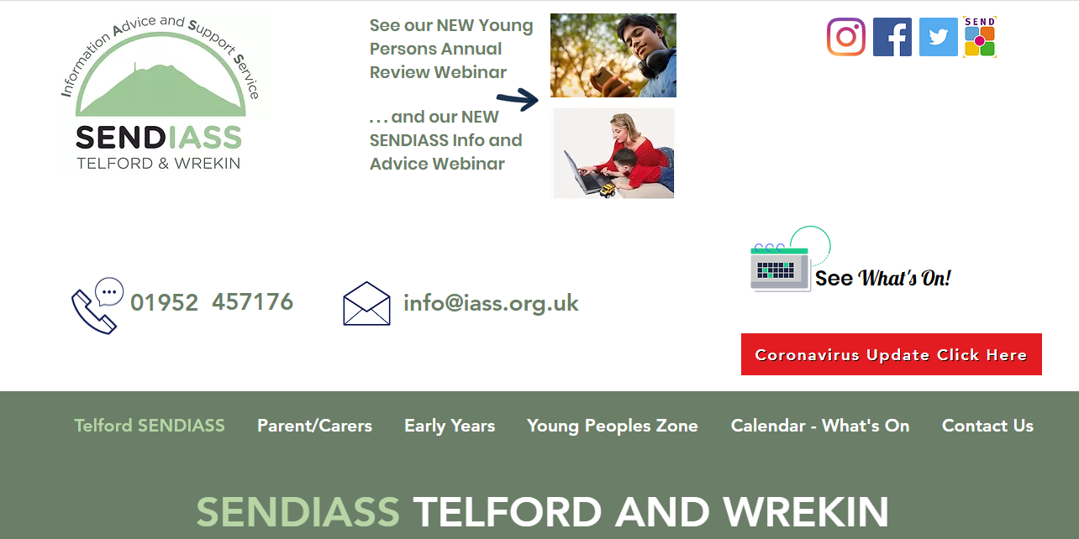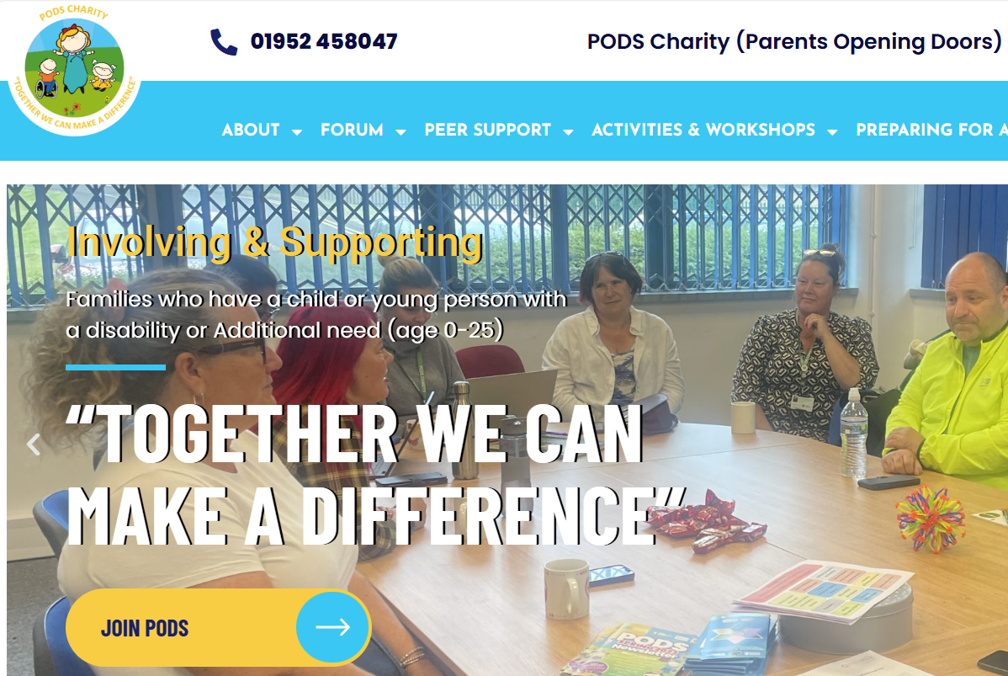
:

How is St Mary’s Catholic Primary School accessible to children with SEND?


-The school is fully compliant with Disability Discrimination Act (DDA) requirements.

-The school is on one level with easy access and double doors to main entrants and exits. Each classroom has a single outside access door and a ramp is fitted to support the independence of wheelchair users over the door frame. There is a ramp down onto the bottom layer of the playground.

-The front desk has a wheel-chair height section and is DDA compliant.

-There are three disabled toilets and changing facilities.

-The school gates are electric; the office number is fitted to the gate so that disable access can be granted through the office.

-We ensure wherever possible that equipment used is accessible to all children regardless of their needs.

-After-school provision is accessible to all children, including those with SEND all clubs are free to all children.

-Extra-curricular activities and all school responsibilities are accessible for children with SEND.

-Quiet areas and calming zones are provided for children who need a space to support their emotional regulation, as much as our building allows.

-All staff wear a black uniform with a black or white shirt/blouse to reduce distraction for children

-Staff are trained to be aware of and cater for children who are neurodiverse and are well trained in making reasonable adjustments for all children as necessary.

-We use widgits as a visual form of communication for all our visual timetables and in some work to allow easy access for children
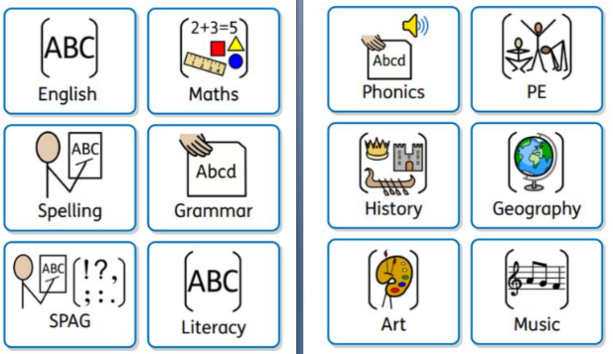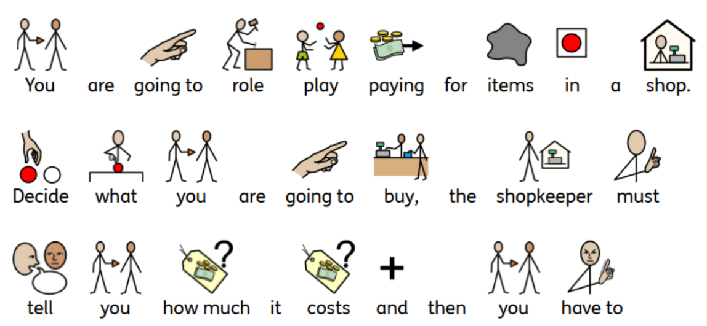

SEND Procedures
The progress of all children is monitored regularly by all staff. When staff feel additional support is required for a child, outside of that offered in the classroom as part of normal differentiation, teachers will discuss the child with the SENDCo or Senior Leader, parents and child. Appropriate targets and provisions are identified using an Individual Provision Map. The provision maps are written in conjunctions with/shared with parents and children.

Further advice and support is regularly sought from outside agencies, for example Educational Psychologist, Speech Therapy, Occupational Therapy and Learning Support and Advisory Teachers (LSATs).

If progress is still very limited the school and family may collaboratively request further assessment and/or a statutory assessment by the Local Authority.

General Resources
All children who attend our school have a right to a broad and balanced curriculum irrespective of their need. As a school we are inclusive with skilful differentiation using multisensory methods and technology. 
- Writing slopes
- Pencils and pencil grips
- Different types of scissors
- Wobble Cushions
- Outdoor learning areas
- Role-play areas
- Quiet areas
- Gross and fine motor skills equipment
- ICT resources
- Adjustable, sloping tables
- Ramps and slopes
- Left handed writing maps
- Support mats for eating
- Grab rails
- Widgits for communication
- Talk mats
- Colour overlays/book marks
- Personal checklist
- Word/phonics/spelling cards
- Well trained staff and a variety of interventions

Accessibility
Early Years staff support children with toileting needs, in conjunction with parents. The school has wheelchair access, such as ramps and there are disabled toilets. (see accessibility plans at the end of this document)

Lunchtimes and Break times.
The catering team offer a wide range of specialist dietary requirement meals e.g. dairy free and make reasonable adjustments as required on a one to one basis.
Water is available within school through cool water dispensers. Children are encouraged to bring a water bottle into school to make use of this. All our lunchtime staff receive training and are aware of the needs of children where needs are encountered over the lunch hour. There is a lunchtime games club available, and St Mary’s School Guardians are on duty to support play.



Pupils Voice
Each stage in school will cater for children at the appropriate level but generally these are the ways children’s voice is accessed. Each child completes their own ‘One Page Profile’ (with support where necessary). This allows them to communicate their strengths, weaknesses, likes, dislikes and what it is that helps them learn the best. Where necessary, teacher and child devise an individual passport that clearly lays out best practice and strategies for individual children that is easily accessible to all adults working within that class. (see examples)

There are representatives from each class that are part of the whole School Eco Council, School Council, Faith Council, Guardians and Minnie Vinnies. Conversations with pupils are had regularly via these forums.

Parents Voice
Parents are welcomed into school regularly to attend parents evenings, special lunches, curriculum assemblies etc, this is an opportunity for parents to meet staff informally and familiarise themselves with school.
As a school we publish a newsletter weekly to update parents regularly on school events, we use Parent Mail and our web page to inform parents of any school events. The website also provides links to policy, curriculum and Local Authority links to support.

As a school we have an ‘open door’ policy, teachers are at classroom doors both at the beginning and end of the school day. This is a good opportunity for parents to speak to school staff. If there are concerns or issues or information sharing that requires more time then seeing teachers at the start or end of the day is an ideal opportunity to arrange a meeting, additional time, to discuss this. If parents do not bring children to school a phone call to the school office will ensure that communication can quickly be establish either by a teacher or the SENDco, to call parents back or to arrange a meeting at a mutually convenient time.
Parent meeting are held throughout the school year, giving parents the opportunity to meet and discuss the progress of their child. In addition to these meetings, parents, and if appropriate the child with SEND are offered an additional, or extended time slot to review and co-produce provision maps and plans for children. Additional meetings with the class teacher and/or SENCO will be made throughout the year to discuss any outside agency involvement parents and review reports provided by other professionals.

Progress and Monitoring
Each term, the class teacher and SENCO meet to review progress towards individual targets . Children who are not making progress following specific interventions may then be referred to outside agencies such as Speech therapy, LSAT and Educational Psychology.
Provision maps are created for children with specific needs to show targets and progress over time. These maps are monitored and reviewed by the SENDCO. The LSAT also supports teachers throughout the year in reviewing and creating targets. At the end of each academic year, class teachers pass on relevant information and intervention and provision maps to the pupil’s new class teacher.

Each intervention has a starting point and children’s progress is monitored throughout. The SENDCo, teacher and
Adult leading the intervention make decisions as to when children are ready to come off an intervention, remain on it, or need some other input, possibly from another intervention.

In school the Governing body dedicates a link Governor who take on the responsibility for monitoring the work of the SENDCO. This includes reviewing the level of interventions, their effectiveness and discussion how the school is moving forward in its provision for its children. These meeting look at data, quality of intervention, observing sessions, looking at work and talking to the children, reviewing spending etc.

Staff Training and Qualifications
*Child Protection and Safeguarding
* Epi-pen training
*Asthma training
*Lifting and Managing
* PINS training
*ELSEC training
*Behaviour management
* First Aid
*Read, Write, inc training
*build to express
*dyslexia training
*how to write a provision map
*Talkboost and language interventions
*Cool kids
*Socially speaking
*SENDCO attends termly SEN updates
*SEND accreditation

Interventions

We have a package of intervention available that support staff have been trained in
* Literacy Pathway  *Fresh Start  *1:1 Reading support  * Talk boost  * Speaking and listening  *Social skills group  * Precision Teaching  *Additional phonics support  * Practical Maths  * Lego Build 2 Express  *Volcano in my Tummy  *Numicon Breaking Barriers | *Write from the start /Speed up handwriting  *SNIP spelling program  *Word Wasp  *The Power of 2  *Socially speaking  *Cool Kids  *variety of personalization for individual children

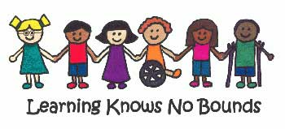

Disability Access Statement

St Mary’s Catholic Primary School.
With the introduction of the Equalities act 2010 an in light of the May 2014 update St Mary’s Catholic Primary School, assumed a mandatory obligation to provide easy access to all parts of its premises for people with Disabilities, wherever reasonably practicable.
At St Marys we are aware that the challenges that disabilities can bring may need proactive and extra measures taken so that all children, including those with disabilities can reach their full potential.
We make every reasonable adjustment possible to ensure that the children and adults who entre St Marys have full access to our services and provision.
The Act recognizes, however, that full access is not always reasonably achievable in older existing buildings, and therefore states that in these cases people with disabilities should be able to gain easy access into the premises and that the services they require should be made available to them in close proximity to their entry point.
St Mary’s Catholic Primary school comprises of a single level building contained on one site only. Access to the site can be gained through two pedestrian entrances, one at the front and one at the rear of the building that are opened at specific times during the school day to allow ease of drop off and pick up of pupils. The driving access is only opened on request via an intercom system. The telephone number for disabled drivers use is signposted on the gates to enable them to contact the office to gain access as the driveway could not facilitate an intercom at driver height. There is a designated disabled parking bay clearly marked on the school car park.
The school building has 100% disabled access to all areas. There are two ramped areas on the rear playground to allow ease of access to all facilities.
Doors to enter the school and all classrooms are also 100% accessible for wheelchair users and there are no changes in floor levels within the building structure.
In addition to the above, there are accessible disabled lavatory facilities in the main school reception area that is clearly signposted as such.
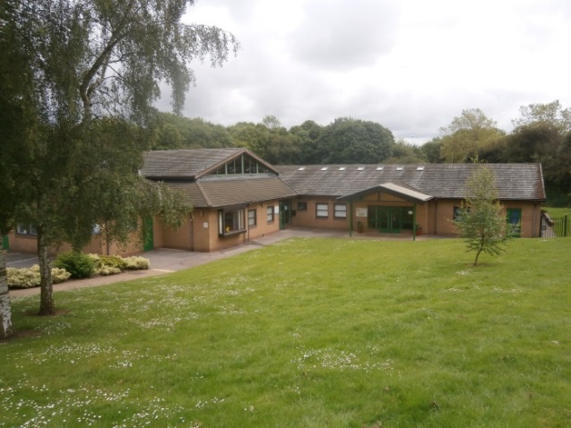

St Mary’s Easy Read Accessibility Plan
Our school values everybody.
We particularly welcome those with disabilities and special educational needs.
We want to ensure that every disabled child matters in our school, and that all children, including those with disabilities and /or special educational needs are helped to:
- Stay Safe
- Be healthy
- Enjoy and Achieve
- Make a positive contribution
- Achieve economic wellbeing

We will make sure that children and adults with mobility impairments can get into our school, and can access our main facilities.

We will make sure that this plan, and other documents are available in alternative formats (such as in large print / audio).

Other school documents for children will also be available in other formats.

We will make sure that pupils with special educational needs and / or disabilities clear plans and will make changes so that their needs are met in the school, and their progress regularly reviewed
We will consider all activities that our school does to make sure that they are accessible for all

We will review the physical nature of our school building, and make sure when any alterations or adaptations are made, that these improve the physical accessibility of our school
We want our disabled students, staff, and visitors to tell us what they think about our accessibility plan, or how they find coming to or being at St Marys. Any feedback should be given to Mrs Griffiths, Mrs Lambie or Mrs Evans, who will consider what should be done.

If our school develops any extended school activities, we will make sure that the needs of disabled pupils and parents are considered,

We will make sure that our school’s anti bullying policy is regularly updated. Disabled children are often bullied, so we will make sure that our policy tells us what we should do if this happens.

We will consider how, within the curriculum, we can ensure that disabled children and young people are represented, and that the curriculum supports all pupil and staff’s awareness of disability awareness and access issues.

We recognise that accessibility is about more than physical access, and attitudes make a significant contribution to how accessible settings can be.

Example of a ‘Single Page Profile’

Name:
St Mary’s    Catholic Primary School |  | My name is  Susan  I am a Year  5
What people appreciate about me

People like my smile and my friends say I am funny. I am a kind friend and try to help those around me. I love telling funny stories and making people laugh.
What is important to me
My family is important to me I love my Mum and Dad and baby sister May. I have a cute bunny called Fluffy. I play with my bunny every day. My best friends are Kate and Julie at school and at home my best friend is Amber. I love dancing and do it 3 times a week I am very good at it!
What I need to help me learn well at school
I love reading but find spelling very difficult, what helps me is my spelling card and phonics board. I am learning how to use a dictionary so having one near me helps. I use boxes to help me have a best go . Having a coloured background on the board helps me as white hurts my eyes and makes the writing go all funny. I like sitting at the front of the class.

Roles and Responsibilities Quick Check
SENCO | Teacher | Parent | Child | Governor
-Providing advice and practical support in identification, assessment and intervention within the SEN Code of Practice  -Providing day-to-day support for teachers and parents in ensuring arrangements are in place to support children with SEND  -Strengthening the links between all stake holders, work with parents and children to ensure provision is meeting needs  -Developing and disseminating training and good practice  -Ensure interventions are delivered , monitored and assed regularly for effectiveness  -Informing parents of and working with local impartial Information, Advice and Support Services, to promote effective work with parents of children  - where appropriate complete referral forms and secure external support  -broker outside agencies and secure professional involvement | -responsible and accountable for progress of children in their class  -provide high quality daily teaching  -assess and monitor all children’s progress  -identify individuals needs, identifying what the gaps are  -take advice on best interventions to help support child and close gap  -Use the Plan, do and review model for intervention  -generate in consultation the Provision maps as part of the . assess, plan, do review cycle  -monitor interventions and review provision maps  -communicate with parents  -write passports for children in their class | -share aspirations and concerns about child  -ensure children attend school  -support children at home with reading, mental maths practice, homework etc  -meet with class teacher and or SENCO to share information  -attend meetings  -ask for help when needed | -Always do my best  -fill in my single page profile to the best of my ability  -share with the adults around me what help me do my best  -come to school everyday  -have high aspirations for myself | -monitor provision, ensuring all children are getting the best provision possible  -ensure finances are used well  -challenge and support the SENCo and Headteacher to carry out their duties  -

Key Staff

Head teacher | Mrs Griffiths
Assistant Head Teacher and SENCO | Mrs Lambie
Early Years Manager | Mrs Rushton
Business Manager | Mrs Pryce
Chair of Governors | Mrs Monaghan
Governor for SEND | Mrs Sue Maguire

Helpful Abbreviations
LSAT | Learning Support Advisory Teacher
Ed Phyc | Educational Philologist
TAC | Team around the Child
CAF | Common Assessment Form
BeeU | Telford’s Child and Adult Mental Health Services
EHC plan | Education Health and Care Plan
DDA | Disability Discrimination Act
ASD | Autism Spectrum Disorder
ADHD | Attention Deficit Hyperactivity Disorder

Communication and interaction
6.28 Children and young people with speech, language and communication needs (SLCN) have difficulty in communicating with others. This may be because they have difficulty saying what they want to, understanding what is being said to them or they do not understand or use social rules of communication. The profile for every child with SLCN is different and their needs may change over time. They may have difficulty with one, some or all of the different aspects of speech, language or social communication at different times of their lives.
6.29 Children and young people with ASD, including Asperger’s Syndrome and Autism, are likely to have particular difficulties with social interaction. They may also experience difficulties with language, communication and imagination, which can impact on how they relate to others.

Cognition and learning
6.30 Support for learning difficulties may be required when children and young people learn at a slower pace than their peers, even with appropriate differentiation. Learning difficulties cover a wide range of needs, including moderate learning difficulties (MLD), severe learning difficulties (SLD), where children are likely to need support in all areas of the curriculum and associated difficulties with mobility and communication, through to profound and multiple learning difficulties (PMLD), where
98 children are likely to have severe and complex learning difficulties as well as a physical disability or sensory impairment.
6.31 Specific learning difficulties (SpLD), affect one or more specific aspects of learning. This encompasses a range of conditions such as dyslexia, dyscalculia and dyspraxia.

Social, emotional and mental health difficulties
6.32 Children and young people may experience a wide range of social and emotional difficulties which manifest themselves in many ways. These may include becoming withdrawn or isolated, as well as displaying challenging, disruptive or disturbing behaviour. These behaviours may reflect underlying mental health difficulties such as anxiety or depression, self-harming, substance misuse, eating disorders or physical symptoms that are medically unexplained. Other children and young people may have disorders such as attention deficit disorder, attention deficit hyperactive disorder or attachment disorder.
6.33 Schools and colleges should have clear processes to support children and young people, including how they will manage the effect of any disruptive behaviour so it does not adversely affect other pupils. The Department for Education publishes guidance on managing pupils’ mental health and behaviour difficulties in schools – see the References section under Chapter 6 for a link.

Sensory and/or physical needs
6.34 Some children and young people require special educational provision because they have a disability which prevents or hinders them from making use of the educational facilities generally provided. These difficulties can be age related and may fluctuate over time. Many children and young people with vision impairment (VI), hearing impairment (HI) or a multi-sensory impairment (MSI) will require specialist support and/or equipment to access their learning, or habilitation support. Children and young people with an MSI have a combination of vision and hearing difficulties. Information on how to provide services for deafblind children and young people is available through the Social Care for Deafblind Children and Adults guidance published by the Department of Health (see the References section under Chapter 6 for a link).
6.35 Some children and young people with a physical disability (PD) require additional ongoing support and equipment to access all the opportunities available to their peers.
Broad areas of need as quoted in the SEND code of practice 2015

