St Mary’s Catholic Primary School Teaching Handwriting Progression Document

September 2024

St. Mary’s Handwriting Progression
The National Curriculumn
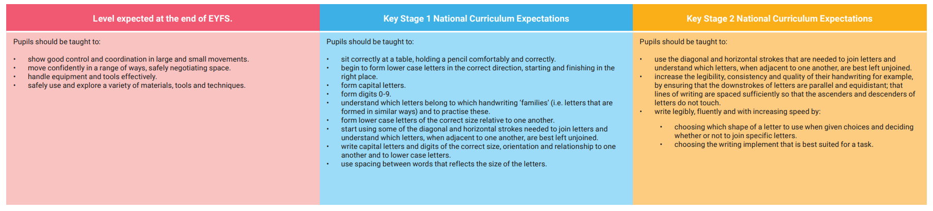

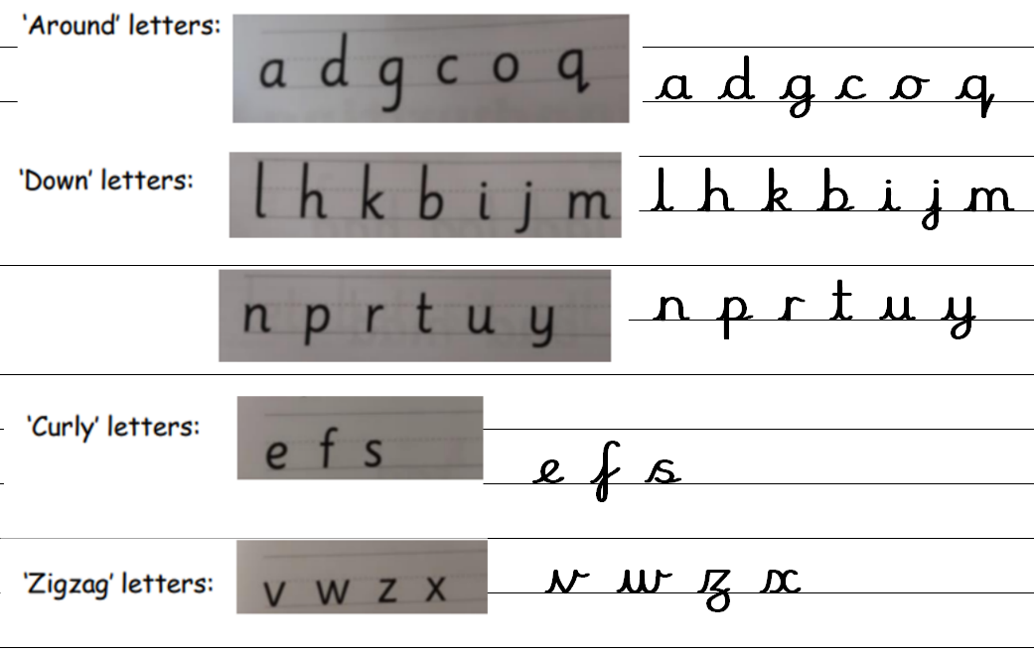 | 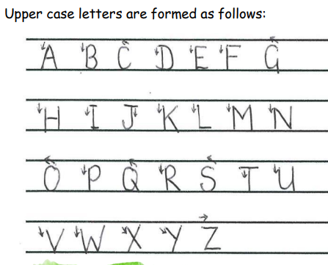

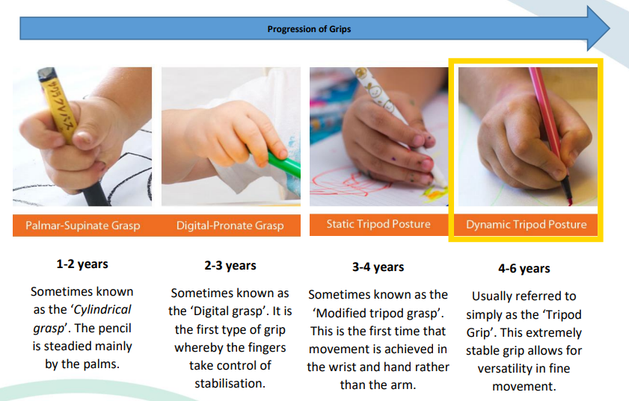
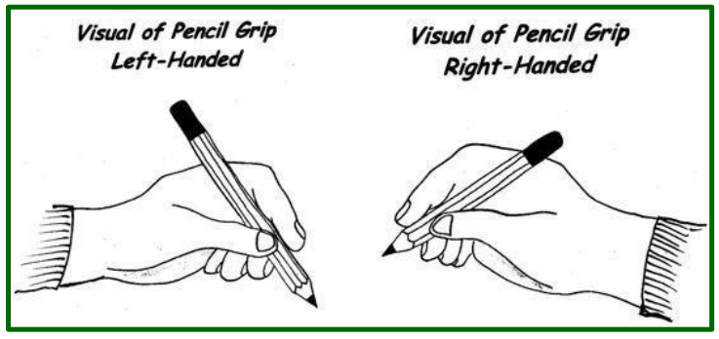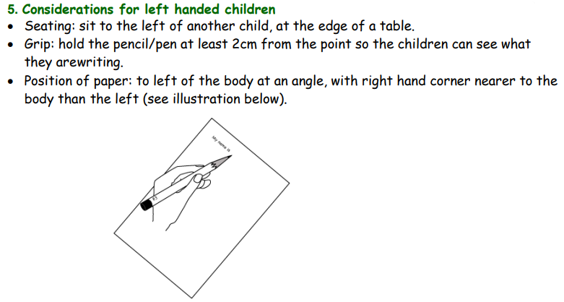

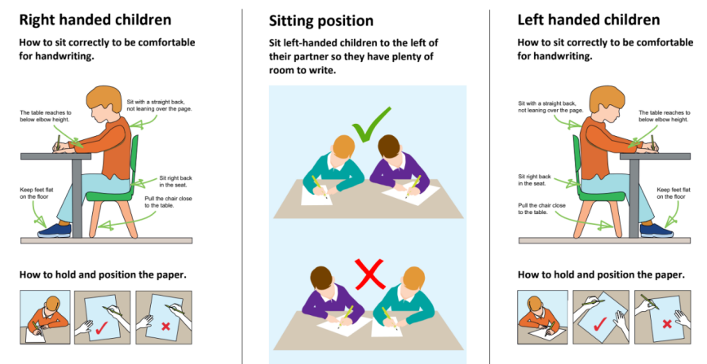
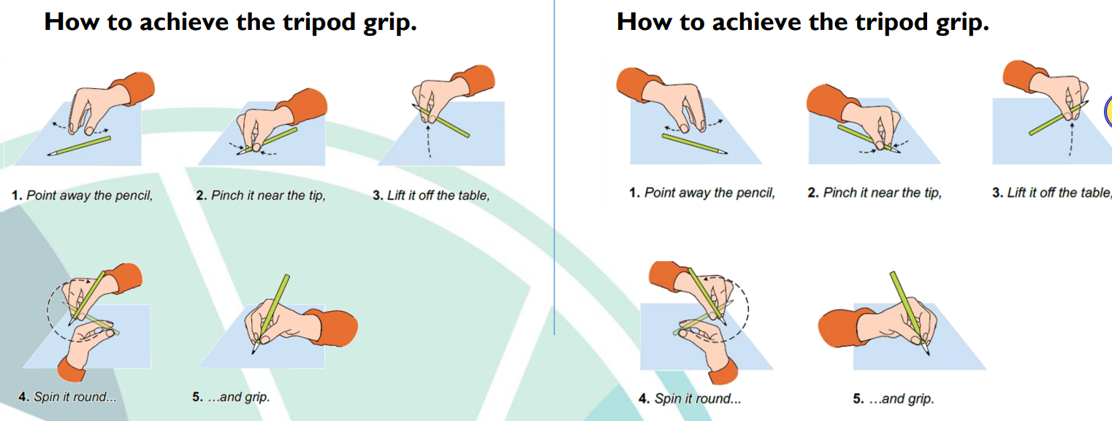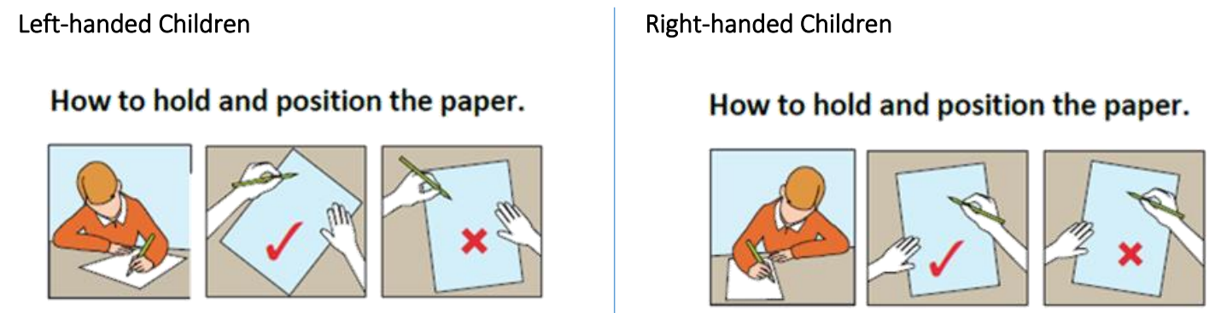
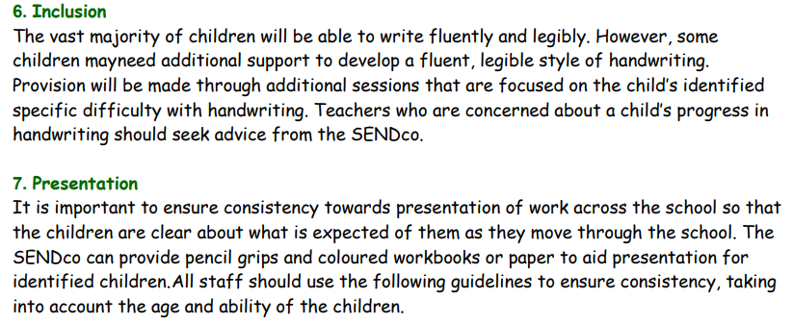
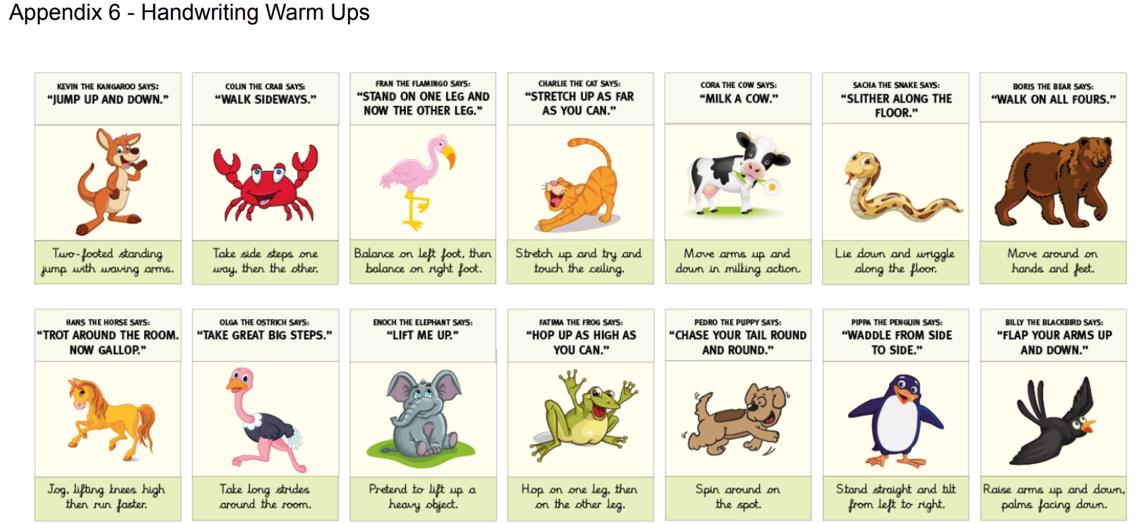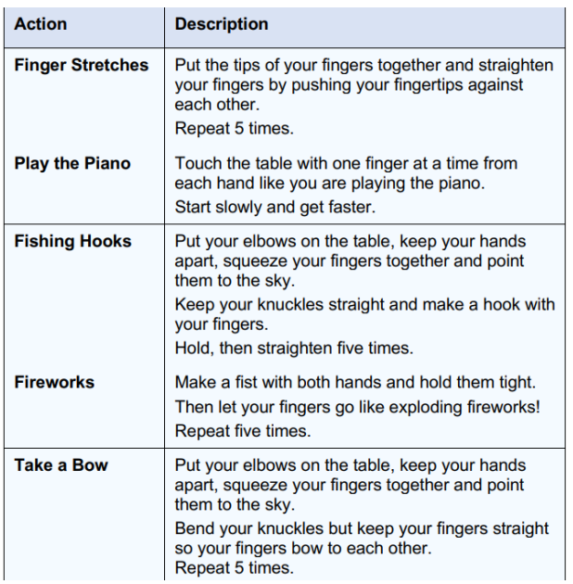
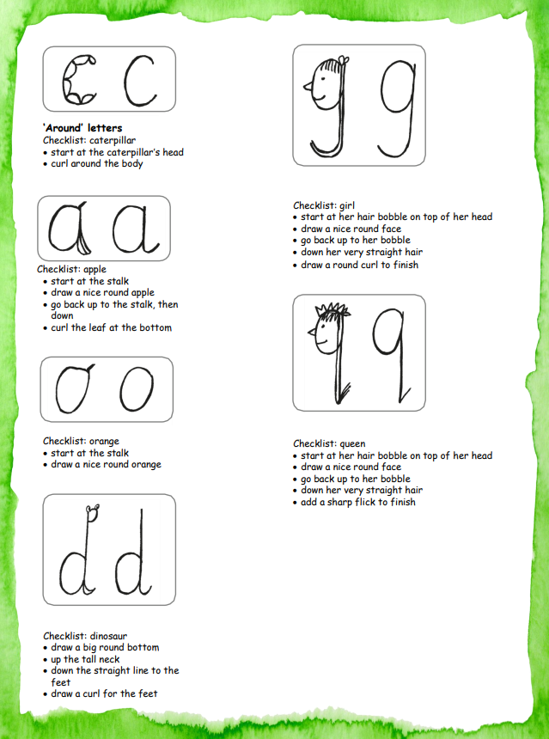 |  | 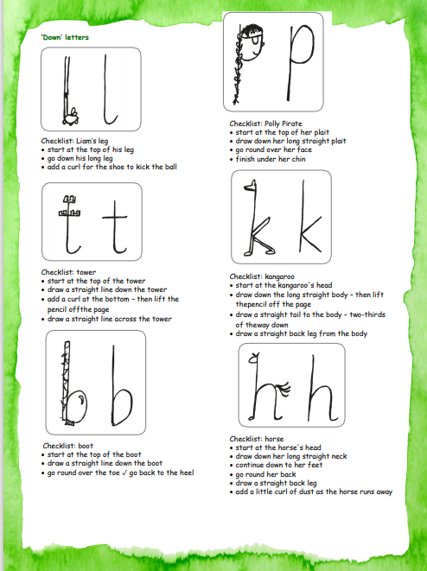
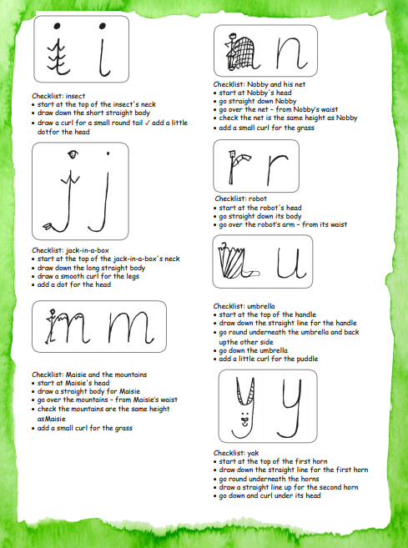 |  | 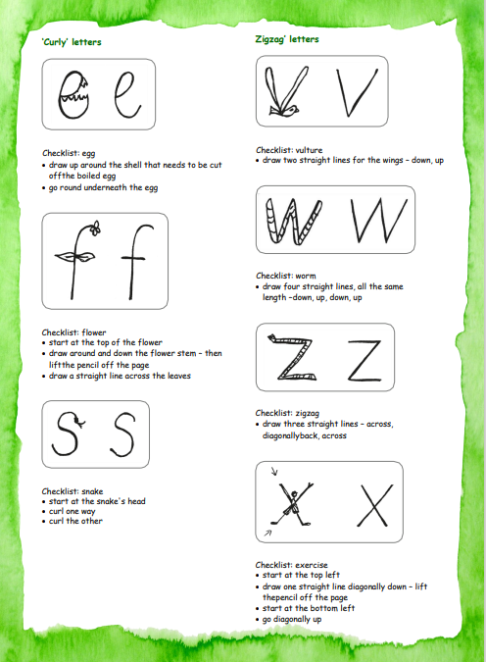
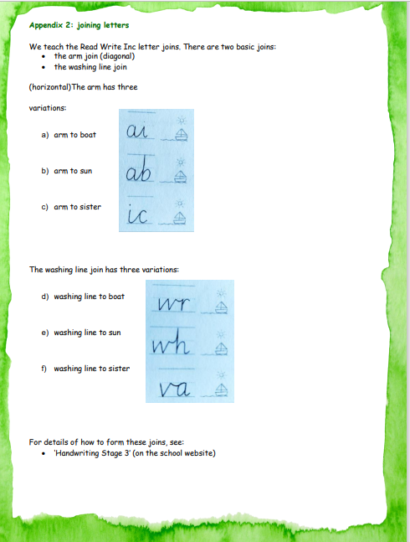 |  | 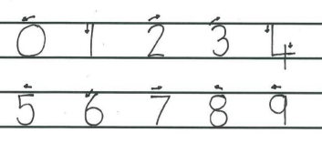  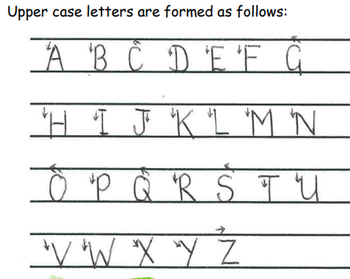
Handwriting Milestones: Nursery (3-4 years old)
• Use large-muscle movements to wave flags and streamers, paint and make marks.
• Use one-handed tools and equipment, for example, making snips in paper with scissors.
• Use a comfortable grip with good control when holding pens and pencils.
• Shows a preference for a dominant hand.
• Use some of their print and letter knowledge in their early writing. For example: writing a pretend shopping list that starts at the top of the page; write ‘m’ for mummy.
• Write some letters accurately.
Types of Joins
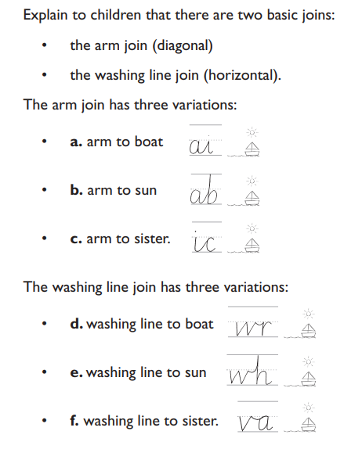 | 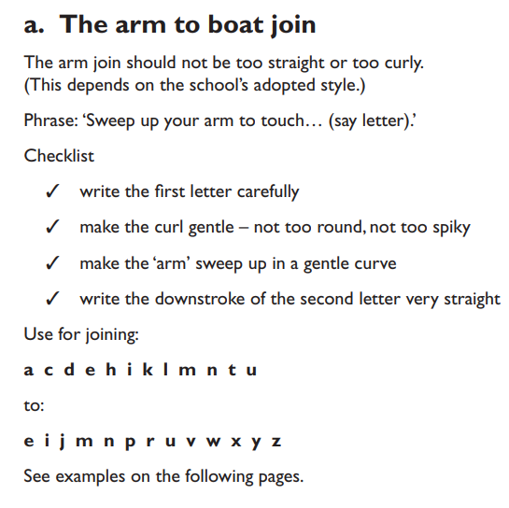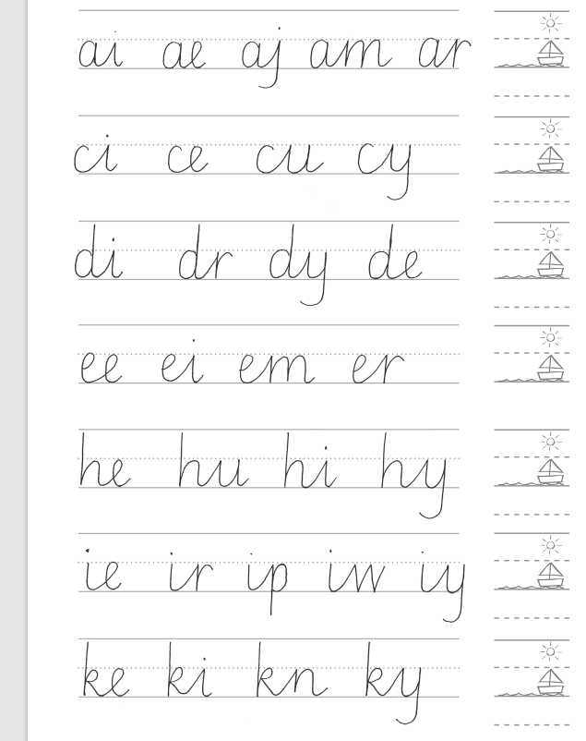 |  | 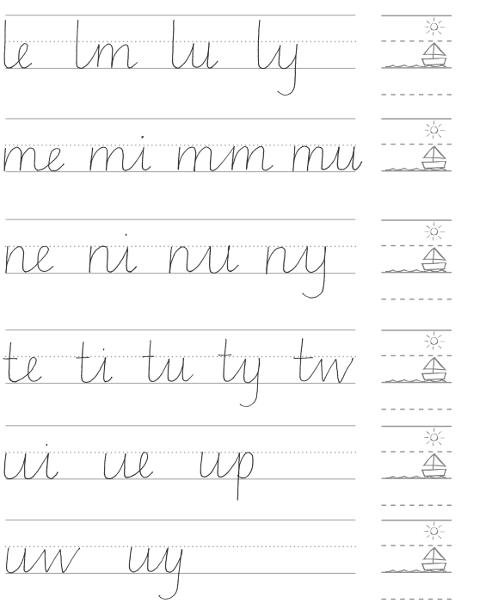
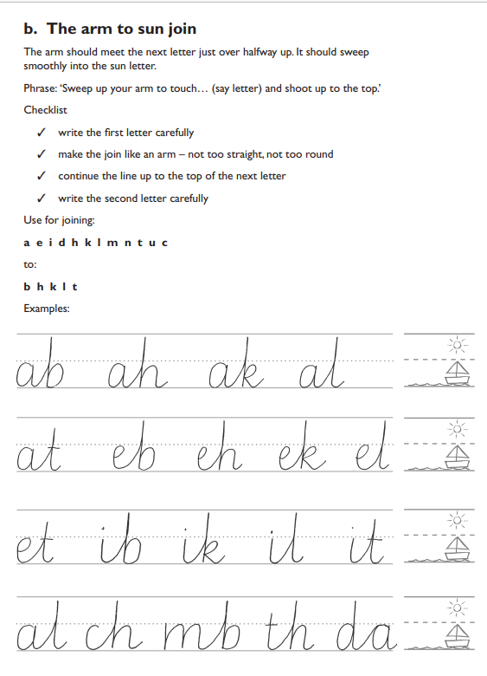  Letters that do not join, or need a loop to join them .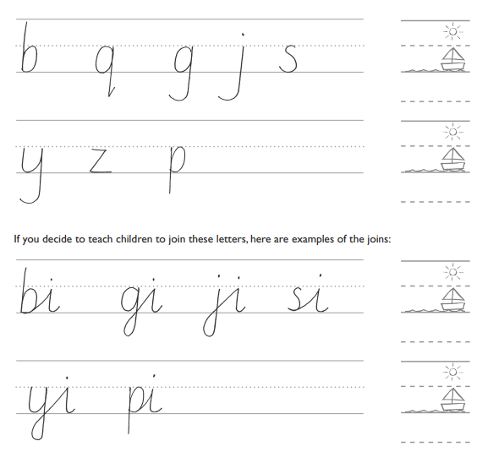 | 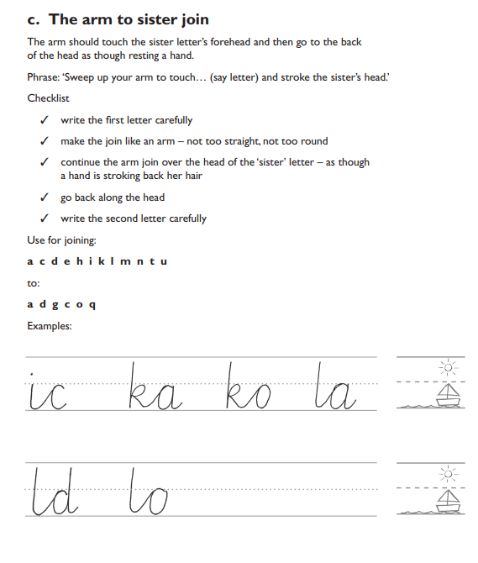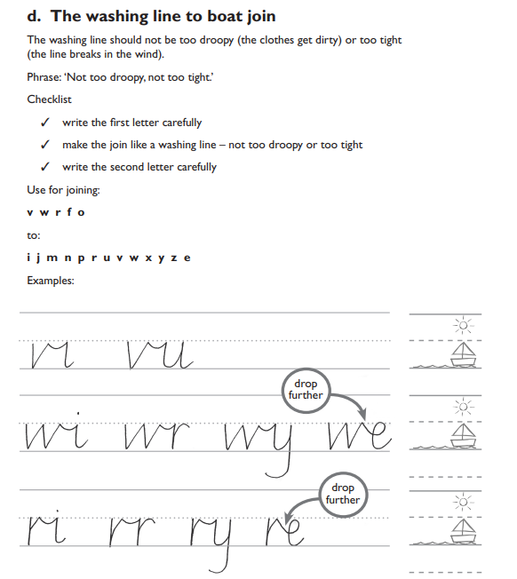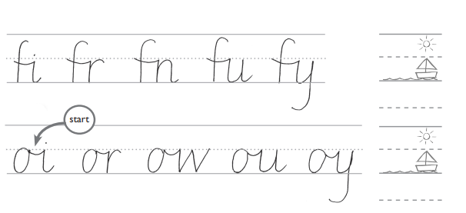 |  | 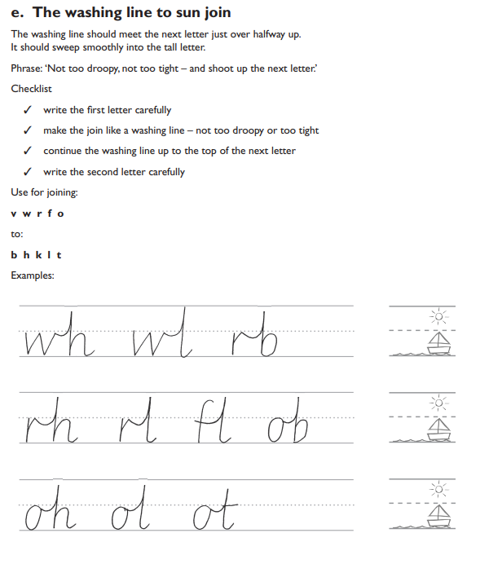  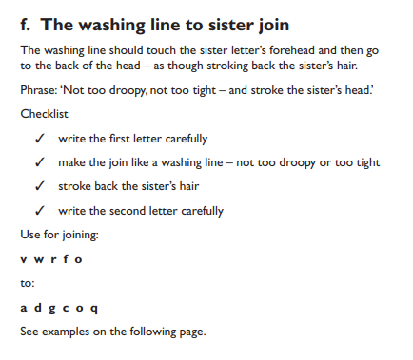  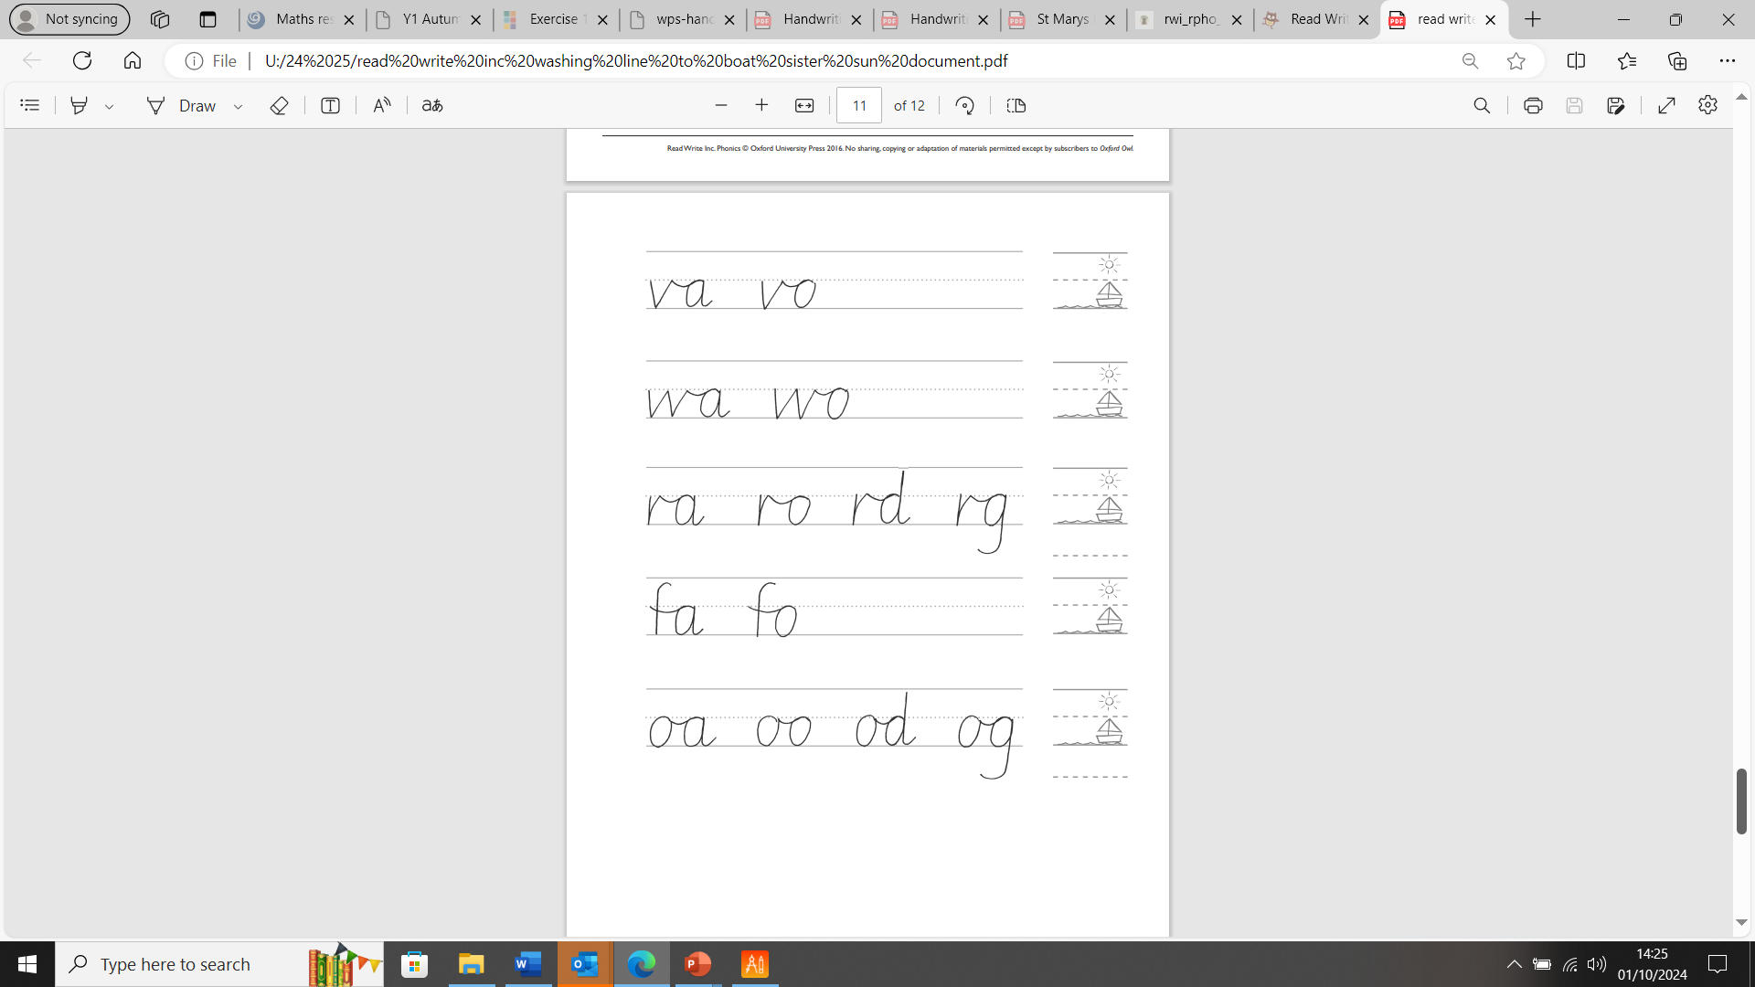
Reception
We aim for the children to:
• use a comfortable and efficient pencil grip
• write first name correctly, beginning with a capital letter
• form lower case letters using the correct sequence of movements, aided by the Read Write Inc. formation rhymes
• form capital letters in the correct direction
• form digits 0-9
Throughout the Early Years Foundation Stage the children will be provided with a range of activities to develop their fine and gross motor skills needed for handwriting.
Children in reception will have the opportunity to practise letter formation in a range of contexts. They are taught how to form letters in line with the phonics programme.
They are not taught to join at this stage. When teaching children digraphs, emphasis should not be placed on joining letters but this can be modelled and discussed with the children.

Strategies
Children progress best when provided with a variety of different strategies to practise their handwriting, e.g.
• tracing
• copying under the teacher’s writing
• sky writing
• talking through the letter formation as it is being modelled
• practice on paper
• practice in handwriting books

Handwriting Milestones: Reception (4-5 years old)
• Develop their small motor skills so that they can use a range of tools competently, safely and confidently. Suggested tools: pencils for drawing and writing, paintbrushes, scissors, knives, forks and spoons.
• Use their core muscle strength to achieve a good posture when sitting at a table or sitting on the floor.
• Develop the foundations of a handwriting style which is fast, accurate and efficient.
• Form lower case and capital letters correctly.
• Hold a pencil effectively in preparation for fluent writing – using the tripod grip in almost all cases. • Write recognisable letters, most of which are correctly formed. Sequences outlined through the Read Write Inc phonics & letter formation.
Reception
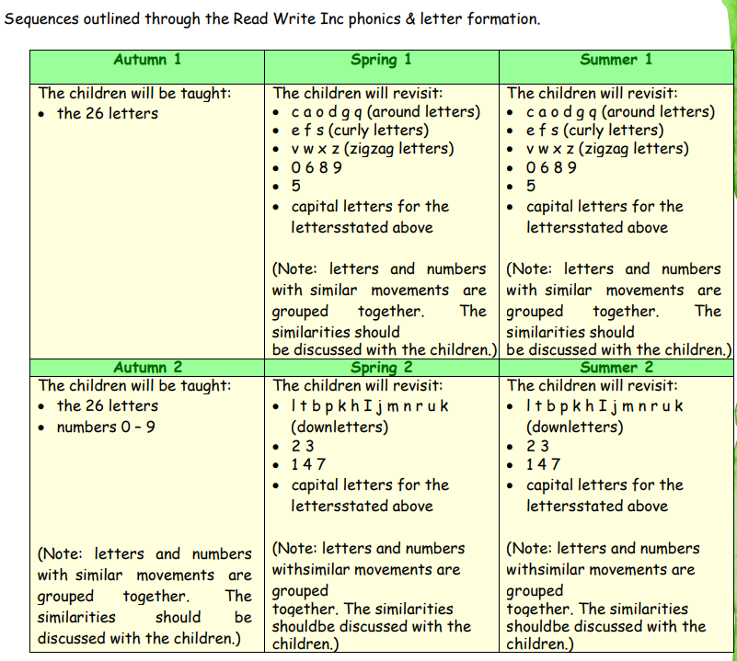
Year 1
We aim for the children to:
• sit correctly at a table, holding a pencil comfortably and correctly
• begin to form lower case letters in the correct direction, starting and finishing in the right place
• form capital letters correctly
• form digits 0 to 9 correctly
• understand which letters belong to which handwriting ‘families’ (i.e. letters that are formed in similar ways) and to practise these
Handwriting Milestones Year 1, Age 5–6
Pupils should be taught to:
• sit correctly at a table, holding a pencil comfortably and correctly
• begin to form lower-case letters in the correct direction, starting and finishing in the right place
• form capital letters • form digits 0–9
• understand which letters belong to which handwriting ‘families’ (i.e. letters that are formed in similar ways) and to practise these.

Handwriting requires frequent and discrete, direct teaching.

Pupils should be able to form letters correctly and confidently.
The writing implement being used should allow the pupil to hold it easily and correctly so that bad habits are avoided. Left-handed pupils should receive specific teaching to meet their needs.

In Year 1, the children have daily handwriting practice. Sequences below are outlined through the Read Write Inc phonics & letter formation
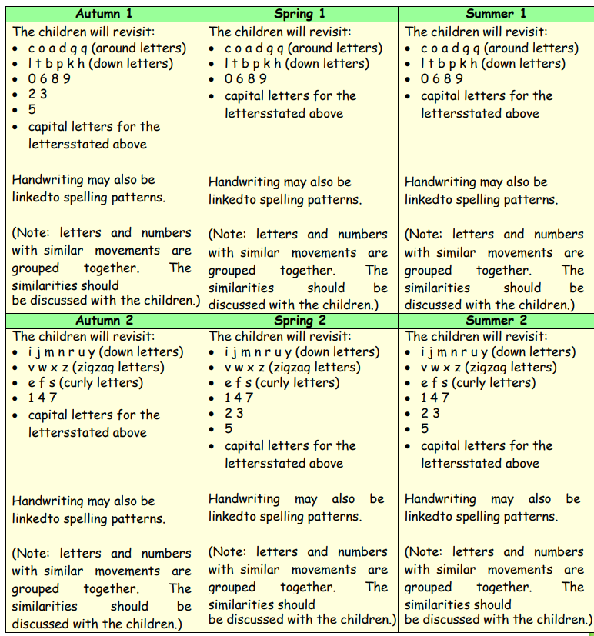
Year 2
We aim for the children to:
• sit correctly at a table, holding a pencil comfortably and correctly
• form lower case letters of the correct size relative to one another
• start using some of the diagonal and horizontal strokes needed to join letters and understand which letters, when adjacent to one another, are best left unjoined *
• write capital letters and digits of the correct size, orientation and relationship to one another and to lower case letters
• use spacing between words that reflects the size of the letters. * Read Write Inc gives two options about joining some letters the arm join (diagonal)and the washing line join (straight)

Handwriting Milestones Year 2, Age 6–7
Pupils should be taught to:
• form lower-case letters of the correct size relative to one another
• start using some of the diagonal and horizontal strokes needed to join letters and understand which letters, when adjacent to one another, are best left un-joined
• write capital letters and digits of the correct size, orientation and relationship to one another and to lower case letters
• use spacing between words that reflects the size of the letters.
Pupils should revise and practise correct letter formation frequently. They should be taught to write with a joined style as soon as they can form letters securely with the correct orientation. Children in year 2 have daily handwriting practice.
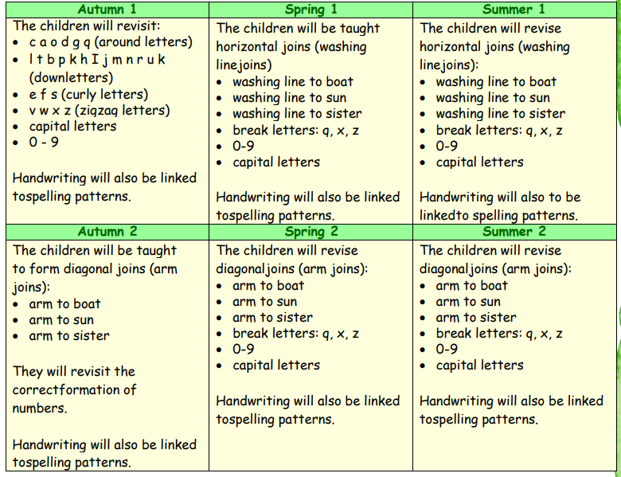
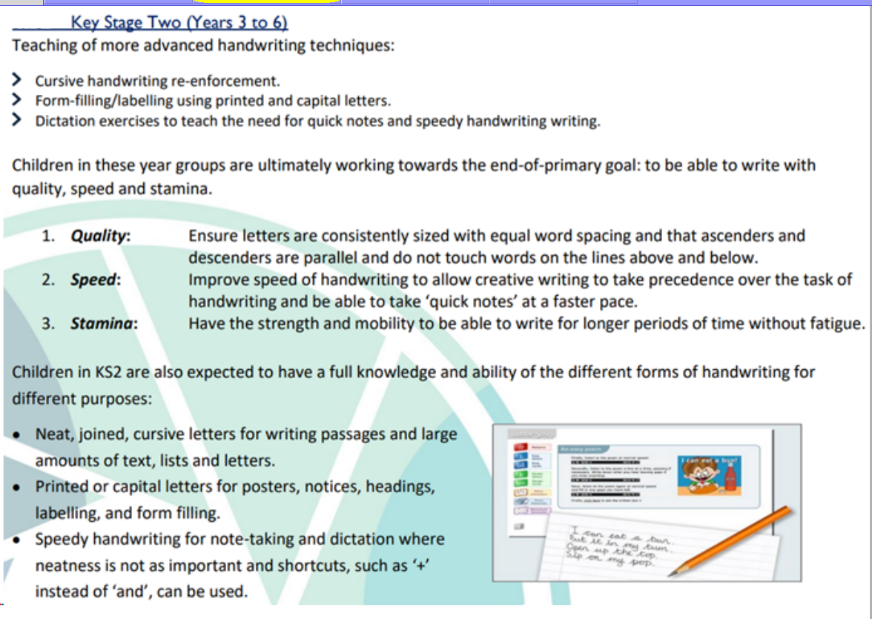
Years 3 and 4
We aim for the children to: • sit correctly at a table, holding a pencil comfortably and correctly
• use the diagonal ( arm joins) and horizontal (washing line joins) strokes that are needed to join letters and understand which letters, when adjacent to one another, are best left unjoined. Use language start on the line rock it up…
• increase the legibility, consistency and quality of their handwriting (for example, by ensuring that the downstrokes of letters are parallel and equidistant; that lines of writing are spaced sufficiently so that the ascenders and descenders of letters do not touch)
• increase the fluency with which they are able to write what they say.

In Years 3 and 4, handwriting is taught regularly a minimum of 3 times a week. The teaching of handwriting is also linked to the spellings being taught.

Handwriting Milestones Years 3–4, Age 7–9
Pupils should be taught to:
• use the diagonal and horizontal strokes that are needed to join letters and understand which letters, when adjacent to one another, are best left un-joined
• increase the legibility, consistency and quality of their handwriting (for example, by ensuring that the downstrokes of letters are parallel and equidistant; that lines of writing are spaced sufficiently so that the ascenders and descenders of letters do not touch). Pupils should be using joined handwriting throughout their independent writing. Handwriting should continue to be taught, with the aim of increasing the fluency with which pupils are able to write down what they want to say. This, in turn, will support their composition and spelling.
 |  | Year 4
  Year 3
  Autumn 1 | Spring 1 | Summer 1
  -arm join and washing line join.  Review the correct join to match the spelling patterns in RWspell  for dis, im, ous  ensure all number formation is correct, include mathematical symbols | Practise joing for ch, ion, ian linked to spelling of whole words | Revise all joins. Practise joins for recap of spellings, practise tricky joins for s/f/g/y in the context of whole words and phrases
  Autumn 2 | Spring 2 | Sunner 2
  Practice joins for ly, ture, ation  Practise in the context of full words | Practise joins for re, anti, super, sun  Linked to spelling in whole words and phrases  Look at break letter qu/x/z | Review and practise join in whole sentences.
  Autumn 1 | Spring 1 | Summer 1
  -arm join and washing line join.  Review the correct join to match the spelling patterns in RWspell  mis, un, in, dis, sure, ou, auto  ensure all number formation is correct, include mathematical symbols, commas and decimal points. | Practise joing for ous, sc,sion linked to spelling  Practise inter context of wholewords, phrases and sentences | Revise all joins. Practise joins for  ir, wr,ion, ph  practise tricky joins for s/f/g/y in the context of whole words, phrases and sentences
  Autumn 2 | Spring 2 | Sunner 2
  Practice joins for  ly,inter, eigh, ei, ey  Practise in the context of full sentences | Practise joins for un,in, mis, dis ,que,gue  Linked to spelling in the context whole words, phrases and sentences  Look at break letter qu/x/z | Review and practise join in whole sentences.  Practise redrafting and final drafting whole pieces of work
Years 5 and 6 We aim for the children to:
• write legibly, fluently and with increasing speed by:
- using the basic joins confidently when writing - making choices about their own personal writing style - making decisions about when it is best to leave writing un-joined,
e.g. when labelling a diagram or filling in a form
- choosing which shape of a letter to use when given choices and deciding whether or not to join specific letters (as long as they are consistent in their choices)
- choosing the writing implement that is best suited for a task • be clear about what standard of handwriting is appropriate for a particular task, e.g. quick notes or a final handwritten version

In Year 5 & 6
Handwriting is taught in discrete sessions 2 x 15 mins weekly as a minimum using the teaching sequences for previous year groups according to the needs to the children in the class. The teaching of handwriting is also linked to the spellings being taught. This should include whole words, phrases and verses, and should only be single letter or two letters if the child needs additional support with particular letter formations.

Handwriting Milestones Years 5–6, Age 10–11
Pupils should be taught to write legibly, fluently and with increasing speed by:
• choosing which shape of a letter to use when given choices and deciding whether or not to join specific letters • choosing the writing implement that is best suited for a task.
Pupils should continue to practise handwriting and be encouraged to increase the speed of it, so that problems with forming letters do not get in the way of their writing down what they want to say.
They should be clear about what standard of handwriting is appropriate for a particular task, for example, quick notes or a final handwritten version.
They should also be taught to use an un-joined style, for example, for labelling a diagram or data, writing an email address, or for algebra; and capital letters, for example, for filling in a form
  Year 5
  Autumn 1 | Spring 1 | Summer 1
  -arm join and washing line join.  Review the correct join to match the spelling patterns in RWspell  ible, able,  ensure all number formation is correct, include mathematical symbols,  Ensure consistancy of all Capital letters, size and oreientation | Practise joing for ence, ei,ant linked to spelling  Practise inter context of wholewords, phrases and sentences | Revise all joins. Practise joins for  cial, tial practise tricky joins for s/f/g/y in the context of whole words, phrases and sentences
  Autumn 2 | Spring 2 | Sunner 2
  Practice joins for  Ibly, ably, ent  Practise in the context of full sentences | Practise joins for ant, ance, ancy,cious,tious  Linked to spelling in the context whole words, phrases and sentences  Look at break letter qu/x/z | Review and practise join in whole sentences and verses  Practise redrafting and final drafting whole pieces of work
  Year 6
  Autumn 1 | Spring 1 | Summer 1
  -arm join and washing line join.  Review the correct join to match the spelling patterns in RWspell  Ing, ed, er est, inle ensure all number formation is correct, include mathematical symbols, commas and decimal points. | Practise joing for ous,ei,ie, ough linked to spelling  Practise inter context of wholewords, phrases and sentences | Revise all joins. Practise joins for  Orange words and building writing speed and stamina  Rehearse any tricky joins and practise orange words at speed building stamina.  practise tricky joins in words and sentences and verse.
  Autumn 2 | Spring 2 | Sunner 2
  Practice joins for  Able ion,ian, ant , ough  Practise in the context of full sentences | Practise joins for orange words, and writing at speed  Linked to spelling in the context whole words, sentences and verses  Look at break letter qu/x/z | Review and practise join in whole sentences.  Practise redrafting and final drafting whole pieces of work

Overview Formal handwriting instruction will be carried out regularly and systematically to ensure that key stage targets are met Throughout these lessons, children are encouraged to engage in gross and fine motor ‘warm up’ tasks to prepare them for the activities and develop key strengths and muscle groups. Teachers should be teaching no less than 60 minutes of handwriting lessons weekly, broken into sessions (x2 30 mins, 4x 15 mins). Handwriting sessions should be timetabled and all adults within a year group should be utilised in these sessions to support children.
As a school, we also recognise that handwriting is a cross-curricular skill. As such, children will be expected to implement their handwriting learning during all lessons and in all subjects. Teachers will have a high expectation with regard to this implementation.

